Antimicrobial Activity of green synthesized ZnO –Ag Nanocomposite against Food-borne Pathogen

Mina Zare, Centre for Materials Science and Technology, Vijnana Bhavana, University of Mysore, Mysore, India
K. Namratha, Centre for Materials Science and Technology, Vijnana Bhavana, University of Mysore, Mysore, India
K. Byrappa, Centre for Materials Science and Technology, Vijnana Bhavana, University of Mysore, Mysore, India

Abstract
In this study, ZnO-Ag nanocomposite (NCs) was synthesized uniform Ag spherical size with less than 5 nm through a simple and eco-friendly bio-hydrothermal method by using aqueous Thymus vulgaris (T. vulgaris) leaf extract. For the first time T. vulgaris leaf extract was used as a reducing agent and surfactant in the green synthesis of ZnO-Ag NCs. Crystal structure, Functional group, morphology, chemical elemental, the band gap of ZnO-Ag NCs were characterized by using powder X-ray diffraction, Fourier Transform Infrared Spectroscopy, Transmission Electron Microscopy, Energy Dispersive X-ray analysis, UV-visible spectroscopy, respectively. TEM results confirmed the size and morphology of nanocomposite. The influence of silver nitrate concentration in the formation of ZnO-Ag NCs was studied. The in-vitro Antimicrobial activity of as prepared NCs were analysed against selected gram negative and gram positive foodborne pathogens. Remarkably, the ZnO-Ag NCs was found to be less effective for E. coli than S. aureus. However, ZnO/Ag NCs illustrated synergistic and enhanced antibacterial activities for both Gram-positive and Gram- negative positive bacteria attributable to the strong interaction between semiconductor ZnO and metallic Ag.
Keywords: ZnO-Ag Nanocomposite, Green synthesis, Thymus vulgaris, Hydrothermal method

Image

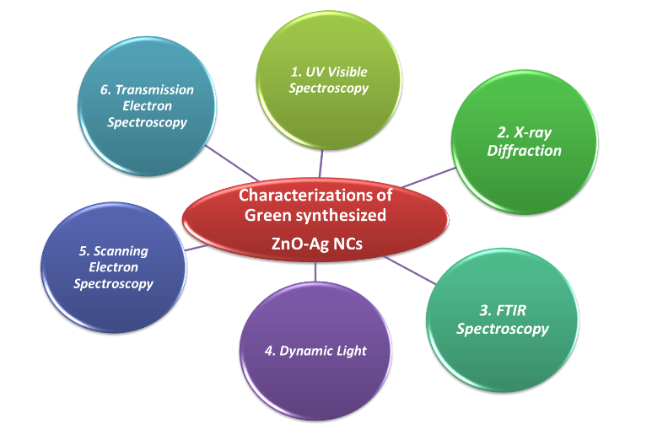

Figure1: Characterization of green synthesized ZnO-Ag NCs
Recent Publications
- A. Hezam, K. Namratha, Q.A. Drmosh, B.N. Chandrashekar, K.K. Sadasivuni, Z.H. Yamani, C. Cheng, K. Byrappa, S. Jiazhong, Y. Shi, N. Wang, C. Cheng (2017) Heterogeneous growth mechanism of ZnO nanostructures and the effects of their morphology on optical and photocatalytic properties, CrystEngComm. 19 (2017) 3299–3312.
- S. H, Manikandan, B. Ahmed M, G. V, G. V (2017) Enhanced Bioactivity of Ag/ZnO Nanorods-A Comparative Antibacterial Study (Sbds), J. Nanomed. Nanotechnol. 4 (2017) 1–7.
- M. Zare, K. Namratha, K. Byrappa, D.M. Surendra, S. Yallappa, B. Hungund (2017) Surfactant assisted solvothermal synthesis of ZnO nanoparticles and study of their antimicrobial and antioxidant properties, J. Mater. Sci. Technol. (2017).
- N. Senthilkumar, E. Nandhakumar, P. Priya, D. Soni, M. Vimalan, I. Vetha Potheher (2017) Synthesis of ZnO nanoparticles using leaf extract of Tectona grandis (L.) and their anti-bacterial, anti-arthritic, anti-oxidant and in vitro cytotoxicity activities, New J. Chem. 41 (2017) 10347–10356
- S. Aiswarya Devi, M. Harshiny, S. Udaykumar, P. Gopinath, M. Matheswaran (2017) Strategy of metal iron doping and green-mediated ZnO nanoparticles: dissolubility, antibacterial and cytotoxic traits, Toxicol. Res. (Camb). 6 (2017) 854–865. doi:10.1039/C7TX00093F.

Biography
Mina Zare is a research student pursuing her Ph.D. degree under the supervision of Prof. K. Byrappa at the Centre for Materials Science and Technology, University of Mysore, India. She passed her Master of Science degree in Food science, University of Mysore, India. She is specialised in biomimetic synthesis and characterization for nanoparticles and at present working on bio-assisted hydrothermal synthesis of iron oxides.
Email: zare.mina@yahoo.com

Notes/Comments:

