Selective detection of halide anions in water using a paper-printed silver-epoxy nanocomposite
Dr Víctor Rentería-Tapia, PhD, CUVALLES-UdG, México
Dr Enrique Barrera-Calva, PhD, UAM-I, México

Abstract
Statement of the Problem: Selective, rapid and sensitive detection of halides in water is critically important in the diagnosis of diseases and assessment of aquatic ecosystems. The recognition is usually carried out by numerous analytical methodologies such as ion selective electrodes, amperometry, liquid chromatography, etc. Although these methods offer high sensitivity, they are expensive and time-consuming sample treatment. Therefore, great efforts have been focused on sensing of halide anions in water through a simple, fast, low-cost and portable paper-based colorimetric platform. In particular, the metallic nanoparticles printed on filter paper of cellulose offer a viable alternative to be used as selective colorimetric platform for the recognition and quantification of water-soluble analytes of chemical or biological interest. Methodology & Theoretical Orientation: In this work, a silver-epoxy nanocomposite printed on filter paper of cellulose was prepared for colorimetric detection of I⁻ and Cl⁻ anions in aqueous solution. Findings: The sensing of halide anions based on the aggregation of silver nanoparticles shows fast naked–eye response (seconds) and high specificity toward I⁻ and Cl⁻ detection at concentrations in the 0–400 mM range with detection limit of 0.8 and 1.4 mM, respectively. The paper–based plasmonic sensor can distinguish individual I⁻ and Cl⁻ from other species such as: F–, OH–, NO₃–, SO₄^{2–}, HPO₄^{2–}, H₂PO₄–, Fe³⁺, Zn²⁺, Ca²⁺, Mg²⁺, K⁺, Na⁺, NH₄⁺, urea and lactate. The selective recognition of iodide and chloride anions in simulated environmental and physiological systems, it is also shown. On the basis of the optical spectra and SEM images, the sensing mechanism involves anisotropic silver nanoparticles (faceted and elongated shapes) approaching one another in presence of water. Subsequently, the interaction between I– or Cl⁻ on the surface of the silver nanoparticles caused oxidative etching, shape conversion (faceted to triangular and spherical shapes) and formation of chain–like aggregates resulting in strong interparticle plasmonic coupling. Conclusion & Significance: The paper–based plasmonic sensor based on silver-epoxy nanocomposite comprises a practical colorimetric platform for the selective determination of halide anions at high concentration in physiological and environmental systems.

Image
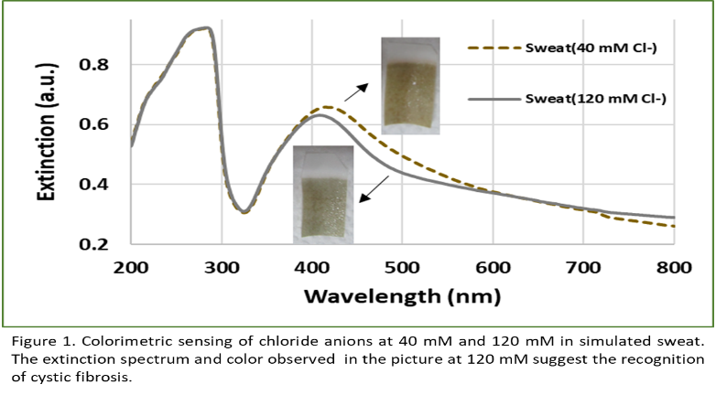
Recent Publications
- Franco A, Velásquez-Ordoñez C, Ojeda-Martínez ML, Ojeda-Martínez M, Barrera-Calva E, Rentería-Tapia V (2022) Paper-based colorimetric sensor for detection of chloride anions in water using an epoxy-silver nanocomposite. J. Nanoparticle Research 24: 54.
- Murphy CJ, Sau TK, Gole AM, Orendorff CJ, Gao J, Gou L, Simona EH Li T (2005) Anisotropic metal nanoparticles: synthesis, assembly, and optical applications. J. of Physical Chemistry B 109:13857-13870.
- Phoonsawat K, Ratnarathorn N, Henry CS, Dungchai W (2018) A distance-based paper sensor for the determination of chloride ions using silver nanoparticles. Analyst 143:3867-3873.
- Zhang J, Xu X, Yang C, Yang F, Yang X (2011) Colorimetric iodide recognition and sensing by citrate-stabilized core/shell Cu@ Au nanoparticles. Analytical Chemistry 83:3911-3917.
- Wei SC, Hsu PH, Lee YF, Lin YW, Huang CC (2012) Selective detection of iodide and cyanide anions using gold-nanoparticle-based fluorescent probes. ACS Applied Materials & Interfaces 4:2652-2658.

Photograph

Biography
Dr Víctor Rentería-Tapia has expertise in the synthesis and plasmonic properties of silver and gold nanoparticles for applications in sensing and solar energy. He has experience in research, evaluation, teaching and administration of projects in the industry, government and education institutions. He is associated professor of the Department of Natural Sciences and Exacts from Guadalajara University, campus CUVALLES in México.
Email:victor.renteria@academicos.udg.mx

Notes/Comments: Dr. Víctor Rentería-Tapia thanks to Conacyt for the granted fellowship

