Abstract Title: A reusable polyaniline functionalized activated carbon composite based system for enhanced removal of industrial dyes and chromium from waste water
Nitesh Kumar¹, V.K. Jain^{1,2}, Suman Nagpal^{1,2}

¹ Amity Institute for Advanced Research and Studies (Materials & Devices) (Amity University, India)
²Amity Institute of Renewable and Alternative Energy (Amity University, India)

Abstract

In this article, we report the preparation of a novel efficient, rapid and reusable system based on polyaniline impregnated activated carbon composite (PANI-ACC) for the remediation of dyes and chromium from waste water. The prepared composite PANI-ACC was characterized by SEM and FTIR techniques whereas the chromium adsorption studies were recorded by the flame AAS. Dyes and metal undergo interactions with the content of the aromatic ring structures and nitrogen-containing functional groups on the surface of modified PANI-ACC leading to significant adsorption of responsible contaminants adsorb on the surface of composites, filled in the fixed bed column as shown in figure 1. The above mentioned system able to greatly remove the dyes and chromium at a trace level and provides 96.5% removal of different industrial dyes along with 99.6% removal-efficiency within 60 minutes of incubation time at pH (6-7). This study provides an innovative two-in-one approach for initially complete removal of dyes and chromium contamination from water bodies. This system can solves the major technical and economical constraints present in the developing countries for the treatment of waste water using a low-cost, reusable and user-friendly novel composite.

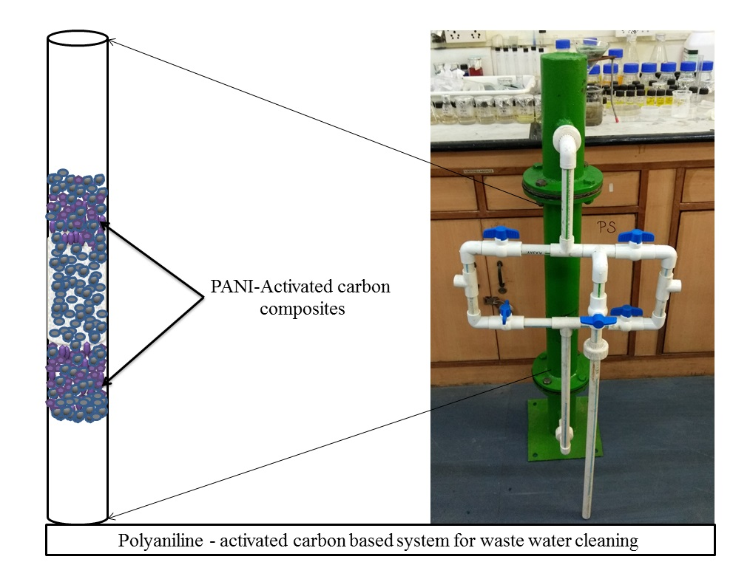
Figure 1

Keywords—Activated carbon, Chromium removal, PANI-ACC, Waste water treatment

Professional Biography

Nitesh Kumar is currently pursuing PhD in Materials and Devices from Amity University, Noida, India and he is also working as Senior Research Fellow at Amity Institute for Advanced Research and Studies (Materials & Devices), Amity University, India. His research interests include synthesis of nanomaterials, developing methods for sensing of heavy metals based on nanomaterials, water purification using nanomaterials. He has published 3 research papers in reputed journals.

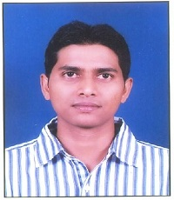

Email Id: nkumar10@amity.edu

Any Comments: NA

