Numerical comparison of various adsorption models for assessing
the microporous structure of activated carbons

Mirosław Kwiatkowski¹, Vanessa Fierro², Alain Celzard²

¹ AGH University of Science and Technology, Poland
² Université de Lorraine, France

Abstract
Herein, a comprehensive analysis of DFT methods as a tool for evaluating the impact of the nature of activating agent on the porous structure of activated carbons derived from hazelnut shells is given. The study was based on the use of NLDFT, 2D-NLDFT, and QSDFT methods applied to nitrogen adsorption isotherms, and the results were compared with those formerly obtained by using DR, BET, and LBET methods. The analyses carried out using NLDFT, QSDFT, and 2D-NLDFT indicated a very strong dependence of the results on the assumptions regarding the specific model of pores, which questions the reliability and credibility of those methods. However, if one considers errors of measurement that may occur when determining adsorption isotherms, as well as the difficulty of selecting a representative sample from a batch of (most often inhomogeneous) material to be analysed, certain imperfections of the DFT methods become acceptable. Considering the above, it is advisable to perform concurrent analyses using all together NLDFT, 2D-NLDFT, QSDFT, and BET, DR and LBET methods, which – provided that the results of analyses are correctly interpreted – may yield complementary and reliable information on the analysed porous structure and corroborate the results obtained using different methods.

Keywords: Adsorption, activated carbons, porous structure, DFT methods.

Acknowledgments: The research was led within the subvention from the Polish Ministry of Science and Higher Education for the AGH University of Science and Technology in Krakow.

Professional Biography
Dr. hab. eng. Mirosław Kwiatkowski in 2004 obtained Ph.D. degree at the AGH University of Science and Technology in Kraków (Poland), and in 2018 D.Sc. degree at the Wrocław University of Technology (Poland). His published work includes more than 45 papers in reputable international journals and 90 conference proceedings. He is the editor in chief of The International Journal of System Modeling and Simulation (United Arab Emirates), anassociate editor of Micro & Nano Letters Journal (United Kingdom) and a member of the editorial board of internationals journals as well as a member of the organizing and scientific committees many international conferences in Europe, Asia and United States of America. Dr. hab. eng. Mirosław Kwiatkowski is also a regular reviewer in a most reputable scientific journals.
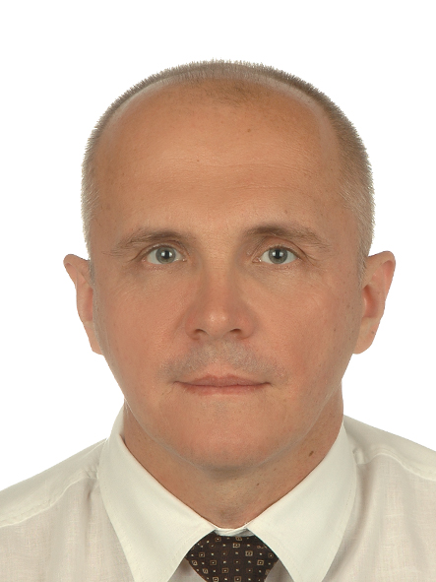
Email Id: kwiatkow@agh.edu.pl

