Title: Selective ablation of nano-layer Ti based thin films by single pulse femtosecond laser
Biljana Gaković, Atomic Physics Laboratory, Vinča Institute of Nuclear Sciences, University of Belgrade, Belgrade, Serbia

Abstract
Laser processing of materials is unique method, which allows their morphological as well as composition modifications. In case of usage of ultra-short laser pulses (pulse duration less than picosecond) laser processing is extremely precise. Irradiation of materials by femtosecond laser enables removal or alteration of their surface at nano/micro level without change of non-irradiated area. Nano scale multi-layer thin films are attractive composite materials due to their properties that cannot be obtained in the case of materials of the same bulk constituents. Selective ablation of the upper layer of the nano-layer thin film, with little or no damage of the layer or the substrate beneath, is significant for applications. The effects of ultra-short laser pulses on reactive titanium-aluminium (Ti/Al) and nickel-titanium (Ni/Ti) nano-layer thin films (NLTF) were investigated. The samples, composed of five bilayers (Ti/Al and Ni/Ti, respectively), were prepared by ion sputtering on a Si substrate. Single pulse irradiations were done in air with focused and linearly polarized Gaussian laser beam- 515 nm wavelength, 200 fs pulse duration and variable pulse energy. One step selective ablation of upper layer from NLTFs at low laser pulse energies (Figure 1 and 2), and complete ablation of the thin films from the Si substrate at higher pulse energies, were registered. Effects of laser induced morphological and composition changes were monitored by scanning electron microscopy (SEM&EDS) and profilometry. Spalative ablation could be the main mechanism that caused ablation of the upper layers from the nano-layer thin films.
Images
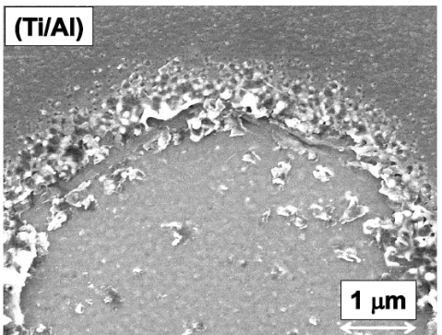

Figure 1: Fs laser selective ablation of the first layer from Ti/Al.

Recent Publications
- Gaković B, Radu C, Zamfirescu M, Radak B, Trtica M, Petrović S, Panjan P, Zupanic F, Ristoscu C, Mihailescu IN, Femtosecond laser modification of multilayered TiAlN/TiN coating, Surface Coatings and Technology, 206, 411-416 (2011)
- Gaković B, Radak B, Radu C, Zamfirescu M, Trtica M, Petrovic S, Stasic J, Panjan P, Mihailescu IN, Selective single pulse femtosecond laser removal of alumina (Al₂O₃) from a bilayer Al₂O₃/TiAlN/steel coating, Surface Coatings and Technology, 206, 5080 (2012)
- Petrović S, Gaković B, Peruško D, Stratakis E, Bogdanović –Radović I, Čekada M, Fotakis C, Jelenković B, Femtosecond laser-induced periodic surface structure on the Ti-based thin films, Journal of Applied Physics, 114, 233108 (2013)
- Gaković B, et al. Precise femtosecond laser crater fabrication in hard nanolayered AlTiN/TiN coating on steel substrate, Optics & Laser Technology, 89, 200–207, (2017)
- Kudryashov SI, Gaković B, Danilov AP, Petrović S, Milovanović D, Rudenko AA, Ionin AA, Single-shot selective femtosecond laser ablation of multi-layered Ti/Al and Ni/Ti films: "cascaded" heat conduction and interfacial thermal effects, Applied Physics Letters, 112, 023103, (2018)

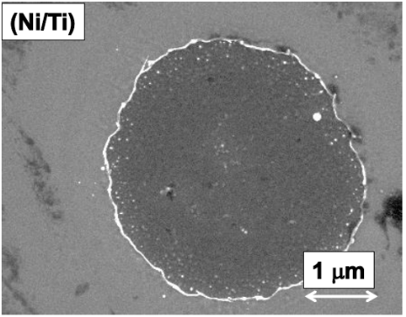

Figure 2: Fs laser selective ablation of the first layer from Ni/Ti.

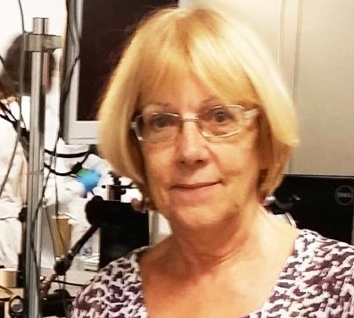
Biography

More than twenty years of research experience at Atomic Physics Laboratory, Vinča Institute of Nuclear Sciences, University of Belgrade, Serbia. Research interests are: physical phenomena associated with energetic beams - material interaction, surface modification of materials (metals, ceramics and semiconductors - thin films or bulk) with short and ultra-short pulse laser beams, on micro- and nano-meter scale, material characterizations. About 100 scientific publications in peer-reviewed journals; advisor of several MSc and DSc/PhD theses; 15 plenary/oral lectures at international conferences; referee for international journals (Optics & Laser Technology, Surface Coatings and Technology, Applied Surface Sciences, Laser and Particle Beams, Thin Solid Films, etc.) Participated in many national and international research projects and in 5 EU founded COST actions.
E mail:biljagak@vin.bg.ac.rs

