Title: Synthetic Viral Synthesis Methodology
Tory C. Weston, Science Director of West Nanorobotics, USA.

Step I:Custom Oligonucleotide Synthesis
Materials
•Commercial Nucleic Acid Synthesizer
•Solution of the four DNA phosphoramidite monomers (bases)
•All the 5’-hydroxyl groups must be blocked with a DMT group for all four bases
•All phosphorus linkages must be blocked with a cyanoethyl group.
•Blocking solutions
•Reaction chamber and a type of solid support such as controlled pore glass
•The solid support should be prepared with the desired first base already attached via an ester
linkage at the 3’-hydroxyl end.
•Dichloroacetic acid or trichloroacetic acid
•Tetrazole
•Acetic anhydride and N-methylimidazole
•Dilute iodine in a water/pyridine/tetrahydrofuran solution
•Concentrated ammonia hydroxide.
•Materials for one desalting method
Final Product: DNA Chains from 1 to 10,000 base pairs in length.

Step II:Molecular Cloning: Polymerase Chain Reaction

Materials
-Thermal Cycler
-Taq polymerase
-Generated DNA Fragments

Final Product: Exponential DNA cloning

Step III:Mass Ligation Reaction or Standard Ligation Reaction
Materials
•Two or more fragments of DNA that have either blunt or compatible cohesive ("sticky") ends.
•A buffer which contains ATP. The buffer is usually provided or prepared as a 10X concentrate
which, after dilution, yields an ATP concentration of roughly 0.25 to 1 mM. Most restriction
enzyme buffers will work if supplemented with ATP.
•T4 DNA ligase. A typical reaction for inserting a fragment into a plasmid vector (subcloning)
would utilize about 0.01 (sticky ends) to 1 (blunt ends) units of ligase.
Final Product: Every possible recombination or a Single Recombination

Step IV:Activation and Reproduction : Plasmid Vector
(sub-cloning)

Materials
-Anything with ribosomes
-NotI Ligase
Final Product: Synthetic Viral Vector
MV-2 Retroviral Vector Gene map
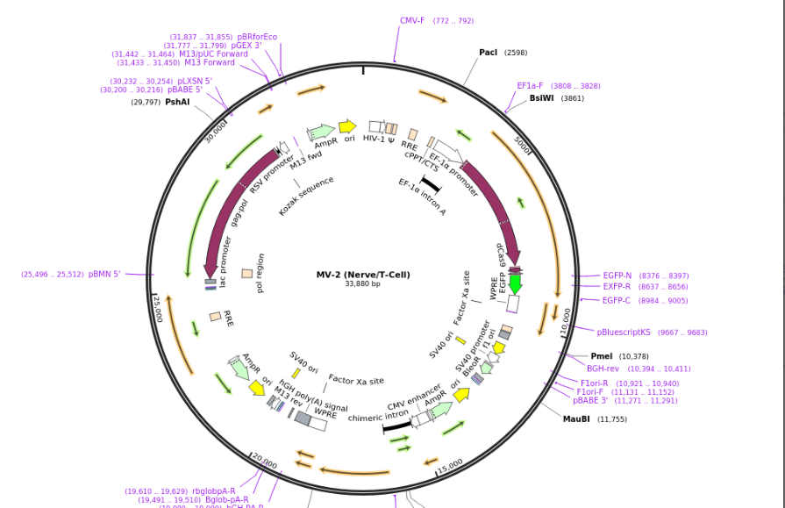Figure 1: Synthetic Viral Vector Plasmid (MV-2) that targets only Nerve and T-cells which can be constructed by Synthetic Viral Synthesis which cannot be produced by other means which contains Cas9 to add to the cells of a certain type. (33,800 bp)
Recent Publications
- Multivalent Retroviral Vectors, www.scienceforums.com
- Carbon Fusion and Thorium Cycle, www.scienceforums.com
- Nano-factory Discuss,
www.scienceforums.com
- Hybridization of Vectors MV-x strains,
www.Sciencemadness.com
- Promise and Peril of Nanotechnology
www.Sciencemadness.com

Biography
Since childhood, Tory Weston has been fascinated by science which include biology and physics then went to college for Biophysics at Ivytech school for Biotechnology and Biochemistry at Ball State during the middle of his schooling at Ball State University was experimenting with Viral Vectors and how to make them more exact then standard methods. Shortly after he tested created his first synthetic hybrid bacterial plasmid containing extra genes; him and a professor Eric Rubenstein proceeded to make the first Multivalent Viral Vector in 2014 which was perfectly fused being the MV-2 Vector which could be designed directly afterward Tory Weston began a company named West Nanorobotics and began to conduct Bio-nanorobotics research for 4 years making hundreds of synthetic hybrid viral nano-machines for cancer research and to market, which now include up to MV-28 being in the experimental stages at age 27.
E mail: qauikai@yahoo.com

