Optimization of Al-doped ZnO transparent electrodes with and without thermal assistance using HiPIMS

David Horwat, Institut Jean Lamour, Universityof Lorraine, France

Abstract

Aluminum-doped zinc oxide (AZO) is a transparent conductor that can be used in thin film form as transparent electrode of electro-optical devices. For most of actual applications, a large conductivity is required on large surface areas.

The rapid growth of transparent electronics and electro-optical devices on flexible supports calls for the development of methods that enable the synthesis of transparent conducting films without thermal assistance while keeping high electrical and optical performances. Magnetron sputtering has emerged as a reference method for the synthesis of AZO films. It is particularly due to, its scalability to industrial scale. Unfortunately, AZO films usually produced without thermal assistance using magnetron sputtering tend to a strong inhomogeneity of the electrical properties with a large sensitivity to the process parameters (composition of the gas phase, geometry of the experiment) [1].

This presentation first highlights the interest of high power Impulse Magnetron Sputtering (HiPIMS) to synthesize AZO films of high electronic conductivity on large surface areas and without thermal assistance. Electronic structure measurements using X-ray absorption spectroscopy evidence a correlation between the distribution of the electrical behavior and dopant activation/inactivation [2, 3]. A deactivation mechanism, complementary to the well-known compensation of dopants, is proposed in the case of conventional sputtering. A model explaining the minimization of the deactivation amplitude is proposed in case of HiPIMS [4, 5].

In a second part we will show how the electrical properties of AZO films degraded after long term exposure to ambient moisture can be restored by low temperature thermal annealing and how thermal assistance during growth can prevent degradation upon exposure to ambient moisture [6, 7].

Finally, self-nanostructured AZO films could be obtained using HiPIMS under certain conditions and their interest for flexible electronics is highlighted.
Image
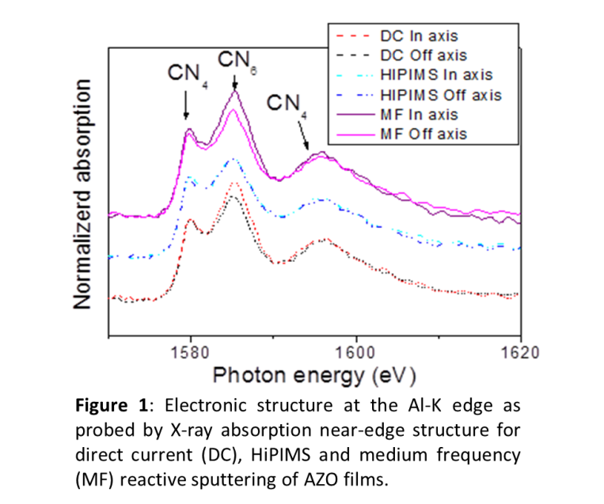
Recent Publications (minimum 5)
- D. Horwat, A. Billard, Effects of substrate position and oxygen gas flow rate on the properties of ZnO: Al films prepared by reactive co-sputtering, Thin Solid Films 515 (2007) 5444
- D. Horwat, et al, On the deactivation of dopant and electronic structure in reactively sputtered transparent Al-doped ZnO thin films. J. Phys. D : Appl. Phys. 43 (2010) 132003
- M. Jullien, et al. Influence of the nanoscale structural features on the properties and electronic structure of Al-doped ZnO thin films: an X-ray absorption study, Sol. Energ. .Mater. Sol. Cells. 95 (2011) 2341
- M. Mickan et al., Room temperature deposition of homogeneous, highly transparent and conductive Al-doped ZnO films by reactive high power impulse magnetron sputtering, Sol. Energ. Mater. Sol. Cells. 157 (2016) 742
- D. Horwat, M. Mickan, W. Chamorro, New strategies for the synthesis of ZnO and Al-doped ZnO films by reactive magnetron sputtering at room temperature, Phys. Stat. Sol. C 13 ( 2016) 951
- M. Mickan, M. Stoffel, H. Rinnert, U. Helmersson, D. Horwat, Restoring the Properties of Transparent Al-Doped ZnO Thin Film Electrodes Exposed to Ambient Air
- Journal of Physical Chemistry C 121 (2017) 14426–14433, J. Phys. Chem. C 121 (2017) 14426
- M. Mickan, U. Helmersson, D. Horwat, Effect of substrate temperature on the deposition of Al-Doped ZnO thin films using high power impulse magnetron sputtering, under press

Biography (150 word limit)
David Horwat has an expertise in the physico-chemistry of inorganic functional thin films. He is more particularly interested in understanding how physical properties, more particularly electrical and optical, are related to local structural, chemical states and nanostructures and on ways to modify them using physical vapor deposition methods. His research is based on a multidisciplinary approach involving synthesis, spectrometries/spectroscopies and microscopies. He teaches materials science and engineering a the European school of materials engineering (EEIGM) and conducts his research activities in the POEME research group of Institut Jean Lamour at University of Lorraine.
Email: david.horwat@univ-lorraine.fr

Notes/Comments:

