Synthesis and Characterization of Chitosan Nanoparticles in the Pharmaceutical Application
F. DAMIRI^{1*}, A. LAARAIBI¹, I. CHARHOUF¹, N. KNOUZI¹, A.BENNAMARA¹, M. BERRADA¹
¹Department of Chemistry, Laboratory of Biomolecules and Organic Synthesis (BIOSYNTHO),
Faculty of Sciences Ben M'sik, University Hassan II of Casablanca, Morocco.
* Correspondence: fouad.damiri@ outlook.fr

Abstract (300 word limit)
Nanoparticles have been widely studied for applications in drug release systems. To prevent a drug from rapid release, the use of biodegradable polymers, which serve as protective drug coatings, has been developed. Chitosan, as a biodegradable and biocompatible polymer, is extensively used as a carrier for encapsulation of drugs and biological substances in the pharmaceutical industry due to: its ability in a drug controlled-release system, its solubility in aqueous acidic solution which avoids the use of hazardous organic solvents while fabricating particles, its cationic nature that allows ionic to crosslink with multivalent anions, the capacity of chemical crosslink applied by its amino groups and its mucoadhesive character of increasing residual time at the site of absorption. Emulsion crosslinking, coacervation/precipitation, ionic gelation methods are usually used in preparing chitosan nanoparticles.
Water-soluble drugs can be loaded by using the emulsion crosslinking technique with high encapsulation efficiency. In this method, a water/oil (W/O) emulsion was prepared by emulsifying the chitosan aqueous solution in the oil phase and aqueous droplets are stabilized by using a suitable surfactant. Then the stable emulsion is solidified by an appropriate crosslinking agent.

Image
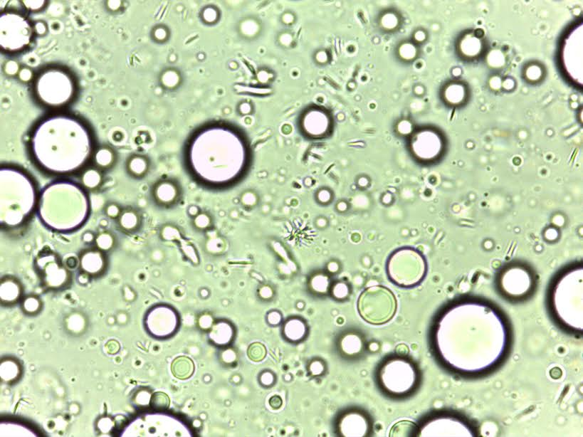
Recent Publications (minimum 5)

- Jun Jie Wang, Zhao Wu Zeng,RenZhong Xiao, TianXie, GuangLin Zhou, Xiao Ri Zhan, Shu Ling Wang; Recent advances of chitosan nanoparticles as drug carriers; 2011; 765.
- AvneshKumari, Sudesh Kumar Yadav, Subhash C. Yadav; biodegradable polymeric nanoparticles based drug delivery Room R, BaborT, Rehm J (2005) Alcohol and public health. Lancet
365: 519-530.
- Jiannan Li, Xiangru Feng, Baichun Liu, Yingjie Yu, Leming Sun e, Tongjun Liu a,Jianxun Ding, Xuesi Chen; Polymer materials for prevention of postoperative adhesion; ActaBiomaterialia; 2017; 27.
- Bodmeier, R., H. G. Chen, and O. Paeratakul. 1989. A novel approach to the oral delivery of micro- or nanoparticles. Pharm. Res. 6: 413-417.
- Kreuter, J. 1994. Nanoparticles. In: Colloidal Drug Delivery Systems, edited by Kreuter, J. New York: Marcel Dekker, 261-276.

Biography (150 word limit)
Fouad Damiri is currently a two year PhD student in polymers and science pharmaceutical at the University of Hassan II-Casablanca; Morroco. The working title of his thesis is “synthesis and characterization of nanoparticles based on polysaccharides for medical applications.”
Email: fouad.damiri@outlook.fr
Notes/Comments:

