Toward Strategies for Enzyme Immobilization using Hierarchical Metal-Organic Frameworks as Substrates

Jyotsana Mehta, PhD, CSIR-CSIO, Chandigarh, India*
Akash Deep, Senior Scientist, CSIR-CSIO, Chandigarh, India
A. K. Paul, Vice-Chancellor, DAV University, Jalandhar, India

Abstract
Long considered nanostructures par-excellence, metal-organic frameworks (MOFs) have garnered worldwide research orientation in storage, sensing, separation and opto-electronics owing to their tunable porosity, ease of functionality, high surface area and chemical/thermal stability. Recently, these robust materials have been exploited as interesting platform for immobilization of enzyme for enhanced stability, activity and reusability. Enzymes are natural catalysts that accelerate biochemical reaction without actually being consumed. Analytically purified enzymes have replaced chemical catalysts in heath care, chemical and food industry due to high specificity and green chemistry. However, the widespread applicability of enzyme is thwarted by denaturation, wash out and non-reusability in solution form. Therefore, MOF-enzyme biocalaytic supports offers improved stability, enhanced biocalaytic efficiency, high loading capacity and better recyclability. Here, we report immobilization of horse radish peroxidise (HRP) enzyme on MOF using two different strategies namely- surface immobilization and in-situ encapsulation along with their comparative analysis. In the former approach, Tb-TATB MOF was activated using dicyclohexyl carbodiimide (DCC) followed by covalent linking of HRP to MOF surface. For in-situ encapsulation, HRP enzyme was incorporated within the structure of MOF during the synthesis of Tb-BTC MOF itself. Both the approaches were compared on the basis of enzyme loading, resulting enzymatic activity and reusability. It was found that even though higher loading capacity was achieved in case of surface immobilization of enzyme, the catalytic activity of in-situ encapsulated enzyme was superior due to micro-environment provided by the surrounding MOF structure protecting the enzyme against denaturation. Also, both platforms exhibit reusability as MOF-enzyme composites are easy to recover after use by centrifugation. Thus, the proposed MOF based biocatalytic platforms are anticipated to find wide variety of commercial applications in industrial catalysis, biosensing and removal of organic pollutants in more stable, recyclable and economical manner.

Image
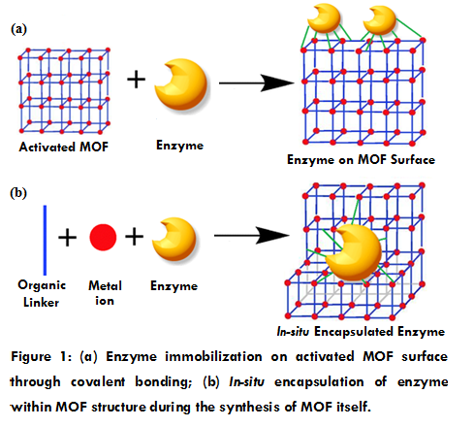
Recent Publications
- Mehta J, Bhardwaj N, Bhardwaj SK, Tuteja SK, Vinayak P, Paul AK, Kim KH, Deep A (2017) Graphene Quantum Dot modified Screen Printed Immunosensor for the Determination of Parathion. Analytical Biochemistry 523:1-9.
- Mehta J, Bhardwaj N, Bhardwaj SK, Kim KH, Deep A (2016) Recent Advances in Enzyme Immobilization Techniques: Metal-Organic Frameworks as Novel Substrates. Co-ordination Chemistry Reviews 322:30-40.
- Mehta J, Bhardwaj SK, Bhardwaj N, Paul AK, Kumar P, Kim KH, Deep A (2016) Progress in the biosensing techniques for trace-level heavy metals. Biotechnology advances 34:47-60.
- Mehta J, Vinayak P, Tuteja SK, Chhabra VA, Bhardwaj N, Paul AK, Kim KH, Deep A (2016) Graphene modified screen printed immunosensor for highly sensitive detection of parathion. Biosensors and Bioelectronics 83:339-346.
- Bhardwaj N, Bhardwaj SK, Mehta J, Mohanta GC, Deep A (2016) Bacteriophage Immobilized Graphene Electrodes for Impedimetric Sensing of Bacteria (S. arlettae). Analytical Biochemistry 505:18-25.
- Bhardwaj N, Bhardwaj SK, Mehta J, Kim KH, Deep A (2016) Highly Sensitive Detection of Dipicolinic Acid with a Water-Dispersible Terbium-Metal Organic Framework. Biosensors and Bioelectronics 86:799-804.
- Bhardwaj N, Bhardwaj SK, Mehta J, Nayak MK, Deep A (2016) Bacteriophage Conjugated IRMOF-3 as a Novel Opto-Sensor for S. Arlettae. New Journal of Chemistry 40:8068-8073.

 Biography
Jyotsana Mehta is pursuing Ph.D from CSIR-CSIO, Chandigarh, India and has qualified various national level exams such as CSIR-UGC(JRF), DBT-JRF and GATE. She has her expertise in synthesis and characterization of different nanomaterials such as graphene sheets, quantum dots and metal organic frameworks for biosensing applications along with several analytical instruments, including UV-Vis spectrophotometer, FTIR & PL spectroscope, Surface area analyzer, Raman microscope, Particle size analyzer, Atomic force microscope, Cyclic voltammetry, and Scanning electron microscope.. Ms. Mehta has also practiced revival and growth of bacterial cultures, protein purification and identification, nucleic acid isolation and transformation. She has 11 publications to her credit out of which 4 are first author in high impact journals of international repute. She intends to continue research in the interdisciplinary field of nanomaterials based biosensing and bioremediation of environmental pollutants.
Email: jyotsanamehta1@gmail.com

Notes/Comments:

