Title: Longitudinal creep behavior of nanocrystalline Ni-NiZr glass nanocomposite

Md. Meraj, Ph. D scholar, Metallurgical and Materials Engineering Department, National Institute of Technology Rourkela, Rourkela-769008, INDIA.
Snehanshu Pal, Ph. D, Metallurgical and Materials Engineering Department, National Institute of Technology Rourkela, Rourkela-769008, INDIA.

Abstract:
Longitudinal creep behavior of nanocomposite for nanocrystalline (NC) Ni-NiZr glass has been studied at various temperatures (from 1200 to 1400 K) at 1 GPa stress using molecular dynamics (MD) simulations. A simulation box of the specimen 15.85 × 15.85 × 15.85 nm dimension (contains 312,924 atoms) is taken for performing MD simulation. Common neighbor analysis (CNA), Centro-symmetry parameter (CSP) analysis, Wigner–Seitz defect analysis and radial distribution function (RDF) have been carried out to investigate the structural evolution and deformation mechanism of nanocomposite specimen during creep process. Self-diffusion of nanocomposite specimen has been performed using MD simulation for interface region and whole specimen at different temperature. Average atomic displacement and local stress in the regions (2Å, 4Å, and 6Å) adjacent to the NC Ni-NiZr glass interface is evaluated during creep deformation process to investigate the atomic movement near the interface of NC Ni-NiZr glass. It is found from creep curves that primary and secondary creep regime is reduced with increasing creep temperature. Creep rate for nanocomposite specimen is observed to be shifted downward with increasing creep temperature after 180 ps time period. Creep rate for creep process occurring at 1400 K temperatures are observed to be increased more from starting of tertiary creep regime to 180 ps time period and then decreased to 300 ps.

Image
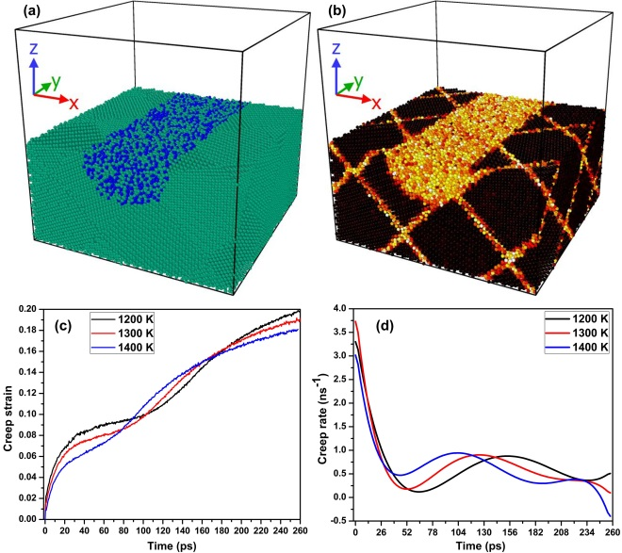Figure 1: Three dimensional sectional view of nanocomposite for NC Ni-NiZr glass specimen (a) particle type, (b) CSP, (c) creep and (d) creep rate curves of nanocomposite of NC Ni-NiZr glass for different temperatures at 1 GPa stress.
Recent Publications
- Meraj, M., Yedla, N., & Pal, S. 2016. The effect of porosity and void on creep behavior of ultra-fine grained nano crystalline nickel. Materials Letters, 169, 265-268

- Pal, S., & Meraj, M. 2016. Structural evaluation and deformation features of interface of joint between nano-crystalline Fe–Ni–Cr alloy and nano-crystalline Ni during creep process. Materials & Design, 108, 168-182.

- Pal, S., Meraj, M., & Deng, C. 2017. Effect of Zr addition on creep properties of ultra-fine grained nanocrystalline Ni studied by molecular dynamics simulations. Computational Materials Science, 126, 382-392.

- Meraj, M., & Pal, S. 2017. Nano-scale simulation based study of creep behavior of bimodal nanocrystalline face centered cubic metal. Journal of Molecular Modeling, 23: 309. https://doi.org/10.1007/s00894-017-3481-y

- Meraj, M., & Pal, S. 2017. Effect of temperature and stress on creep behavior of ultrafine grained nanocrystalline Ni-3 at% Zr alloy. Metals and Materials International, 23(2), 272-282.

- Meraj, M., & Pal, S. 2017. Healing mechanism of nanocrack in nanocrystalline metals during creep process. Applied Physics A, 123(2), 138.

- Meraj, M., & Pal, S. 2017. Comparative creep behaviour study between single crystal Nickel and ultra-fine grained nano crystalline Nickel in presence of porosity at 1120 K temperature. Metallurgical Research & Technology, 114(1), 107.

- Meraj, M., & Pal, S. 2017. Comparative creep behaviour study between single crystal Nickel and ultra-fine grained nano crystalline Nickel in presence of porosity at 1120 K temperature. Metallurgical Research & Technology, 114(1), 107.


Biography (150 word limit)
Md. Meraj completed his Master of Technology from National Institute of Technology Durgapur, India in 2014. Presently he is pursuing Ph.D. in Metallurgical and Materials Engineering Department, National Institute of Technology Rourkela, Orissa, India since 2014. He has been working on deformation (such as tensile, compressive, creep, indentation and asymmetrical cyclic deformation) of nanomaterial using molecular dynamics simulations. His scientific interests include high temperature material at nanoscale, nanocomposite of metals and high entropy alloy materials. He has been published 16 SCI research papers and 1 book chapter.
E mail: merajkhan113@gmail.com, 514mm1008@nitrkl.ac.in

