Title: Predicting the Mechanical Behaviour of Epoxy Resin based Carbon nanotubes

Mohammed Al-Bahrani, Ph D, Department of Mechanical Engineering, Plymouth University, Uk.
Alistair Cree, Dr, Department of Mechanical Engineering, Plymouth University, Uk.

Abstract

This investigation has done to calculate the mechanical properties of epoxy resin reinforced with different weight fractions (0.1%, 0.2%, 0.3%, 0.4%, and 0.5%) of multiwall carbon nanotubes and two type of functionalization (MWCNTs and COOH-MWCNTs). In this work, the ultrasonic probe and ultrasonic bath were used to prepare the nanocomposites. The ANSYS workbench program version (16.2) and mathematical approach have employed to predict the nanocomposite’s mechanical properties. The scanning electron microscope (SEM) has used to show surface morphology of the tested nanocomposites. The results obtained using simulation approach and after compared with experimental results show that increases in MWCNTs content lead to enhance the mechanical properties of the pure epoxy resin.

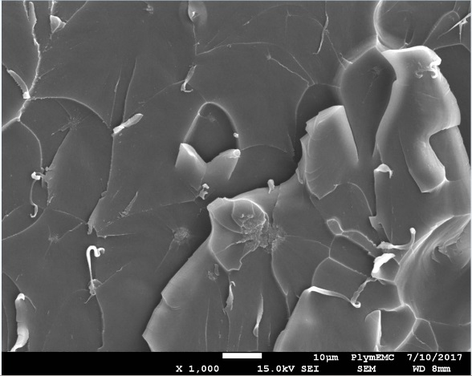

Figure 1: MWCNTs and their effect on epoxy resin

E mail: mohammed.naeem@plymouth.ac.uk

