Title: Study of the influence of voltage and time on the morphology of TiO2 nanotube matrix using graphite as cathode and organic electrolyte
M. Luna-Cervantes1, A. Báez-Rodríguez1, A. M. Ceballos-Valle, A.C. García-Velasco, Ma. G. Soriano-Rosales, J. Hernández-Torres1, y L. Zamora-Peredo1.
1Centro de Investigación en Micro y Nanotecnología, Universidad Veracruzana

Abstract (300 word limit):

A 6x6 matrix of anodization experiments was planned and designed to obtain a tubular matrix of TiO₂ where we can observe and identify exactly how the morphology is influencing by voltage and time under an organic electrolyte and using graphite as cathode, even identify the time-lapse where nanograss is introducing in our nanotubular matrix. The anodization process consisted in an organic electrolyte of ethyleneglycol, deionized water and NH₄F, 6 differents voltages and a time lapse from 1 to 6 hours. After the anodization, the whole set of anodized samples were rinse with DI and dried under heat gun (low temperature), no samples were cleaned in ultrasonic bath because we wanted preserve the nanograss structure if it was there. The anodized samples were annealed to obtain the crystaline Anatase phase. Optical characterization was performed by Raman Spectroscopy to identify the increases in signal intensity, associated with the presence of nanotubes or nanograss.
The morphological characterization was performed with Scanning Electron Microscopy to visually verify the presence and density of the nanotubes, morphological structure (radial and length dimentions) and if nanograss was in there.

Image
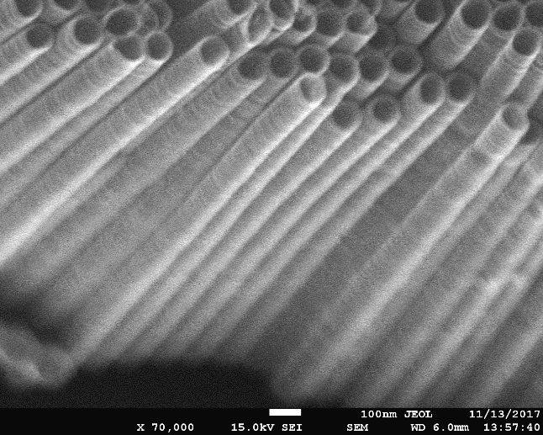Figure 1: TiO2 Nano tubes matrix.
Recent Publications (minimum 5)


Biography (150 word limit)
Industrial Engineer, actually studying a Master Sciences in Micro and Nano Systems. Several years was dedicated to teaching fields in 3d technology (printing, scanning and modeling) using vanguard devices. Currently the goals are focused into research and science to SERS applications and how we can use it for environment cleaning applications.
E mail: marcos_luna_c@hotmail.com

NOTES/ COMMENTS:

