Multiferroic ceramic composites: processing and microstructure

Carmen Galassi
National Research Council of Italy, Institute of Science and Technology for Ceramics, Faenza, ITALY

Abstract
Among multifunctional materials magnetoelectric multiferroics are a special class with coupled ferromagnetic and ferroelectric orders. They are particularly appealing because they not only show the characteristic of the single ferroic orders where the electric field E, magnetic field H, and stress σ control the electric polarization P, magnetization M, and strain ε, respectively, but also because interactions between them lead to additional functionalities. Therefore in a magnetoelectric multiferroic, H may control P or E may control M. In composite materials the electric and magnetic degrees of freedom are located in different components and are interfacially coupled to each other.
Magnetization (emu/g)
Several applications, including magnetic sensors, high-frequency inductors, memory devices, and high-frequency signal processing devices, (very high-density memory storage media) have been proposed and demonstrated. Nanopowders are mainly synthesized by solid state synthesis, coprecipitation, hydrothermal and sol-gel methods and the magnetic properties vary by changing the processing parameters (Fig.1) and/or the stoichiometry.
The magnetostrictive and piezoelectric materials used as constituents of ME composites are ferromagnetic oxides, including ferrites like Cobalt ferrite (CFO), manganites, 3d-transition metals/alloys for the magnetic phase and lead zirconate titanate (PZT), barium titanate (BTO), or lead magnesium niobate-lead titanate (PMN-PT) for the ferroelectric phase. Bulk and thin or thick film structure are produced where the connectivity of the phases plays a critical role; and the 3-0 -type particulate structure, 2-2 type laminate structure and the 1-3 type cylinder matrix are the most frequently investigated.
The influence of the processing on the microstructure and final properties is shown for PZT-CFO particulate and laminate composites with focus on the role played by the milling and densification treatments that allow to produce high- and low-coercivity nanosized cobalt ferrite nanoparticles and fully dense composites.

Image

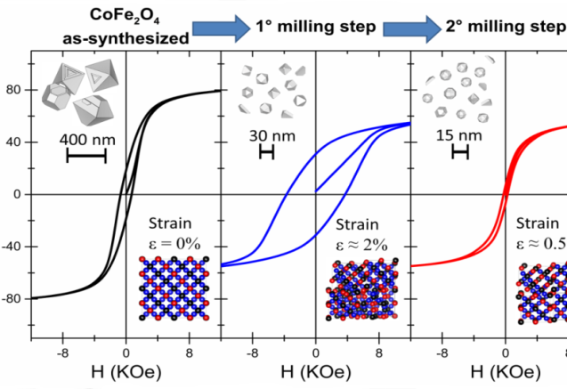
Magnetic field strength
Figure 1 Influence of milling on the particle size and strain of the cobalt ferrite particles
(from Materials & Design, 130, 2017, pp 327-335)

Recent Publications
- Srinivasan G, Priya S and Sun N X (ed) (2015) Composite Magnetoelectrics: Materials, Structures, and Applications (Cambridge: Woodhead) ISBN: 978-1-78242-254-9.
- Galizia P, Ciuchi I V, Gardini D, Baldisserri C, Galassi C (2016) Bilayer film based on composite CoFe₂O₄/TiO₂ and niobium-doped PZT by electrophoretic Deposition J Eur Ceram Soc 36, 2, 373–380.
- Galizia P, Baldisserri C, Capiani C, Galassi C (2016) Multiple parallel twinning overgrowth in nanostructured dense cobalt ferrite Materials and Design 109, 19–26.
- Galizia P, Ciomaga C E, Mitoseriu L, Galassi C(2017) PZT-cobalt ferrite particulate composites: densification and lead losses control by quite-fast sintering J Eur Ceram Soc 37 161–168.
- Galizia P, Cernea M, Mihalache V, Diamandescu L, Maizza G, Galassi C (2017) Easy batch-scale production of cobalt ferrite nanopowders by two-step milling: structural and magnetic characterization Materials and Design 130, 327–335.

Biography
Carmen Galassi is Research Director at CNR-ISTEC (Italy), head of the Research Project «Smart multifunctional ceramic materials : piezoelectrics, ferroelectrics, antiferroelectrics, multiferroics with main expertise in ceramic processing (powder treatments, shaping and densification), chemico-physical characterization of dispersed ceramic systems, R&D on piezoelectric ceramic materials, magnetic ceramic materials and relative composites, multifunctional materials. Her main activity is research projects coordination and dissemination on ceramic materials development, processing and characterization and tutoring of MSC and PhD students. She has got the National Scientific Qualification to function as full Professor of Materials Science and Technology in Italian Universities. Out of 259 papers co-authored, 168 are published in international, refereed journals.
Email: carmen.galassi@istec.cnr.it

Notes/Comments:

