Title: Morphological instability of thin films deposited on substrates
Jérôme Colin, Ph D, Institut P’, Université de Poitiers, ENSMA, SP2MI-Téléport 2, 86962 Futuroscope-Chasseneuil cedex, France.

Abstract:
The main topic of this presentation is concerned with the study of the coupling between the mechanical properties of thin films on substrates and their morphologies. In a first part, the aging of the buckling patterns experimentally observed at the mesoscopic scale onto the surface of metallic thin films deposited on substrates is studied by means of finite element simulations (FEM). The conditions for the transition from straight-sided wrinkles to telephone-cords or circular blisters are first discussed. The conjugated effects of the atmospheric pressure and plastic folding are then considered to explain, through static energy variation calculations, the formation of croissant and donut-like structures observed onto the surface of gold thin films deposited on the surface of silicon substrates (see figure 1). The propagation of the buckles is finally discussed from a dynamical point of view, in the case where atomic steps are present at the film-substrate interface. Although it has only been experimentally observed that the buckles always propagate along the steps onto the surface of the gold films, the conditions on the internal compression strain, the orientation of the steps with respect to the buckles and the step heights have been determined for the “step crossing” or “step following” phenomena.
In a second part, the evolution of the vicinal surface of gold single crystals deformed by external uniaxial compression tests and in situ observed by UHV scanning tunneling microscopy is investigated (see figure 2). It is demonstrated that the slip traces resulting from the emergence of moving dislocations at the free surface highly modify the organization of the vicinal steps. A model based on energetic considerations is proposed and discussed to explain the observed phenomenon.

Images:
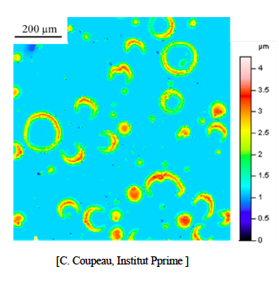
Figure 1: Gold thin film on silicon substrate

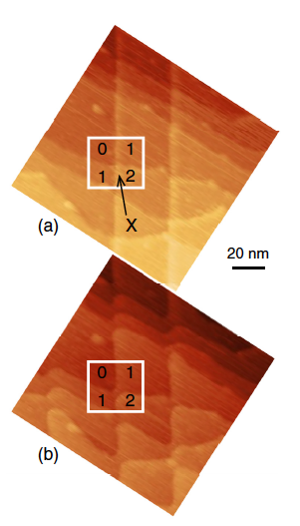
Figure 2: STM observation of gold thin film surface under strain

Recent Publications (minimum 5)
- Coupeau C., Camara O., Drouet M., Durinck J.,
Bonneville J., Colin J., Grilhé J. 2016. Slip trace-induced
vicinal step destabilization Physical Review B 93, 041405.
- Hamade S., Durinck J., Parry G., Coupeau C., Cimetière A., Grilhé J., Colin J. 2001. Effect of plasticity and atmospheric pressure on the formation of donut and croissant-like buckles, Phys. Rev. E 91, 012410.

- Ruffini A., Finel A., Colin J., Durinck J. 2016. Effect of interface plasticity on circular blisters, Scripta Mater. 113, 222-225.
- Coupeau C., Durinck J., Drouet M., Douat B., Bonneville J., Colin J., Grilhé J. 2015. Atomic reconstruction of niobium (111) surfaces, Surface Science, 632, 60-63.
- Colin J., Coupeau C., Durinck J., Cimetière A., Grilhé J. 2014. Re-deposition of a straight-sided buckle under pressure, Phys. Rev. E 89, 032410.

Biography:
Jérôme Colin works in the field of the mechanics of materials and materials science. He is involved in the modeling of the mechanical properties of nano-structured materials, thin films on substrates and coatings. More precisely, he has developed models in the framework of the elasticity and thermodynamics theories, to characterize the morphological evolution of layers under strain, the formation of atomic defects such as dislocations in strained nanostructures or the delamination and buckling of thin films on substrates.
E mail: jerome.colin@univ-poitiers.fr

