Title: Room temperature hydrogenation in functional oxide nanowires by an electric field via air nanogap
Teruo Kanki, Accosi. Prof., Institute of Scientific and Industrial Research, Osaka University, Japan

Abstract
Large reversible changes of the electronic transport properties of solid-state oxide materials induced by electrochemical fields have received much attention as a new research avenue in iontronics. The action on time-dependence of conductive modulation is slower. Despite the slow modulation, the emergence of non-linear, plastic and/or memristive behaviors provides an opportunity to obtain new abilities in information processing, like signal flow in brain, in addition to sensing and energy devices.
In this conference, dramatic transport changes in VO₂ nanowires were demonstrated by electric field-induced hydrogenation at room temperature As a suitable device structure to perform transport modulation through electrochemical reactions, we proposed a planar-type field effect transistor with side gates and a nanowire channel separated by air nanogaps (denoted PG-FET), as illustrated in Fig. 1.This unique structure allowed us to investigate hydrogen intercalation and diffusion behavior in VO₂ channels with respect to both time and space. Figure 2 shows the reversible, non-volatile resistance changes in a VO₂ nanowire channel with a width (w) of 500 nm obtained by applying positive and negative V_{G} at 300 K under a humidity of around 50%. The normalized resistance (R/R₀, where R and R₀ are the measured resistance and resistance of the pristine device before applying a V_{G} at 300 K, respectively) slowly decreased down to the saturation line at roughly R/R₀ = 0.75 during the application of V_{G} = +100 V. This state was held after the removal of the V_{G}. Namely, the device exhibited a non-volatile memory effect. The R/R₀ increased again with applying V_{G} = -100 V.
Our results will contribute to further strategic researches to examine fundamental chemical and physical properties of devices and develop iontronic applications, as well as offering new directions to explore emerging functions for sensing, energy, and neuromorphologic devices combining ionic and electronic behaviors in solid-state materials.

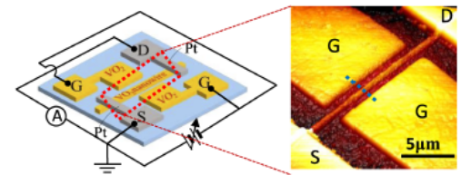
Images
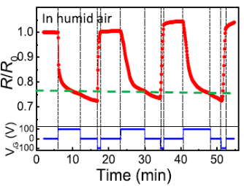
Figure 1: Typical deice architecture (Left) and an atomic force microscopy image of the VO₂ channel area (right). S, D, and G indicate the source, drain, and gate electrodes, respectively.

Figure 2: Time dependence of normalized resistance (R/R₀) with V_{G} of 100, 0, and -100 V in humid air.
Recent Publications
- Manca. N, Pellegrino L., Kanki T., Venstra W.J., Mattoni G., Higuchi Y., Tanaka H., Caviglia A.D., and Marré D. 2017. Selective High-Frequency Mechnical Actuation Driven by the VO₂ Electronic Instability. Advanced Materials 29. 1701618.
- Wei T., Kanki T., Chikanari. M, Uemura T., Sekitani T., and Tanaka H. 2017. Enhanced electronic-transport modulation in single-crystalline VO₂ nanoeire-based solid-state field-effect transistor. Scientific Reports7, 17215.
- Kanki T., and Tanaka H. 2017. Nanoscale electrochemical transistors in correlated oxides. APL Materials 5, 042303.
- Wei T., Kanki T., Fujiwara K., Chikanari M., and Tanaka H. 2016. Electric field-induced transport modulation in VO₂ FETs with high-k oxide/organic parylene-C hybrid gate dielectric. Applied Physical Letters 108, 053503.
- Sasaki T., Ueda H., Kanki T., Tanaka H. 2015. Electrochemicalgating-induced reversible and drastic resistance switching in VO₂ nanowires. Scientific Reports 5, 10417.

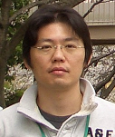Biography (150 word limit)
Teruo Kanki has completed his Ph.D. in material physics from Osaka University in 2004. After a visiting researcher in IBM’s Almaden Research Center from 2004 to 2006, he became a specially appointed assistant professor in Osaka University. Now he is an associate professor in Osaka University and works on novel and new concept oxide nano-electronics. He has published more than 80 papers in reputed journals. E mail: kanki@sanken.osaka-u.ac.jp

NOTES/ COMMENTS:
Dear Organizer members,
Thank you for your invitation to me as a plenary speaker.
I look forward to holding the conference.
Best regards,
Teruo Kanki

