Title: Formation of 2H-1T and 2H-3R homojunctions in WS2 monolayers for device applications

^{1*}Pawan Kumar, ²Navneet C. Verma, ³Kartikey Thakar, ³Jayeeta Biswas, ³S. Lodha, ²Chayan K. Nandi and ¹B. Viswanath
¹School of Engineering, Indian Institute of Technology Mandi, Kamand, Himachal Pradesh, 175005, India; *e-mail: pawan.iit13@gmail.com.
²School of Basic Sciences, Indian Institute of Technology Mandi, Kamand, Himachal Pradesh, 175005, India.
³Department of Electrical Engineering, Indian Institute of technology Bombay, Powai, 400076, India.

Abstract (300 word limit):
Growth of two dimensional (2D) materials with ability to control the co-existing polymorph assembly in single domain provides unique platform to produce seamless homojunctions with different properties. Forming such homojunctions addresses important and long standing issue of lattice mismatch that affect the device performance of conventional heterostructures. We achieved large area of chemical vapour deposited (CVD) growth of 2D monolayer WS2 having their two polymorphs (2H/1T or 2H/3R) forming homojunctions in single domain. Interestingly, co-existing triangular shaped 2H/1T or 2H/3R polymorphs formed in monolayer WS2 with atomically smooth interface. We have identified CVD grown homojunctions with different phases of WS2 monolayers using detailed microscopic (Atomic force microscope, Fluorescence life time imaging and Kelvin probe force microscope) as well spectroscopic (Raman, Photoluminescence and X-ray photoemission spectroscope) techniques. Lateral homojunctions arranged alternatively with coexisting phases of WS2 show interesting behaviour for the luminescence decay as well as surface potential. The electronic properties has been analysed by making FET devices in individual phase as well as across homojunctions of WS2 monolayers.
Image
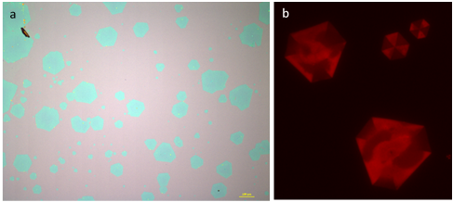Figure: (a) Optical image of CVD grown monolayer WS2 along with (b) fluorescence scanned image showing co-existing polymorph in single domain.
Recent Publications (minimum 5)
- Pawan Kumar and Viswanath Balakrishnan, Horizontally and Vertically Aligned Growth of Strained MoS2 Layers with Dissimilar Wetting and Catalytic Behavior, CrystEngComm, 2017, 19(34).
- Pawan Kumar, Temperature-dependent conduction mechanism of vertically aligned graphene nanoflakes incorporated with nitrogen in situ, Materials Research Express, 2017. 4(7), 075011.
- Pawan Kumar and Viswanath Balakrishnan , Effect of Sulfur Evaporation Rate on Screw Dislocation Driven Growth of MoS2 with High Atomic Step Density, 2016, Crystal Growth & Design 16(12).
- Pawan Kumar and Viswanath Balakrishnan, Growth and microstructural evolution of WS2 nanostructures with tunable field and light modulated electrical transport, 2017, just accepted in Applied Surface Science.
- Pawan Kumar and Amit Kumar, Carrier type modulation in current annealed graphene layers, 2014, Applied Physics Letters, 104(8).
- Pawan Kumar, Jay Ghatak, P. V. Satyam, R. Prakash, Devesh Avasthi, Amit Kumar, Nano tracks in fullerene film by dense electronic excitations, 2014, Applied Surface Science 313.

E mail: pawan.iit13@gmail.co

