Title: Gradient Oxygen-Doped CdS Nanorod with Built-in Band Bending as a Highly Efficient Photoanode for Hydrogen Evolution
Department of Chemistry, School of Science, Tianjin Key Laboratory of Molecular Optoelectronic Science, Tianjin University, Tianjin 300072, China
Collaborative Innovation Center of Chemical Science and Engineering (Tianjin), Tianjin 300072, China

Abstract (300 word limit):
Elaborate design of a facile strategy to realize the highly efficient separation/transportation of photogenerated carriers is highly challenged in photoelectrochemical (PEC) cells. By selecting sub-15 nm CdS nanorod-based hierarchical nanostructures supported Ti foil as the typical example, we report a convenient gradient oxygen-doped method to achieve a built-in continuous bending band structure for improving the separation efficiency of charge carriers. Both the inward diffusion of oxygen and the outward diffusion of lattice sulfur under non-equilibrium conditions are the critical factors to produce gradient oxygen-doped CdS nanorods (Grad-O CdS). The fabricated Grad-O CdS as the anode for PEC cell exhibits a superior and highly stable activity for hydrazine oxidation and hydrogen evolution reactions. A photocurrent density of 6.0±0.1 mA cm⁻² at a potential of 0.4 V versus the reversible hydrogen electrode (RHE) can be achieved and maintained for 42 h, with the charge separation efficiency of 86%. The experimental characterization and density functional theory calculations reveal that the origins of the enhanced PEC activity is the formation of built-in bending band due to the gradient oxygen doping in CdS. The combination of ultrathin hierarchical configuration with unique built-in bending band can accelerate the rapid charge carrier separation via the energy funnel, rather than the spontaneous carrier diffusion.

Image
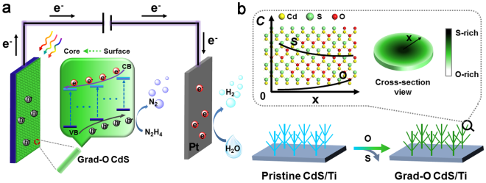
Figure 1: (a) Schematic description of the two-electrode PEC H₂ evolution cell and the electron transfer process in the Grad-O CdS. (b) Scheme illustration of the gradual doping method.
Recent Publications (minimum 5)
- Yu Yu, Yi Huang, Yifu Yu, Yanmei Shi, Bin Zhang*, Design of Continuous Built-in Band Bending in Self-supported CdS Nanorod-based Hierarchal Architecture for Efficient Photoelectrochemical Hydrogen Production, Nano Energy, 2018, 43, 236–243.
- Yifu Yu, Jin Zhang, Xuan Wu, Weiwei Zhao, Bin Zhang*, Nanoporous Single-crystal-like CdxZn1-xS Nanosheets Fabricated by Cation Exchange Reaction of Inorganic-Organic Hybrid ZnS-Amine with Cadmium Ions, Angew. Chem. Int. Ed., 2012, 51, 897–900.
- Xiling Han, Yifu Yu, Yi Huang, Dali Liu, Bin Zhang*, Photogenerated Carriers Boost Water Splitting Activity over Transition-Metal/Semiconducting Metal Oxide Bifunctional Electrocatalysts, ACS Catal., 2017, 7, 6464–6470.
- Yifu Yu, Shuangxia Hou, Ming Meng*, Xutang Tao, Wenxian Liu, Youlei Lai, Bin Zhang*, Converting Inorganic-Organic Hybrid Sulfides into Oxides: A General Strategy to Hierarchical-Porous-Structured Thermal-stable Metal Oxides with Improved Catalytic Performance, J. Mater. Chem., 2011, 21, 10525–10531.
- Yifu Yu, Xue-Jun Wu, Meiting Zhao, Qinglang Ma, Junze Chen, Bo Chen, Melinda Sindoro, Jian Yang, Shikui Han, Qipeng Lu, Hua Zhang*Anodized Aluminum Oxide Templated Synthesis of Metal-Organic Frameworks Used as Membrane Reactors; Angew. Chem. Int. Ed., 2017, 56, 578-581;


Biography (150 word limit)
Yifu Yu is currently working as Associate Professor in the School of Science, Tianjin University, China. His research interests include the synthesis and catalytic applications of nanostructured materials. Published >34 international research papers with citation times of 884 and h-index of 14.
E mail: yyu@tju.edu.cn

