From metastable to stable structure – the way to construct functionality of Fe-Ga alloys
I.S. Golovin, V.V. Palacheva, A. Emdadi: NUST MISiS, Moscow A.M. Balagurov, I.A. Bobrikov: JINR, Dubna, Russia

Abstract
Fe-Ga alloys exhibit unique functional properties such as magnetostriction that can be varied from the highest positive values among iron-based alloys to negative values including zero magnetostriction, if proper compositions and heat treatments are chosen. This remarkable behavior is related to rather complex phase transformation sequences in this alloy family that are still unresolved. In earlier studies, the phase transformations in Fe-Ga alloys were studied by X-ray diffraction, which provides structural information limited to the near-surface sample area. In this paper, we use electron back-scatter diffraction and in situ neutron diffraction to characterize the D0₃ and L1₂ phases that originate from the fcc and bcc phases in the Fe-27Ga type bulk alloy, respectively. Different ratios between these phases, characterized by magnetostriction values of different signs, were achieved using an isothermal annealing treatment that produces an intrinsic composite in the alloy. Depending on the relative fraction of the D0₃ and L1₂ phases, the magnetostriction values of the alloy, λ_{S}, vary from +100 to -50 ppm, including the value of λ_{S} = 0 for the alloy with L1₂:D0₃ = 2:1 achieved after 600 min annealing at 400°C, thus demonstrating the controlled adjustment of magnetostriction in these advanced alloys.
Microalloying by Tb increases magnetostriction and influences on phase transitions in the Fe-27Ga type alloys in the range of 20 - 750°C as observed by in situ neutron diffraction and vibrating sample magnetometry. The conventional transition sequence of phase transitions at heating D0₃ → L1₂ → D0₁₉ → B2 → A2 in binary Fe-27Ga is changed for D0₃ → B2 → B2+L1₂ → B2+ D0₁₉ → B2 → A2 transitions in the Tb-containing alloy. The increase in Tb content from 0.15% to 0.3% decreases the amount of closed packed phases in two phases ranges. At slow cooling (2 K/min), the mixture of D0₃ + L1₂ is recorded in the Tb-containing sample instead of dominating L1₂(~90%) and a very limited amount of D0₁₉ and A2 phases in the binary Fe-27Ga alloy. This influence of Tb on the phase transition kinetics explains temperature dependent magnetization curves with step by step accumulation of the L1₂ phase in subsequent heating and cooling cycles. Thus, we conclude that the additions of Tb stabilize bcc-born phases (A2, B2 and D0₃) and prevents the appearance of closed packed (fcc ordered L1₂ and hcp ordered D0₁₉) phases, which contributes to the functional properties of that alloys.

Image
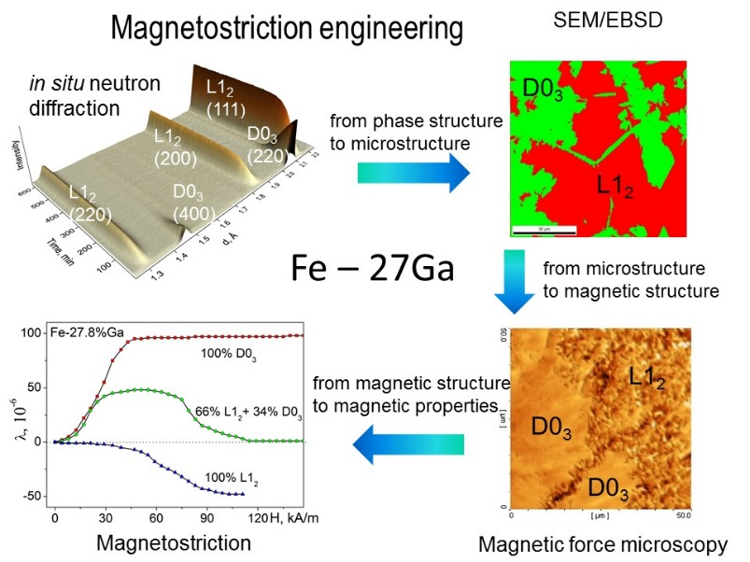
Recent Publications
- V.V. Palacheva, A. Emdadi, F. Emeis, I.A. Bobrikov, A.M. Balagurov, S.V. Divinski, G. Wilde, I.S. Golovin. Phase transitions as a tool for tailoring magnetostriction in intrinsic Fe-Ga composites. Acta Materialia 130 (2017) 229-239.
- I.S. Golovin, А.M. Balagurov, V.V. Palacheva, I.A. Bobrikov, V.B Zlokazov. In-situ neutron diffraction study of bulk phase transitions in Fe-27Ga alloys. Materials and Design, 98 (2016) 113-119
- I.S. Golovin. Anelasticity of Fe-Ga based alloys. Materials and Design. 88 (2015) 577-587
- S.V. Divinski, G.Reglitz, I.S. Golovin, M. Peterlechner, R. Lapovok, Y. Estrin, G. Wilde. Effect of heat treatment on diffusion, internal friction, microstructure and mechanical properties of ultrafine grained nickel severely deformed by equal channel angular pressing. Acta Materialia 82 (2015) 11–21
- I.S. Golovin, V.V. Palacheva, V.Yu. Zadorozhnyy, J. Zhu, H. Jiang, J. Cirfe, T.A. Lograsso. Influence of composition and heat treatment on damping and magnetostrictive properties of Fe-18%(Ga+Al) alloys. Acta Materialia, 78 (2014) 93–102


Prof. Dr. Igor S. Golovin graduated from Tula Polytechnic Institute (now Tula State University), Russia in 1982. PhD dissertation in 1987, Habilitation / Higher Dissertation in 1998. Since 2008 - professor at National Research Technological University "Moscow Institute of Steel and Alloys". Interests: Anelasticity, mechanical spectroscopy, internal friction, phase transitions, neutron diffraction, mechanisms of relaxation in solids, functional alloys: crystals, ultrafine grained crystals, quasicrystals, hidamets, cellular metallic materials..
Email: i.golovin@misis.ru

