Chitosan/gellan gum/β-cyclodextrin/curcumin hydrogel as a support matrix for enhancing adhesion and proliferation of human adipose-derived stem cells
Ariel C. de Oliveira, Master's Degree student, Postgraduate Program in Materials Science & Engineering, Federal University of Technology, Brazil.
Bruno H. Vilsinski, Assist Prof Dr, Department of Chemistry, Federal University of Technology, Brazil.
Matt J. Kipper, Assoc Prof Dr, Department of Chemical and Biological Engineering, Colorado State University, USA.
*Alessandro F. Martins, Assist Prof Dr, Postgraduate Program in Materials Science & Engineering, Federal University of Technology, Brazil.

Abstract
Chitosan (CS) is recognized for its excellent performance to interact with polyanionic macromolecules (such as gellan gum, GG) to enable the production of physical hydrogels (polyelectrolyte complexes; PECs). CS was associated with GG, β-cyclodextrin (β-CD) and curcumin (CU) to create PECs for wound healing purpose. CS/GG/β-CD/CU hydrogels containing large contents of pores were produced by the first time, controlling the pHs of the CS solutions and CS:GG/β-CD/CU weight ratios. Stable PECs matrices were created using a suitable level of CU (23 mg) at GG/β-CD solutions in a 2/1 rate at pH 6.0. The CU could organize the polymeric chains in the hydrogel networks, allowing the formation of materials with well-defined pore structures. After neutralization step, the hydrogels loaded with CU displayed self-assembling behaviors. SEM images of the CS/GG/β-CD/CU hydrogels before and after neutralization (performed in ultrapure water) confirmed the reorganization of polymer chains (Fig. 1).
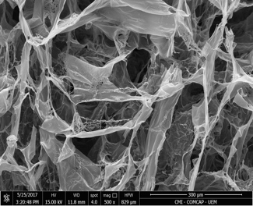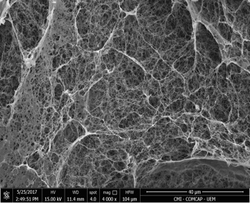Fig. 1. SEM images of the CS/GG/B-CD/CU hydrogel created from a CS-solution at pH 1.0 and in a 50:50 CS:GG/-B-CD/CU weight ratio: before neutralization (left panel; scale bar of 300 μm) and after neutralization at pH 6.0 (right panel; scale bar of 40 μm).
The self-assembling capacity was also confirmed by thermal analysis. Throughout the neutralization step, the CU was not released from the PEC matrix. So, the β-CD/CU complex can stabilize the PECs arrangements, permitting the development of a stable support matrix (scaffold) to enhance the adhesion and proliferation of human adipose-derived stem cells (ADSC cells). Scaffolds used for wound healing and tissue engineering purposes should similarly promote cell adhesion and provide mechanical and chemical cues that can guide cell shape, cell migration, and other relevant cellular activities. In this facet, CS/GG/β-CD/CU hydrogel significantly promotes ADSC attachment, adhesion, and proliferation. The number of adhered cells on the PEC surface significantly increased throughout seven days (p<0.05). Fluorescence and SEM images confirmed these statements.
Recent Publications
- Martins A.F., Bueno P.V.A., Almeida E.A.M.S., Rodrigues F.H.A., Rubira A.F., Muniz E.C. 2013. Characterization of N-trimethyl chitosan/alginate complexes and curcumin release. International Journal of Biological Macromolecules 57: 174–184.
- Follmann H.D., Navaes A.F., Martins A.F., Félix O., Decher G., Muniz E.C., Silva R. 2016. Advanced fibroblast proliferation inhibition for biocompatible coating by electrostatic layer-by-layer assemblies of heparin and chitosan derivatives. Journal of Colloid and Interface Science 474: 9-17.
- Facchi D.P., da Cruz J.A., Bonafé E.G., Pereira A.G.B., Fajardo A.R., Venter S.A.S., Monteiro J.P., Muniz E.C., Martins A.F. 2017. Polysaccharide-based materials associated with or coordinated to gold nanoparticles: synthesis and medical application. Current Medicinal Chemistry 24:2701-2135.
- Martins A.F., Facchi S.P., Follmann H.D.F., Gerola A.P., Rubira A.F., Muniz E.C. 2015. Shielding effect of ‘surface ion paiirs’ on physicochemical and bactericidal properties of N,N,N-trimethyl chitosan salts. Carbohydrate Research 402: 252-260.
- Martins A.F., Facchi S.P., Follmann H.D., Pereira A.G.B., Rubira A.F., Muniz E.C. 2014. Antimicrobial activity of chitosan derivatives containing N-quaternized moieties in its backbones: a review. International Journal of Molecular Science 15: 20800-20832.
Biography
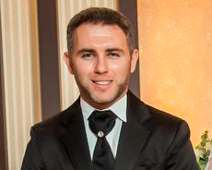
Four years of working research experience at Federal University of Technology (UTFPR). Specialized in polysaccharide-based materials, aiming systems for drug delivery, wound healing, tissue engineering, food packing, scaffolds, among others. Published >35 international research papers, and two book chapters. Also handled one externally funded project and actually is sponsored by six institutional projects at the postgraduate program of Materials Science and Engineering.
E mail: affmmartins@gmail.com

