Multiplex detection of protein biomarkers with surface enhanced Raman spectroscopy (SERS)

Lei Wu, Research fellow, Department of Life Sciences, International Iberian Nanotechnology Laboratory (INL), Braga, Portugal.

Abstract:
As the expression level of proteins in human body is closely related to the occurrence and progression of cancers, the development of highly sensitive, high-throughput, rapid and low-cost optical technology for multiplex protein detection is of great significance to the fundamental research in oncology and the clinical applications in early cancer diagnosis and therapeutics. We focus on the development of a novel multiplex protein detection platform which combines surface enhanced Raman spectroscopy (SERS) technique with the microfluidic chip. This study aims to improve the detection sensitivity, multiplexing ability, efficiency as well as to reduce the overall costs. Here, the spectral-spatial joint encoding method has been proposed to develop a novel analytical platform for high-throughput protein detection, which is further employed for the detection of tumor markers and the study on the interaction mechanism of anti-cancer drugs. This platform provides a new technological route for the early cancer diagnosis and therapeutics.
The main content of this presentation are listed as follows:
- Gold@silver core-shell nanorods were adapted to develop a SERS-based immunoassay with highly increased sensitivity.
- SERS spectral encoding technique was employed for multiplex detection of cancer biomarkers.
- SERS spectral-spatial joint encoding method was proposed to develop a SERS-assisted 3D barcode chip for multiplex protein detection.
- A versatile microfluidic platform for the detection of tumor secretions was presented, in which the mechanism of anti-cancer drugs and the process of intercellular communication were studied.

Image
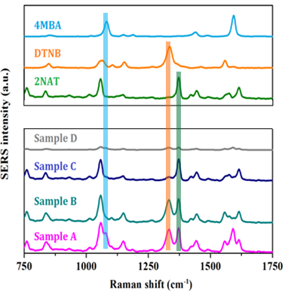
Figure 1: (up) SERS spectra of nanoparticles labeled with different Raman reporters (4MBA, DTNB and 2NAT); (down) Multiplex detection of protein biomarkers with encoded Raman probes.
Recent Publications
- Wu, L.; Wang, Z. Y.; Zhang, Y. Z.; Fei, J.Y.; Chen, H.; Zong, S. F.; Cui, Y. P. In situ probing of cell–cell communications with surface-enhanced Raman scattering (SERS) nanoprobes and microfluidic networks for screening of immunotherapeutic drugs. Nano Research 2017, 10, 584-594.
- Wu, L.; Wang, Z. Y.; Fan, K. Q.; Zong, S. F.; Cui, Y. P. A SERS-assisted 3D barcode chip for high-throughput biosensing. Small 2015, 11, 2798-2806.
- Wu, L.; Wang, Z. Y.; Zong, S. F.; Cui, Y. P. Rapid reproducible analysis of thiocyanate in real human serum and saliva using a droplet SERS-microfluidic chip. Biosensors & Bioelectronics 2014, 62, 13-18.
- Wu, L.; Wang, Z. Y.; Zong, S. F.; Chen, H.; Wang, C. L.; Xu, S. H.; Cui, Y. P. Simultaneous evaluation of p53 and p21 expression level for early cancer diagnosis using SERS technique. Analyst 2013, 138, 3450-3456.
- Wu, L.; Wang, Z. Y.; Zong, S. F.; Huang, Z.; Zhang, P. Y.; Cui, Y. P. A SERS-based immunoassay with highly increased sensitivity using gold/silver core-shell nanorods. Biosensors & Bioelectronics 2012, 38, 94-99.


Biography
Lei Wu is currently a postdoc research fellow in International Iberian Nanotechnology Laboratory (INL). He obtained his bachelor and PhD degree from School of Electronic Science and Engineering, Southeast University, China in 2012 and 2017, respectively. His research interests include biophotonics, nanophotonics and optofluidic systems. He has published 14 research papers with total citations over 200 times, and has delivered 5 oral presentations on international conferences.
E mail: lei.wu@inl.int

NOTES/ COMMENTS:

