SYNTHESIS AND CHARACTERIZATION OF DOPED NANOPARTICLES FOR MAKING LUMINESCENT
EFFICIENT MATERIALS.

Prashant Kumar Bhargav, Department of Mechanical Engineering, University of Petroleum and Energy
Studies (UPES), India.

Abstract
"There is plenty of room at the bottom ” lecture was given by Nobel laureate Richard P. Feynman in 1959 which leads to the origin of idea of Nanotechnology. A lot of research work takes place daily in the field of nanotechnology to synthesize and build smart, efficient and advanced materials that cannot be fabricated by simple methods that have the potential to bring revolution in the history of mankind.
Synthesis and preparation of doped nanoparticles like Aluminium doped, Lanthanide doped, Transition metal (Fe, Co, Ni, Mn, etc.) nanoparticles are the one of the best methods to prepare the high luminescent efficient materials. The various types of doped nanoparticles possess unique and extraordinary Photoluminescent properties. Due to unique optical properties retained by lanthanide ions, e.g. Fluorescence, Phosphorescence, 4f-4f electron transition, Stoke shift, ability to convert near infrared long wavelength excitation radiation into shorter visible wavelengths through a process known as photon upconversion etc., the lanthanide doped nanoparticles also retain luminescent properties. It is because of the interaction of energy between the host lattice (nanoparticle) and the dopant. Similarly Aluminium doped ZnO nanoparticles also show good optical properties as after the doping some sites of the Zn are occupied by the Al atoms. Doping of Al into ZnO does not change the crystal structure. Lanthanide doped nanoparticles can be synthesized by processes like Hydrothermal assisted method, Microwave assisted method, etc. and Sol-Gel and Direct precipitation method are the two simplest ways to prepare Al doped ZnO nanoparticles. Further the characterizations like XRD, Photoluminescence spectroscopy, UV-VIS spectroscopy, etc. are made to study and understand their behavior and properties. The results show that after the doping of nanoparticles, the optical and Photoluminescent properties enhances as a comparison to the undoped nanoparticles. If we can learn and know how to regulate the concentration of dopant in the nanoparticles then we can get the desired amount of the optical and Photoluminescent properties of the materials.
Keywords: doped nanoparticles, luminescent materials, lanthanide, Fluorescence, Phosphorescence, Hydrothermal assisted method, Microwave assisted method, spectroscopy.

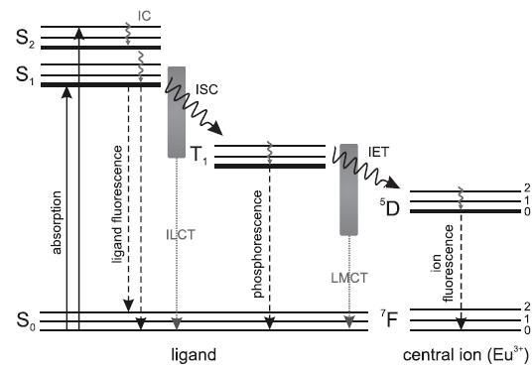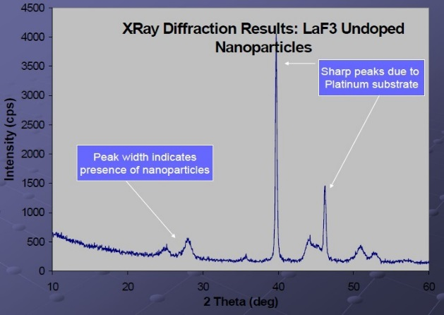
Fig.1. Possible ways of losing the energy of the excited state of a Fig.2. XRD of LaF3 undoped nanoparticles.
Legend-europium complex.

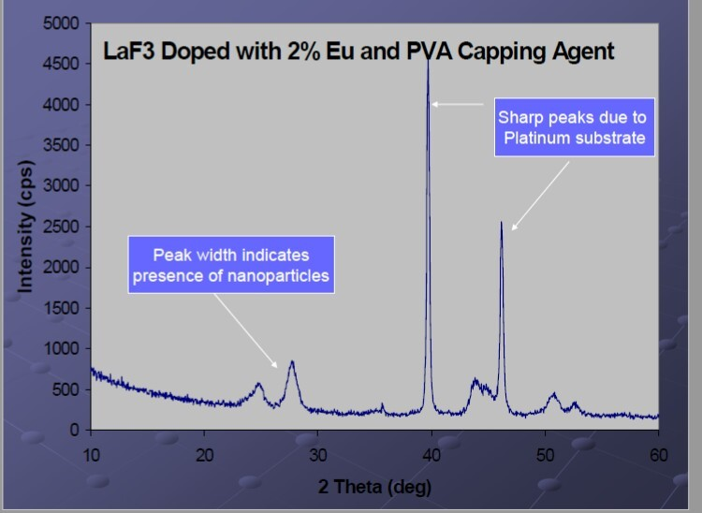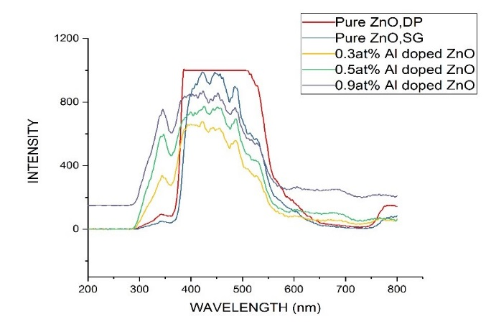
Fig.3. XRD of LaF3 doped nanoparticles Fig.4. PL spectra_of pure and Al doped ZnO nanoparticles.

Biography
I am Prashant Kumar Bhargav, an undergraduate (B. Tech) final year student of subject Material Science Engineering with specialization in nanotechnology. I am pursuing my study from University of Petroleum and Energy Studies, India. I have worked and performed projects on the topics like “Synthesis and characterization of doped nanoparticles” in the center of excellence of Nanoscience and nanotechnology, UPES, Dehradun, India and studied the property variation of ADC 12 alloy with composition of various constituents and with varying temperature.
Email : bhargav0895@gmail.com

