Abstract Template
Abstract Title: Synthesis and optimisation of lipid-polymer hybrid nanoparticles loaded with a mixture of two antiretroviral drugs for the treatment of HIV
Heba Elkateb¹, Steve P. Rannard¹ and Tom McDonald¹.

¹Chemistry department, University of Liverpool, United Kingdom.

Abstract (not more than 300 words)

Purpose: The aim of this study was to synthesize lipid-polymer hybrid nanoparticles (LPHNs) loaded with a mixture of two antiretroviral drugs for the treatment of human immunodeficiency virus (HIV). This system was composed of a polymeric core and a lipid shell, combines the advantages of both polymeric nanoparticles and liposomes. These advantages include the synthesis of nanoparticles from biodegradable materials with high drug loading, relatively small size and low polydispersity, adding ligands to the surface of the LPHNS for active targeting, the drug release can be easily be controlled and the produced particles have high stability.

Method: A nanoprecipitation method was used, where a solution of poly (lactic-co-glycolic acid) (PLGA) in acetonitrile, was slowly added to a stirred aqueous solution of soybean lethicin (lipid). The mixture was then freeze dried for further assessment. The sizes of the LPHNs was characterised by dynamic light scattering and the drug release behaviour quantified by HPLC.

Results: The synthesis method was found to be reproducible and the Z-average of the produced nanoparticles was approximately 120 nm with PDI of 0.3 before freeze drying. Increasing the amount of the drug did not affect the size, even at drug loading of up to 50% in case of the drug-loaded LPHNs. Adding PEG (Mn 2050) as a cryoprotectant during freeze drying reduced the aggregation of the particles and made them easy to re-disperse. The drug loading and encapsulation efficiency were relatively high compared to other drug delivery systems.

Discussion: This work shows a new type of LPHN system to potentially treat HIV using a mixture of two antiretroviral drugs. The lipid nature of the surface of the particles may enhance the uptake of the particles by Peyer patches would might aid drug access to HIV reservoir sites.

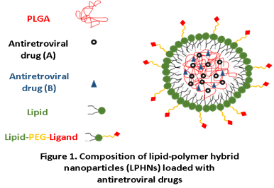

Keywords—Active targeting, Drug delivery, Lipid-Polymer hybrid nanoparticles, HIV.

Professional Biography (100-150 words)

Heba graduated with a BSc. (Hons) in Pharmacy in 2010 from Mansoura University in Egypt. she was one of the top 10 students of her class and accordingly was appointed as a demonstrator in the pharmaceutics department in Mansoura University (2011-2016). In 2016, Heba was awarded a six -months scholarship funded by both the Egyptian government and Ulster university to do a research project in the pharmacy department, Ulster university, Northern Ireland. The project focused on the active targeting of PLGA nanoparticles against anaerobic Clostridium difficile infection.

Heba was awarded the International Postgraduate Research Studentships offered by the chemistry department, University of Liverpool, and joined the McDonald’s group in January 2017 as a PhD student. She is co-supervised by professor Steve Rannard, her PhD project focused in formulating solid lipid nanoparticles and synthesis of polymeric materials for the active targeting and treatment of HIV/AIDS.


Paste your Photograph here

Email Id:

Any Comments:

