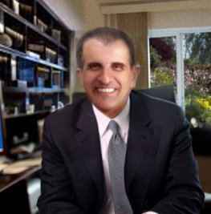
S. Ali Barzanian
Phone in USA 650-257-0505

LinkedIn: https://www.linkedin.com/in/s-a-barzanian-201a47a0
Personal Email: sab24365@gmail.com

====Title ====

Technology in science - new way of learning nanotech & nanobiotechnology
When you just think about it! The digital world has changed our lives in every way.
Education - the days when teachers used chalk, dusters, and blackboards are almost at an end. Black has turned to white, in the form of interactive whiteboards. The white chalk is now digital ink
Digital technology and e-learning made it easier than ever to understand and analyze faster and more efficient about NANOTECH & NANOBIOTECHNOLOGY. It provides the most comprehensive and effective instruction of how nanotechnology industry in the world from a niche activity to a key enabling technology, and to becoming one of the most important industries for the future. And nanotechnology are developed and applied to study biological phenomena.
Digital content has revolutionized the way people in science fields distribute and access information on virtually every platform. How science students benefit from learning with interactive e-books? The interactive e-learning market is growing and so our options for the promotion of science, technology and innovation!

Biography

Over the past 40 years, I have worked for well-known American organizations such as world recognized institutions UC Berkeley University, Stanford University and ProQuest among others in Silicon Valley and the San Francisco bay area. I have diverse background in both academics and industries.
As an e-book specialist and content editor have worked on a wide variety of e-books for well-known international universities, including Harvard, Princeton, Oxford, Cambridge, Stanford, Yale, MIT, and UC Berkeley universities among others educational institutions, and large publishers including Penguin Random House, Elsevier, McGraw-Hill, Wiley and Oxford University Press,
As a keynote speaker, I have successfully delivered 50 conferences including 7 talks, presentations at Stanford University and continue sharing my knowledge and experience to help people around the world.
Earned achievement and recognition awards, prizes and scholarship

Title and Affiliation
International keynote speaker, Former ProQuest content editor, Sanford University and UC Berkeley University employee.

Presenting author details
Full name: Saied Ali Barzanian
Professional employments: ProQuest, Stanford University
Contact number: 650-257-0505 in USA
Linked In account: https://www.linkedin.com/in/s-a-barzanian-201a47a0
Category: (Oral presentation)

