Abstract Title: The characteristics of Ni-Cr-Mn-Y-Cu thin film resistors
Hui-Ru Xu¹, Ying-Chieh Lee^{2*}

¹ Department of Mechanical Engineering, National Pingtung University of Science &Technology, Pingtung 91201, Taiwan
² Department of Materials Engineering, National Pingtung University of Science & Technology, Pingtung 91201, Taiwan

Abstract

Ni-Cr-Mn-Y-Cu resistive thin films were prepared on glass and Al₂O₃ substrates by DC magnetron co-sputtering from targets of Ni-Cr-Mn-Y casting alloy and Cu metals. Electrical properties and microstructures of Ni-Cr-Mn-Y-Cu films under different proportion of elements and annealing temperatures were investigated. The phase evolution, microstructural and composition of Ni-Cr-Mn-Y-Cu resistive films were characterized by X-ray diffraction (XRD), scanning electron microscopy (SEM), transmission electron microscopy (TEM) and Auger Electron Spectroscopy (AES). When the annealing temperature was set to 350 °C, the Ni-Cr-Mn-Y-Cu films with an amorphous structure was observed. The Ni-Cr-Mn-Y films with 6.4% Cu addition annealed at 300 °C which was exhibited the resistivity 770 μΩ-cm with +15 ppm/°C of temperature coefficient of resistance (TCR).

Keywords—Ni-Cr-Mn-Y-Cu alloy, Thin Film Resistors, High Entropy Alloy, DC sputtering

Professional Biography (100-150 words)

Ying Chieh Lee has completed his PhD at the age of 35 years from Department of Materials Science and Engineering, National Chung Hsing University. He is a Professor in Department of Materials Engineering, National Pingtung University of Science and Technology. He has published more than 70 papers in reputed journals and has been serving as Coatings editorial board member of repute.

Recent Publications (up to 5)

- Jie-Ting Shang, Chih-Ming Chen, Ta-Chih Cheng, Ying-Chieh Lee*, “ Influences of Annealing Temperature on Microstructure and Properties for TiO₂ Films Deposited by DC Magnetron Sputtering ” Japan Journal of Applied Physics, 54, (2015) 125501-6
- Wei-Ju Chen, Tung-Yueh Liu, Ho-Yun Lee, Ying-Chieh Lee*, “Ni-Cr-Mn-Y-Nb resistive thin film prepared by co-sputtering” Materials Chemistry and Physic, 210 (2018) 327-335
- Chein-Hui-Yang, Chih-Neng Yang, Ying-Chieh Lee* “Surface Roughness Improvement of Alumina Substrates Coated Using Aluminum Nitride Sol Gel”, Journal of Ceramic Processing Research, 18 [9] (2017) 628~633
- Cheng-Hsien-Lin, Ho-Yun Lee, Yaw-Teng Tseng, Ying-Chieh Lee*, A Study on the Ni-Cr-Mn-Zr Thin Film Resistors Prepared Using the Magnetron Sputtering Technique, Thin Solid Film, Acceped 2018-0412
- Ming-Yuan-Yeh, Pin-Yung Lee, Jie-Ting Shang, Ying-Chieh Lee*, “The Effect of Thermal Oxidation Temperatures on the Phase Evolution and Photocatalytic Property of Tungsten doped TiO2 Thin Film” Japan Journal of Applied Physics, Acceped 2018-0807

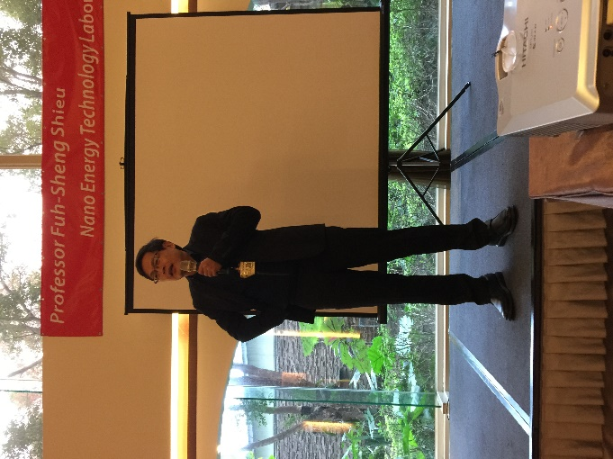
Paste your Photograph here

Email Id:

Any Comments:

