Metal Nanoparticle Electroless Deposition and Nanostructure Production on Silicon.
S. Yae and A. Matsumoto

Department of Chemical Engineering and Materials Science, University of Hyogo, JAPAN

Abstract
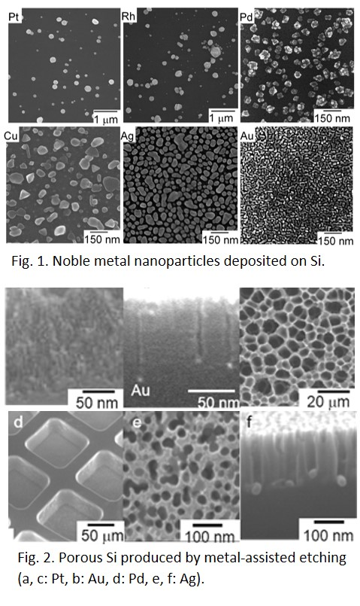
Noble metal nanoparticles on silicon wafers can form microstructures not only by electroless deposition of themselves but also by their catalytic activity for etching of silicon and initiation of electroless metal deposition. We fabricate various noble metal nanoparticles on silicon by electroless displacement deposition and apply them to metal-assisted hydrofluoric acid (HF) etching of silicon autocatalytic electroless deposition of metal on silicon, solar-hydrogen production using photoelectrochemical cells, and noble metal recovery from waste electrical and electronic equipment. In this presentation, noble metal nanoparticles and nanostructures formed on silicon surfaces by these processes are described.

Acknowledgments: This study was partly supported by JSPS KAKENHI Grant Number JP26289276.

Keywords—Electroless plating, Metal-assisted HF etching, Noble metal nanoparticles, Porous silicon

Professional Biography

Shinji YAE is a Professor in the Department of Chemical Engineering and Materials Science, Graduate School of Engineering, University of Hyogo. He holds a Ph.D. (Eng.) from Osaka University, Osaka, Japan. He was a research associate at Osaka University from 1990 to 1998, and an assistant and associate professor at Himeji Institute of Technology (presently University of Hyogo) from 1998 to 2015. He is the vice-chief editor of Journal of the Surface Finishing Society of Japan and the Secretary General of the 3rd International Symposium on Anodizing Science and Technology AST2019, which will be held in Awaji Island, Hyogo, Japan from 2nd to 5th June 2019. He has published more than 90 original papers in reputed journals and 5 book chapters.

Recent Publications (up to 5)

- Yae S, Nasu N, Matsumoto K, Hagihara T, Fukumuro N, Matsuda H (2007) Nucleation behavior in electroless displacement deposition of metals on silicon from hydrofluoric acid solutions. Electrochim. Acta 53:35-41.
- Yae S (2011) Solar to Chemical Conversion Using Metal Nanoparticle Modified Low-Cost Silicon Photoelectrode. Solar Cells - New Aspects and Solutions, Edited by Leonid Kosyachenko, InTech, Rijeka, Croatia, Ch. 11, 231-254.
- Yae S, Morii Y, Fukumuro N, Matsuda H (2012) Catalytic Activity of Noble Metals for Metal-Assisted Chemical Etching of Silicon. Nanoscale Res. Lett. 7:352.
- Hagihara T, Yaori K, Iwakura K, Fukumuro N, Yae S (2015) Electrochemical Quartz Crystal Microbalance Study of The Electrodeposition of Platinum. Electrochim. Acta 176:65-69.
- Fukuda K, Yae S (2016) Electroless Displacement Deposition of Gold from Aqueous Source —Recovery from Waste Electrical and Electronic Equipment (WEEE) using Waste Silicon Powder. The Recovery of Gold from Secondary Sources, Edited by Syed Sabir, Imperial College Press, London, Ch. 3, 57-94.

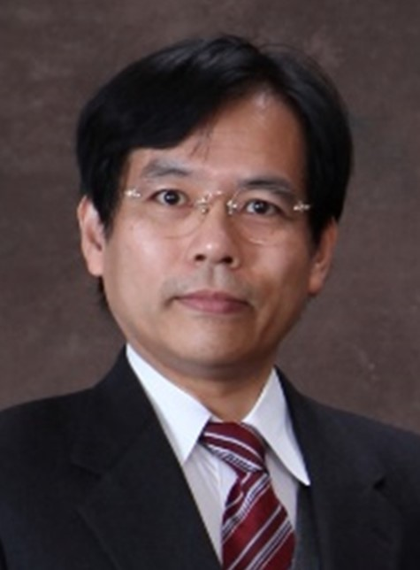
Email Id: yae@eng.u-hyogo.ac.jp

Any Comments:
All of scientists and engineers who are interested in the anodizing science and technology are cordially invited to the 3rd International Symposium on Anodizing Science and Technology AST2019, which will be held in Awaji Island, Hyogo, Japan from 2nd (Sun.) to 5th (Wed.) June 2019. AST2019 will provide a good opportunity to present research results, to visit the beautiful island of Awaji, and to access the historic culture in Kansai area including Kyoto, Osaka, and Kobe. Please visit our web site: http://ars.sfj.or.jp/ast2019/

