Major role of complement activation compared to protein corona composition in the capture of stealth-NP by phagocytes: inter-individual and inter-species variability

Emanuele Papini, Department of Biomedical Sciences, University of Padua, via Colombo 3, 35127 Padua, Italy

Abstract

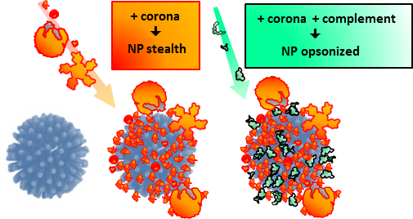
Understanding the functional properties of a new nano-biointerface created by host proteins adsorbed on nanoparticles (NPs), or nanoparticle protein corona, masking the pristine nanomaterial [1] is considered by many the obliged “golden gate” to their clinical application [2]. Rapid clearance by the reticular endothelial system (RES) phagocytes is a major obstacles for nanotheranostics developments and the protein corona may indeed favor or hamper such process [3]. However, also complement activation may increase RES clearance and contribute to proinflammatory and infusion-related reactions [4]. Poly(ethylene glycol) (PEG) NPs coatings, used to minimize protein interaction and RES clearance (stealthing effect) may trigger complement, thereby improving phagocytes capture and infusion-related reactions. Poly(2-mehyl-2-oxazoline) (PMOXA) and poly(2-ethyl-2-oxazoline) (PETOXA) have been proposed as alternative polymer for NP surface modification, due to their improved chemical/physicochemical features compared with PEG [5]. We characterized PEG, PMOXA and PETOXA performance and evaluated the relative importance of protein corona formation vs complement activation. Specifically, we tested the efficacy of human monocytes, macrophages and PMNGs to capture 100 nm ORMOSIL-NPs, coated with above indicated polymers, in human serum. PEG and, especially, PMOXA and PETOXA coatings increased complement activation and opsonine-mediated NP capture by phagocytes compared to naked NPs. The surface-dependent composition diversities of the serum protein coronae formed on the different NP formulations were poorly relevant since, in the absence of complement, a similar stealth effect was invariably measured. Tests using sera from different human subjects, mice and pigs showed crucial subject- and species-dependent differences. We conclude that complement cascade activation is a major factor negatively affecting the stealthing efficacy of PEG , PMOXA and PETOXA coats on NPs. Species-specific diversities of such mechanisms in pre-clinical models, e.g. the murine one, may lead to wrong NP efficacy extrapolations to the human contest. This demands the search for complement-inert nanoparticle coatings.

Image
Recent Publications
- Monopoli MP et al. (2012) Biomolecular coronas provide the biological identity of nanosized materials. Nat. Nanotechnol. 7:779.
- Mahmoudi M (2016) Protein corona: The golden gate to clinical applications of nanoparticles. Int. J. Biochem. Cell Biol. 75:141.
- Fedeli C et al. (2015) The functional dissection of the plasma corona of SiO₂-NPs spots Histidine Rich Glycoprotein as a major player able to hamper nanoparticles capture by macrophages. Nanomedicine 7:17710.
- Moghimi SM and Farhangrazi ZS (2013) Nanomedicine and the Complement Paradigm. Nanomedicine 9: 458.
- Sedlacek O et al. (2012) Poly(2-oxazoline)s-are they more advantageous for biomedical applications than other polymers? Macromol. Rapid Commun. 33:1648.

 Biography
During my career I have worked on several aspects of bio-medicine: the biochemical base of O₂^{.-} production in phagocytes, the action mechanism and cell selectivity of bacterial toxins and adhesins, natural and artificial peptides and foldamers. I gave important contribution to the understanding of the mechanism of cellular intoxication by diphtheria toxin and the vacuolating toxin from H. pylori. Later, I characterized the interaction of N. meningitidis adhesin and anti-menB vaccine component NadA with immune cells. Eventually, I got interested in nanoparticles, investigating their possible application in cancer targeting and other central issues related to nanomedicine. Specifically, I study the functional role of plasma NPs-interacting proteins in phagocyte clearance, including the coagulation and the complement systems and their cross-talk, and the possible modulation of NPs adverse reactions by pathogens or commensals PAMPs. My ambition is to provide critical information useful for the rationale design of nanoparticles for effective biomedical use.
Emanuele Papini
Tel: +390458706993
Session Track 2 - Nanomedicine
Category: oral presentation
Email: emanuele.papini@unipd.it

Notes/Comments:

