A COMPLEMENTARY ANALYSIS OF THE POROUS STRUCTURE OF ACTIVATED CARBONS OBTAINED FROM WASTE MATERIAL OF BIOMASS ORIGIN WITH THE USE OF T-PLOT, DFT AND LBET METHODS

Mirosław Kwiatkowski¹, Dimitrios Kalderis²
¹Faculty of Energy and Fuels, (AGH University of Science and Technology, Poland)
²Department of Environmental and Natural Resources Engineering,
(Technological and Educational Institute of Crete, Greece)

Abstract (not more than 300 words)
This work presents the results of the analysis of the porous structure of activated carbons produced from biomass waste, namely eucalyptus, wood chips, pruning waste and deinking sludge rice husk. The structural analysis was carried out using the t-Plot, the NLDFT and the LBET methods, which yielded not only complementary information on the adsorptive properties of producing activated carbon from these materials, but also information on the usefulness of the structural analysis methods in question for the research into an effect of the technology of carbonaceous adsorbent production. The research pointed also to a correlation between the results produced using different methods, i.e. the t-plot, the DFT and the LBET, testifying to the validity of the assumptions behind the tests and of the mathematical apparatus behind these methods.

Keywords - Activated Carbons, Adsorption, Porous structure, Waste materials.

Professional Biography (100-150 words)
Dr. hab. eng. Mirosław Kwiatkowski in 2004 obtained Ph.D. degree from the Faculty of Energy and Fuels at the AGH University of Science and Technology in Kraków (Poland), and in 2018 D.Sc. degree from the Faculty of Chemistry at the Wrocław University of Technology (Poland). Currently Dr. Mirosław Kwiatkowski is working an assistant professor at the AGH University of Science and Technology, at the Faculty of Energy and Fuels. His published work includes more than 45 papers in reputable international journals and 80 conference proceedings. He is the editor in chief of The International Journal of System Modeling and Simulation (UAE), an associate editor of Micro & Nano Letters Journal (UK) and a member of the other editorial board of internationals journals as well as a member of the organizing and scientific committees many conferences in Europe, Asia and USA. Dr. Mirosław Kwiatkowski is also a regular reviewer in a most reputable scientific journals.
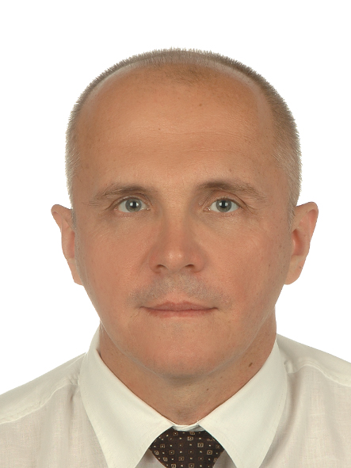

Full Name: Mirosław Kwiatkowski
Email Id: kwiatkow@agh.edu.pl
Contact No: + 48 12 617

