
Mongolian Mind Body Interactive Psychotherapy
Sarnai Arlud, Nagongbilige He
In Center of Mongolian psychosomatic, Inner Mongolia International Mongolian Hospital, there is conventional Mongolian mind–body interactive psychotherapy (MMIP), doctors mainly use MMIP and traditional Mongolian medicine, and achieve significant outcomes in multiple psychosomatic diseases and symptoms. MMIP is different from visiting psychiatric doctors or psychological therapists, it is practised like health education, people are free to come without thinking treatment is for “mantel problems”. MMIP can include both a large number of patients in group therapy (around 200–1000 people each time depending on the therapy room) and individual counselling. Group therapy uses case report narrative therapy and hypnotic methods together, and it is recommended that people begin with group therapy then individual counselling. Nowadays, there are 18 Mongolian hospitals around 6000 people every day attending MMIP. Beside this, Singapore have 100-200 people attending MMIP each day.

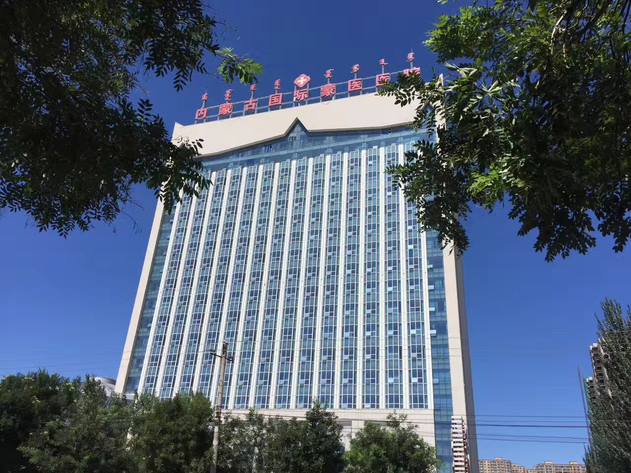
Inner Mongolia International Mongolian Hospital

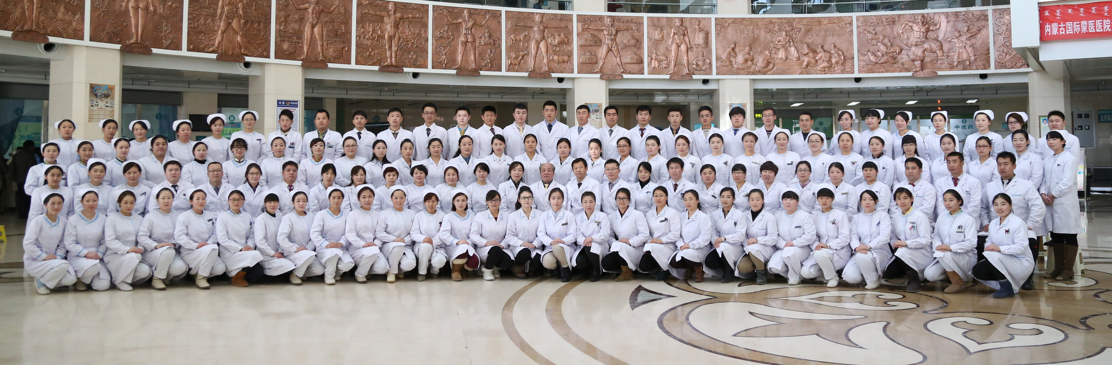
Staff in Center of Mongolian psychosomatic Medicine, Inner Mongolia International Mongolian Hospital
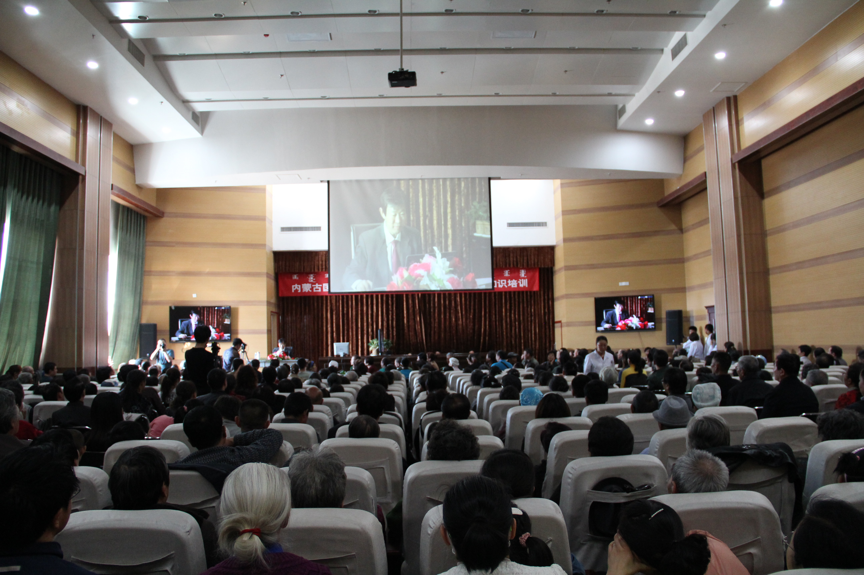
Group therapy in Inner Mongolia International Mongolian Hospital

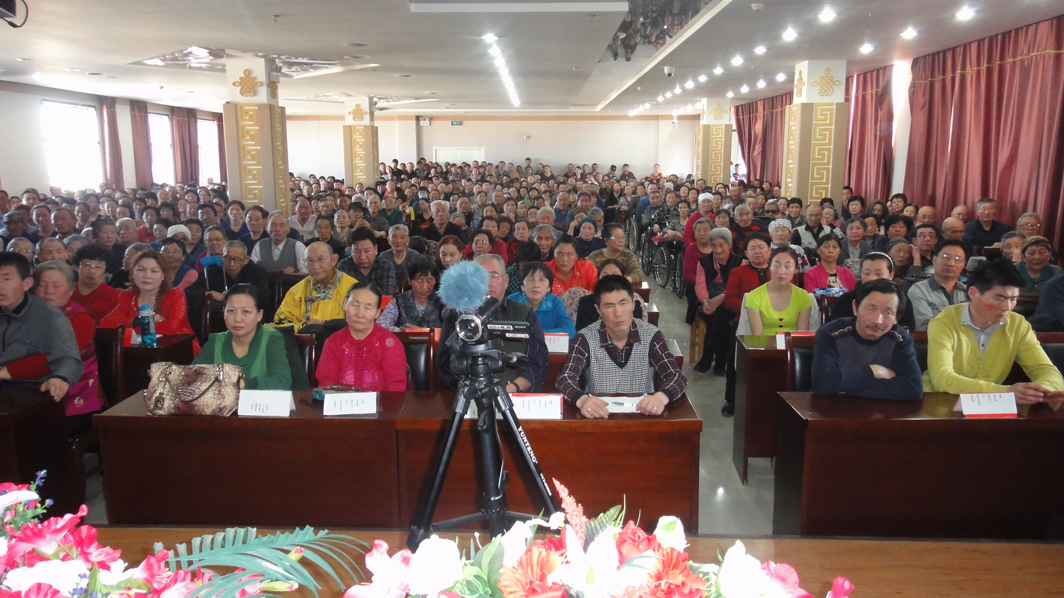
Group therapy in Xilingol Mongolian Hospital

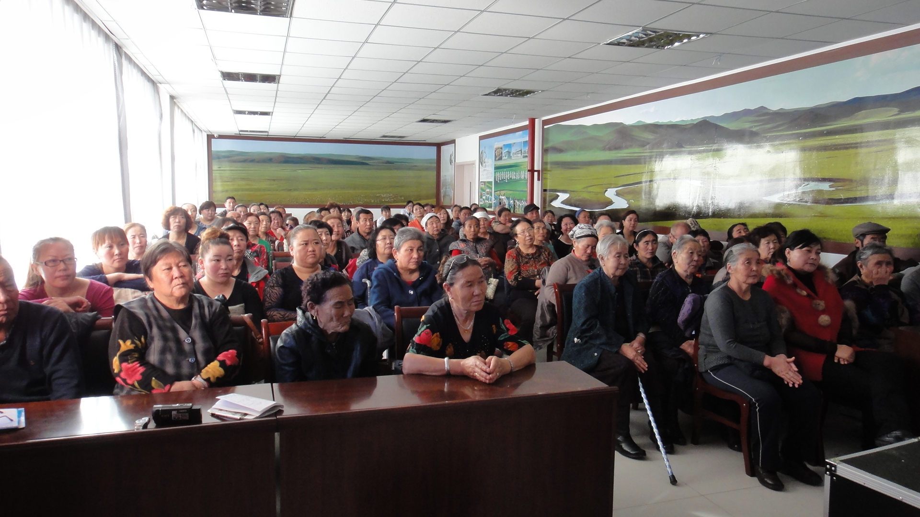
Group therapy in Hulun Buir Mongolian Hospital

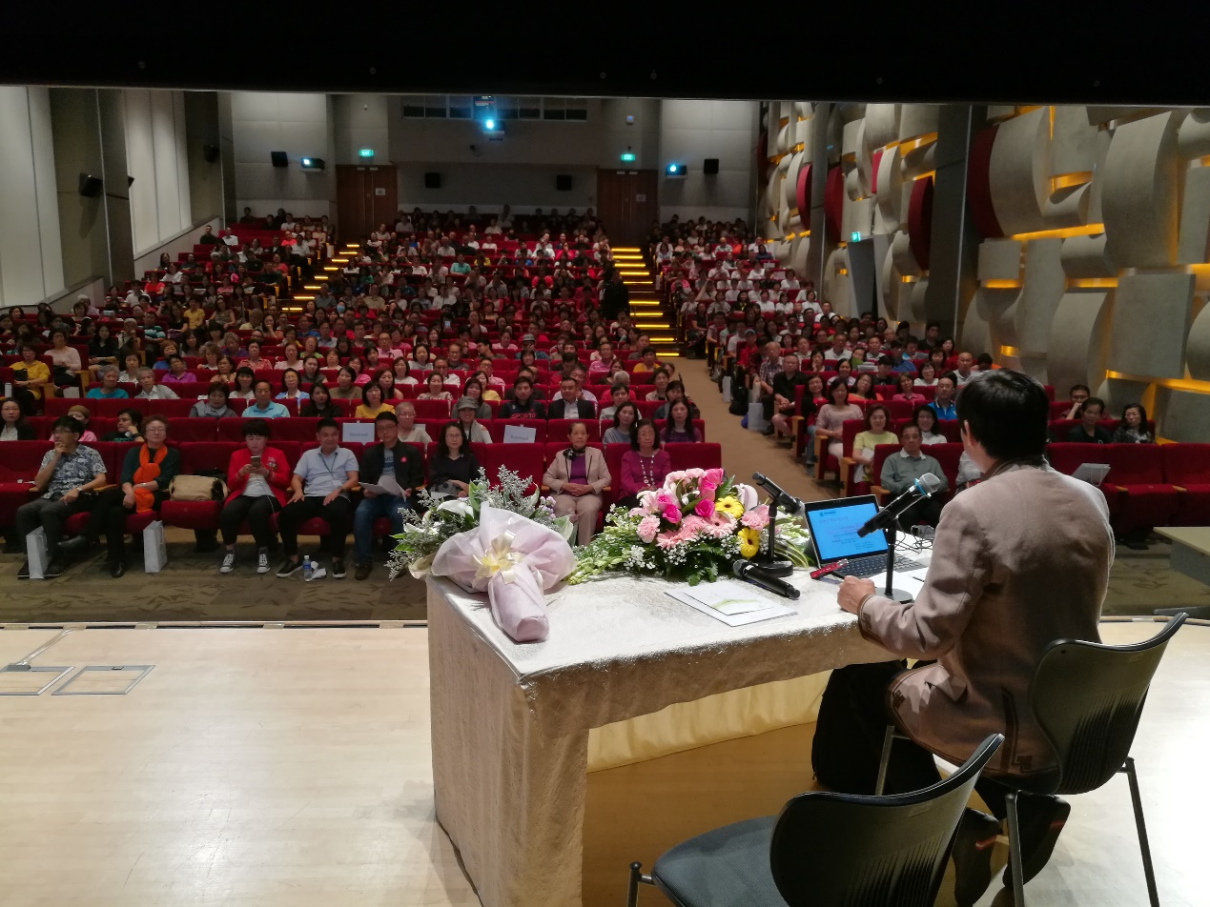
Group therapy in Singapore

Dr Nagongbilige He
Director of center of Mongolian psychosomatic Medicine
Email: nagongbilige@gjmyemail.gjmyy.cn
Office tel: +86 471-5182174
Cellphone: +86 18686039599

Dr. Sarnai Arlud
Email:sarnai@gjmyemail.gjmyy.cn
Office tel: +86 471-5182228
Cellphone: +86 15661057622

