In-silico study on the tumour suppressority effect on hsa-miR-142-3p in breast cancer
Aghayan. Aria¹, Balmeh. Negar², Azadeh. Mansoureh³. Mirzaei. Hanieh⁴, Mohammadi. Shaghayegh⁵, Janghorbani. Negin⁶, Zamani Pozveh. Leila⁷

¹⁻ ⁷ Zist Fanavari Novin Biotechnology Institute, Isfahan, Iran

Abstract

One of the mortality factors in this century between whole women is breast cancer. The World Health Organization (WHO) reckons that breast cancer is one of the three lethal cancers. This cancer are caused by various factors, e.g. genetic including, life style and envirmental situations are reckoned its major factors. The breast cancer such as all types of cancers is caused by a mutation in patient genome. By the way, if a strategy or tact is thought which stop its continue or progress; it can be useful as drug in future. One of this strategies is usage of micro-RNA molecules (miRs). This very small molecules are caused stop agents expression of cancerous genes by vary mechanisms. In this researching letter by using available data analysis at various databases, such as miRTarbase, mirwalk2.0, NCBI, DAVID8.0, miRdSNP and mirnasnp is realized on possible and influential effects at hsa-miR-142-3p against breast cancer tumours suppression. This molecule infects on "WASL", "Jak-STAT", "Adherence Junction" and "Tights Junction" pathways which is inhibited cancerous pathways and tomurgencity suppression. According to the results, is focused on possible positional mutations which may stopped or enhanced right function of this miR. The mutation of Single Nucleotide Polymorphism (SNP) is called in this cancer rs575675, and studied at TMEM200B gene that has a rich frequency in the world wide. The mutation is caused "reduced affinity" of seed part on miR which means that is carcinogenic mutation. At the end, by inclusive of this outputs could estimate that miR-142-3p would be a tumour suppressor which this mutation (rs575675) could be driven advancement and its relation with rs575675 in breast cancer.
Keywords— Breast cancer, hsa-miR-142-3p, in silico study, TMEM200B gene

Professional Biography

Aria Aghayan has studied molecular biology in bachelor degree from Nour-Danesh Institute. Now, he is a researcher of Zist Fanavari Novin Institute. He has published 4 papers in Iranian journals and conferences. His Experience and skills:
- Molecular techniques (PCR/RT PCR / plant and animal cell culture/ primer designing / genomics/ proteomics etc.)
- Isfahan Biology House (IBH) genetics and biology teacher.
- Working on phytoremediation and genetically optimized plants

Email Id: ariaaghayan@hotmail.com

Negar Balmeh has completed her molecular biology in master degree from Nour-Danesh Institute. She is a R&D manager of Zist Fanavari Novin Institute. She has published more than 20 papers in several Iranian journals and conferences. Her Experience and skills:
- Keratin, elastin and collagen extraction and purification by own new method from garbage.
- Bioinformatics and experimental analysis of genes, microRNAs, LncRNAs, piRNAs, miRNAs and SNPs.
- Bioinformatics study of protein's structure, protein modelling, mutation, docking, etc. and dominant on protein's related software and databases.
- Molecular technique mentor (PCR/RT PCR/qRT PCR/ plant and animal cell culture/ primer designing etc)
- R software
- High school biotechnology teacher.
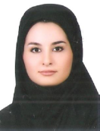
Email Id: n.balmeh@gmail.com

Mansoureh Azadeh has completed her PhD in molecular – cellular biology from Rasht Azad University. She is the founder of Zist Fanavari Novin Biotechnology institute and manager of that institute. One of the most significant her works is establishment of Biotechnology institute for the first time in Isfahan province in Iran. She set up and equipped institute by molecular materials and devices for medical diagnosis. In addition, she is a member of the expert committee in Zist Fanavari Novin Biotechnology institute, editor of training standard of technical and professional and biotechnology field test designer. Now she had trained over than 1000 students in cellular and molecular and biotechnology stage. She has published more than 18 ISI papers in several Iranian and international journals and conferences.
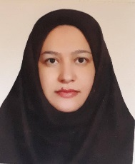
Email Id: mazadeh@phd.iaurasht.ac.ir

Hanieh Mirzaei is studying nursing at Islamic Azad University of Khorasgan. She is a student of Zist Fanavari Novin Institute right now. Her Experience and skills: PCR ,RT PCR , real time PCR and genomics.
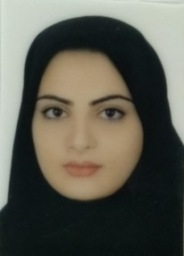
Email Id: hanmir118@gmail.com

Shaghayegh Mohammadi is student of biotechnology in bachelor degree at Ashrafi University. She is a student of Zist Fanavari Novin Institute right now. Her skills are: PCR, electrophoresis, Western blot and SDS Page.
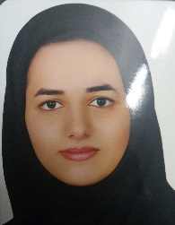
Email Id: Shaghayeghmohammadi9898@gmail.com

Negin Janghorbani is student of genetics in bachelor degree at Islamic Azad University of Isfahan, falavarjan Branch. She is a student of Zist Fanavari Novin Institute right now. Her skills are: RT-PCR, Real-time PCR and genomics.
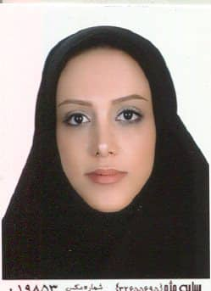
Email Id: neginjanghorbani77@gmail.com

Leila Zamani Pozveh is student of cellular – molecular biology in bachelor degree at Isfahan University. She is a student of Zist Fanavari Novin Institute right now. Her skills are: DNA extraction, RNA extraction, Electrophoresis, PCR, RT-PCR, Real-time PCR, Bioinformatics and Primer Design.
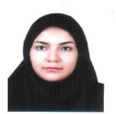
Email Id: Leila.zamani75@yahoo.com

Any Comments:

