Medical Biopolymeric film
Jaleel Kareem Ahmed / University of Babylon / Iraq
Auda J. Braihi /University of Babylon / Iraq
Dalal Abbass Kazm Salman / University of Babylon / Iraq
In this research a therapeutical film from biopolymer and iodine elemental is prepared with different weight percent iodine (24.6). In the average thickness was 0.1mm . Several test are carried out on the film which is suitable for treatment and its effectiveness in healing wounds , burns and infected areas by exposing the infected mice and human and the results are compared with the using medical treatment Celavix (present ointment). The antibacterial activity is examined by exposing film to Escherichia Coli (Gram negative) and Staphylococcus aureus (Gram positive ) microorganism, the results show that the antibacterial ability increases with iodine percent. The healing power increases also as iodine percent increases and complete healing obtained within eight days.
Differential Scanning Calorimeter( DSC )shows the glass transition temperatures ( T_{g} )of the film are shown in the following table:

material | T_{g} / ºC | E_{a at} T_{g /} kJ mol⁻¹ | Energy given by iodine kJ mol⁻¹
Pure biopolymer | 95.57 | 203.00 | 0
+ 2% iodine | 60.90 | 179.40 | 23.59
+ 4 % iodine | 55.86 | 153.02 | 27.02
+ 6% iodine | 50.00 | 149.08 | 31.00

The table shows that addition of iodine to the used biopolymer resulted in iodine supply energy to the polymer and this energy is consumed in destroying secondary bonds (engineering bonds) which is shifted the T_{g} down as a function of iodine concentration. Thus iodine destroys partly the hydrogen bond of the polymer and lowering the T_{g} and the film becomes more flexible. The role of iodine is sublimation at room temperature( transformed from solid iodine to vapor directly). The vapor consists of pure (100%) iodine nano molecules and while the biopolymer film absorbs water and other solutions from the infected area until dryness gives a chance to iodine to contact the dry area directly and reached any point covered by the film notably wounds, it attacks the deepest point and the healing starts from bottom to the top opposite to the healing by ointment thus there is no chance for deep infection remain. In addition, the film is not a pollutant like ointment which is a dust collector. The results shows complete healing takes eight days
shorter than in case of ointment as the following figure shows.
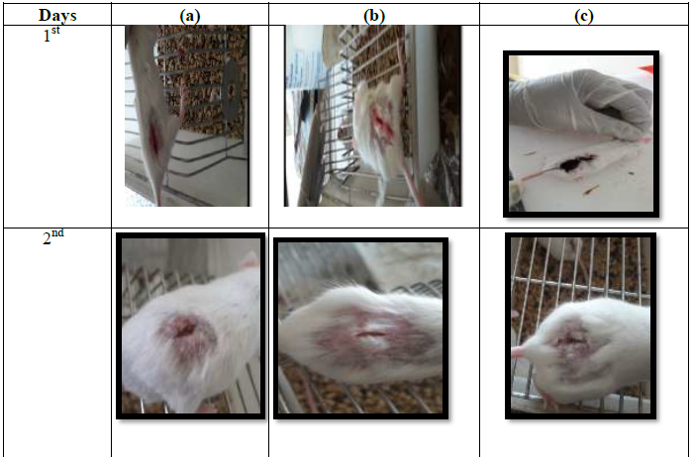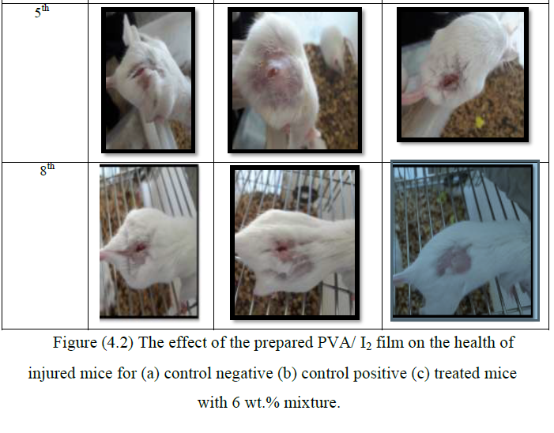

Reference : Iraqi patent 5500.

Biography

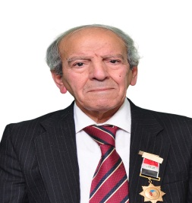
Prof. Jaleel Kareem Ahmed is a Professor of physical chemistry in college of Materials Engineering , Babylon University , Iraq . He was the Dean of the Institute of Foundry and Hammering (2002 – 2013 ) . Dr. Ahmed has his expertise in Iron and steel Industry . He completed his ph.D from Baghdad University and Martin Luther / Germany . I used red beet juice as scavenger for poisonous heavy metal ions and anticancer and detoxification of urea and uric acid from blood via urine system thus it helps kidney work . I have registered 8 patents with 40 published papers and 3 books . He is a reviewer in Jon Wily and Sons since 2016 USA and Editorial board Member of Science publishing Group 2015 USA , and a member in Encyclopedia of Chemistry Scientists 2012 . In 2013 I was awarded Scientists Medal from Iraqi Government for my research " Using Chlorophyll as Gamma ray absorbent to protect Iraqi children from cancer " . In 2014 I became a member in Wh'o is Wh'o network . 2018 Marquis Wh'o is Wh'o has selected me for their official 2018 Albert Nelson Marquis Lifetime Achievement Award in America . Since 2016 I took a part with quality Star (QS) Global Academic Survey ( QS World University Rankings USA ) . In 2018 I awarded honor certificate from International Human Rights for my researches activity .

