Title: Enhanced production, overexpression and characterization of a hyperthermophilic GH family 12 Endo-1,4-β-glucanase cloned from Thermotoga naphthophila RKU-10^{T} in a mesophilic host.

Name: Prof. Dr. Ikram-ul-Haq (Sitar-e-Imtaiz), FPAS,
ISESCO Laureate, Professor Emeritus and
Distinguished National Professor,
Institute of Industrial Biotechnology,
GC University, Lahore-54000, Pakistan.
Phone: +92 42 99211634
+923334570401

Abstract (300 word limit)

The growing demands of bioenergy has led to the emphasis on novel cellulases to improve efficiency of biodegradation process of plant biomass for bioethanol production. Therefore, a novel gene TnEgl (936 bp) was cloned from a hyperthermophilic eubacterium Thermotoga naphthophila and overexpressed as soluble endo-1,4-β-glucanase (TnEgl) belonging to glycoside hydrolase family 12 in Escherichia coli BL21 CodonPlus. Enhancing heterologous expression of cloned protein using various cultivation and induction strategies. After gene cloning and expression of a thermostable protein enhanced using various modifying cultivation media and induction parameters. After optimal production of TnEgl with a molecular weight of 36 kDa, was purified to homogeneity, and characterized completely. High-cell-density or dry cell weight (DCW) and optimal expression of endo-1,4-β-glucanase were obtained in 3×ZYBM9 medium after 72 h inducement at 22°C, induced the culture either with 0.5 mM IPTG/100 mM lactose after heat shock treatment (42°C for 1h) when OD600nm reached at 0.6. Recombinant extracellular enzyme activity was improved by 7.78 and 6.18 fold in 3×ZYBM9 and ZYBM9, respectively under optimal cultivation conditions. Using M9NG and YNG auto-induction medium, activity was 6.5 and 4.76 fold increased after 72 h incubation at 22°C with agitation (200 rev min-1). Hence, the results showed that the effective process strategy is essential to enhance engineered cell mass (production) and enzyme expression. The purified enzyme was optimally active with 1036 Umg-1 of specific activity against 4% CMC at pH 6.0 and 95°C. Enzyme exhibited great stability over a broad pH (6.0-9.0) and temperature range (80-90°C), and was quite stable for 12 hours at 80°C. Enzyme showed great resistance towards various chemical inhibitors and great affinity towards various substrates. A hyperthermotolerant TnEgl with great catalytic efficiency and independence of various chemical inhibitors, all noteworthy features make TnBglB a suitable candidate for various industrial applications.

Image
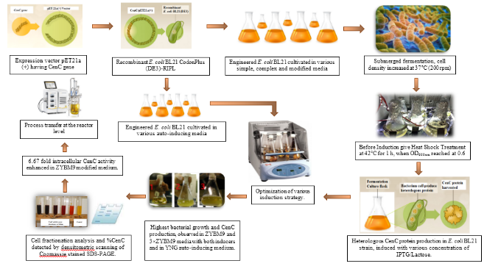

Recent Publications
- Akram F, Haq IU, Imran W, Mukhtar H (2018). Insight perspectives of thermostable endoglucanases for bioethanol production: A review. Renewable Energy 122 (2018) 225-238.https://doi.org/10.1016/j.renene.2018.01.095
- Akram F, Haq IU, and Mukhtar H (2018). Gene cloning, characterization and thermodynamic analysis of a novel multidomain hyperthermophilic GH family 3 β-glucosidase (TnBglB) from Thermotoga naphthophila RKU-10T. https://doi.org/10.1016/j.procbio.2017.12.007.
- Ikram ul Haq and Fatima Akram. Enhanced Production of a Recombinant Multidomain Thermostable GH9 Processive Endo-1,4-β-Glucanase (CenC) from Ruminiclostridium thermocellum in a Mesophilic Host Through Various Cultivation and Induction Strategies. Appl Biochem Biotechnol (2017) 183:171–188. DOI 10.1007/s12010-017-2437-0
- Fatima Akram, Ikram ul Haq, Mahmood Ali Khan, Zahid Hussain, Hamid Mukhtar and Kaleem Iqbal (2016) Cloning with kinetic and thermodynamic insight of a novel hyperthermostable β-glucosidase from Thermotoga naphthophila RKU-10T with excellent glucose tolerance. Journal of Molecular Catalysis B: Enzymatic 124 (2016): 92-104. http://dx.doi.org/10.1016/j.molcatb.2015.12.005
- Haq IU, Akram F, Khan MA, Hussain Z, Nawaz A, Iqbal K, Shah AJ. CenC, a multidomain thermostable GH9 processive endoglucanase from Clostridium thermocellum: cloning, characterization and saccharification studies. World J Microbiol Biotechnol. 2015 Nov;31(11):1699-710. Doi: 10.1007/s11274-015-1920-4. Epub 2015 Aug 7.




Prof. Dr. Ikram-ul-Haq (SI) has completed his Postdoc from Cornell University, New York, USA, and Ph.D. in Industrial Microbiology from University of the Punjab, Lahore, Pakistan. He had been the Dean, Faculty of Science and Technology and founding Director of Institute of Industrial Biotechnology, Government College University (GCU), Lahore. Now, he is ORIC director of GCU, and National Distinction professor emeritus of Industrial Biotechnology department. He is an active researcher and enthusiastically involved in research work. He has successfully completed 21 Projects sponsored by Pakistan Science Foundation, Pakistan Atomic Energy Commission, HEC, GCU & Ministry of Science and Technology while 2 Projects are in process sponsored by MoST, PSF and Pakistan Academy of Sciences. He has published more than 321 papers in journals of international repute, with 2099 citations and has been serving as an editorial board member of various reputed Journals

Presenting author details
Full name: Dr. Ikram-ul-Haq (Sitara-e-Imtiaz), FPAS,
Director ORIC/Professor Emeritus, ISESCO Laureate and
Distinguished National Professor,
Institute of Industrial Biotechnology,
Government College University, Lahore.
Contact number: +923334570401
Email: ikmhaq@yahoo.com and
ravianiib@yahoo.com
Category: (Oral presentation)

Notes/Comments:

