EFFECTIVENESS OF EDUCATIONAL INTERVENTION ON PARENTAL KNOWLEDGE AND SKILLS AMONG PARENTS OF PRETERM NEONATES, RWANDA.
Marie Rose Mukarubayiza MScN, PhD student, University of Rwanda
Assoc. Prof. Oliva Bazirete, RM, PhD, University of Rwanda
Dr Katie Ward, DNP, Utah University/ USA
Dr Nyiringango Gerard MScN, PhD, University of Rwanda/CMHS
Assoc. Prof. Pamela Meharry, CNM, PhD/ Africa Health Sciences University (AHSU) Kigali, Rwanda

Abstract

Background: Preterm birth, defined as delivery occurring before 37 full weeks of gestation, remains a significant factor in neonatal morbidity and mortality globally. Research indicates that parental involvement positively affects neonatal outcomes, and some studies have demonstrated that educational interventions can significantly improve parental understanding of care for preterm neonates.

Purpose: This study aimed to evaluate the effectiveness of a structured educational intervention on parental knowledge and skills related to the care of preterm neonates across six Neonatal Intensive Care Units (NICUs) in Rwanda.

Method: A quasi-experimental one-group pretest–posttest design was used. The intervention used Global Health Media videos translated into Kinyarwanda, combined with demonstrations and discussions on breastfeeding, kangaroo mother care, infection prevention, thermal care, discharge preparation, and recognition of neonatal danger signs.

Results: The study involved 90 parents of preterm infants. After the intervention, parents showed substantial improvements in knowledge and caregiving skills. Mean knowledge scores increased significantly from 10.93 ± 3.21 before the intervention to 18.80 ± 1.16 after the intervention (t = 21.05, p < 0.001), indicating that the educational program was highly effective in improving parental competence in caring for preterm neonates.

Implication for practice and Research: Enhanced parental knowledge, skills contribute to improved caregiving practices, stronger parent–infant relationships, safer discharge transitions, and potentially better neonatal outcomes. This study supports incorporating structured educational interventions as a core component of family-centred neonatal care and underlines the need for research within NICU settings.

Image

This figure shows the statistical evidence: a mean difference of almost 8 points (t = 21.05, p < 0.001) demonstrates that structured education was not only effective but essential in empowering parents to care for their preterm infants.
References

[1] D. Ledinger, B. Nußbaumer-Streit, and G. Gartlehner, WHO Recommendations for Care of the Preterm or Low-Birth-Weight Infant, vol. 86, no. 4. 2024. doi: 10.1055/a-2251-5686.
[2] A. de Costa et al., “Study protocol for WHO and UNICEF estimates of global, regional, and national preterm birth rates for 2010 to 2019,” PLoS One, vol. 16, no. 10 October 2021, pp. 1–13, 2021, doi: 10.1371/journal.pone.0258751.
[3] P. Sahoo, S. K. Panda, and N. Das, “A Literature Review on Early Kangaroo Mother Care : Historical Roots , Neonatal Intensive Care Unit ( NICU ) Integration , and Challenges,” vol. 17, no. 5, 2025, doi: 10.7759/cureus.85140.
[4] S. Tajalli, S. Parvizy, A. Ebadi, F. Zamaniashtiani, and C. Kenner, “Understanding the experience of the mothers’ ability to take care of their preterm infants related to in-hospital and post-discharge: a qualitative content analysis,” BMC Pediatr., vol. 25, no. 1, pp. 1–16, 2025, doi: 10.1186/s12887-024-05338-1.
[5] J. Kelleher, J. Dempsey, S. Takamatsu, J. J. Paul, E. Kent, and A. G. Dempsey, “Adaptation of infant mental health services to preterm infants and their families receiving neonatal intensive care unit services during the COVID-19 pandemic,” Infant Ment. Health J., vol. 43, no. 1, pp. 100–110, 2022, doi: 10.1002/imhj.21961.

Photograph

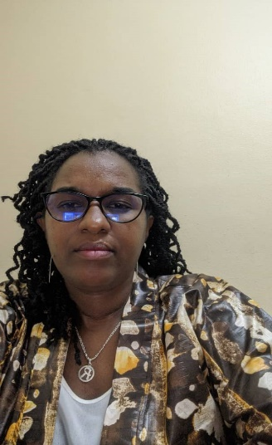
Biography

Mukarubayiza Marie Rose is a PhD student in Nursing at the University of Rwanda’s College of Medicine and Health Sciences, School of Nursing and Midwifery. She is an Assistant Lecturer with an academic background in Midwifery and Nursing Education and a Master’s degree in Neonatology. She has extensive professional experience, including six years of clinical practice at the University Teaching Hospital of Kigali and fourteen years as academic staff at the University of Rwanda, where she has served since 2013. Her professional interests and contributions focus on Nursing and Midwifery education, leadership, research, mentorship, and community engagement. She has contributed to undergraduate and postgraduate education through teaching, student mentorship, research supervision, curriculum-related activities, and academic administration within the School of Nursing and Midwifery. She is also an active member of national and international professional organizations. Her current PhD research focuses on improving maternal and child health care through evidence-based approaches.

Email: roserubayiza@gmail.com

Notes/Comments:
I am a PhD student at University of Rwanda, country located in limited resources countries in Africa. I would like to ask if possible support me through traveling cost, accommodation and restoration because I do not have any fund from my institution. This conference will enhance knowledge, skills and sharing experiences nationally and worldwide. I request also to send me an invitation letter to facilitate travel clearance request. Thank you for your cooperation and favorable feedback

