Visualising Birth Trauma: A history of sexual abuse and assault as contributing factors – A practice-based project
India Lawton Ma, PGCE, SFHEA, Post Graduate Research Student Practice Based Fine Art Photography

Abstract (300 word limit)
According to Rape Crisis Online (2022), the highest number of rapes ever recorded in the UK within a 12-month period was in 2022 with a total of 70,633 reports made to the police. They also state that 1 in 4 women have been raped or sexually assaulted as an adult, and 1 in 6 children have been sexually abused. It has been found that a history of sexual abuse can make the process of pregnancy and birth particularly challenging and leave women feeling vulnerable, isolated, and violated during care and distressing memories may be triggered by childbirth and maternity care (Montgomery et al. 2015, p.54; Pope et al. 2015, p.1; Reed 2017, p.5).
The silence around sexual abuse and assault, even for those who do disclose but still struggle (Montgomery et al. 2015; Pope et al. 2015), and the variety of elements and variables specific to the individual that might contribute to making birth reminiscent of sexual abuse/assault (Pope et al. 2015, p.3-6; Simkin 2004, p.63) creates a particular challenge for those providing care for them and a lack of understanding from those who have not had this experience.
It is argued that the artistic dissemination of research results is more engaging and moves audiences emotionally creating aesthetic and kinesthetic knowing, as visual representations of experiences have been evidenced as helping to transform and share the complex feelings and experiences of trauma into something audiences can interpret, therefore create and an empathetic participation in the lives and experiences of others (Boydell et al. 2012, p.16; Kukkonen & Cooper, 2017, Luckhurst 2008, p.147; p.296; Phillips 2022, p.6).
It has also been documented that imagery that can allow an audience to better understand an experience, and this can also afford relief and recognition for sufferers (Charon 2021, p.34-35), helping in building community through communicating experiences, sharing with others with similar experiences, and finding a common sense of meaning which is central to restoring well-being (Van Der Kolk 2014, p.38).
I am therefore creating artwork that has been informed by secondary research testimonials that express the experience of women who have experienced birth trauma relating to sexual assault or abuse with the aim of sharing the experience, thereby empowering those who have experienced it, and helping others to identify and understand it, leading to positive change (Boydell et al. 2012, p.16; Charon 2021, p.34-35; Hogan et al. 2015, p. 24-29; Van Der Kolk 2014, p.38). Works are ongoing combining photography, photomontage, and mixed media, and focus on words and metaphors used by participants to describe their birthing experience.

Image – Ongoing Practice Based Outcomes

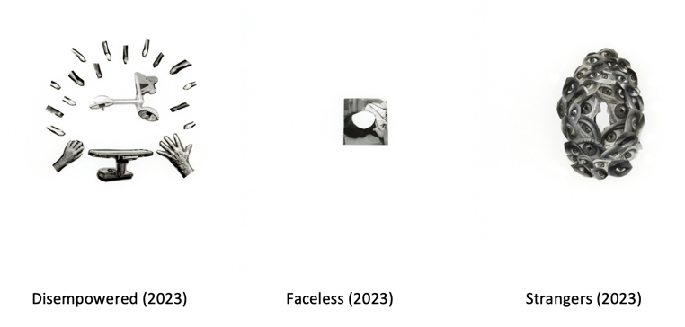

Recent Publications (minimum 5)
- February/March 2023: F-Stop Magazine
F-Stop February Black & White issue #117 – http://www.fstopmagazine.com/
- November 2022: Artist Residency in Motherhood
Artist Residency in Motherhood – http://www.artistresidencyinmotherhood.com
Experimental neurology 213:10-17.
- June 2020: ‘The Last Thing To Burn’ By Will Dean cover image
- February 2019: F-Stop Magazine
F-Stop February Alternative Portrait issue – http://www.fstopmagazine.com/
- January 2017: Southampton City Art Gallery
Collaborative project with students from Winchester School of Art, Lineage, was on show at Southampton City Art Gallery as part of British Art Show 8.

Photograph

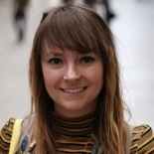 Biography (150 word limit)
India is a lecturer, tutor and unit leader within the art school at Solent University, Southampton. After graduating from her BA (Hons) in Photography at The Arts University Bournemouth, she went on to study for an MA in Photographic Studies at Westminster University, a Postgraduate Certificate in Education (PGCE) at Oxford Brookes University, and then an MA in Education at Oxford Brookes University. India is currently a part-time research student, embarking on a practice-based photography PhD at Solent University. India’s photographic work has been exhibited locally, nationally and internationally. She has been invited to various universities as a guest lecturer, worked in visual merchandising, and was an art ambassador for British Art Show 8. More information and photographic work can be found at www.indialawton.com
Email: india.lawton@solent.ac.uk

Notes/Comments:

