Title: Quality Of Life Questionnaire for women with Gestational Diabetes Mellitus (GDMQ-36): Development and Psychometric Properties
Simbar M^{1*}, Mokhlesi S², Ramezani Tehrani F, Kariman N, Alavi majd H.³

Abstract (300 word limit)
Gestational diabetes mellitus carries serious risks to mother and fetus and causes social, mental, and psychological consequences which can affect mothers’ quality of life. Hence, it is necessary to develop a valid and reliable tool for measuring the quality of life of mothers with gestational diabetes and to plan for a proper intervention which improves their quality of life. The quality of life of mothers with GDM has been measured by a general questionnaire in studies and, no specific quality of life questionnaire has been developed for women with GDM. Accordingly, this study aims to develop and assess the psychometric properties of quality of life questionnaire for women with gestational diabetes mellitus.
A methodological study of sequential exploratory mixed method was developed and implemented. It included qualitative (development of a quality of life questionnaire for mothers with GDM) and quantitative (assessment of psychometric prosperities of quality of life questionnaire for mothers with GDM) phases.
Based on the findings of the qualitative phase and literature review, the primary questionnaire was prepared with 142 items. The outcome of face validity and content validity assessment was a 67-item questionnaire. S-CVI and S-CVR turned out to be 0.92 and 0.68, respectively. The results of exploratory factor analysis yielded an instrument with 36 items in five domains including concerns about high-risk pregnancy, perceived constraints, disease complications, medication and treatment, and support. Five factors explained 46.68% of the total variance of the questionnaire. The results indicated a moderate and significant correlation between the questionnaire of “Diabetes Clients Quality Of Life” and the researcher-made questionnaire (r=0.63). Cronbach’s alpha coefficient for the entire scale was 0.93 and the intra-class correlation coefficient was 0.95.
Quality of life questionnaire for mothers with GDM is a valid and reliable tool capable of measuring the quality of life of women with GDM.

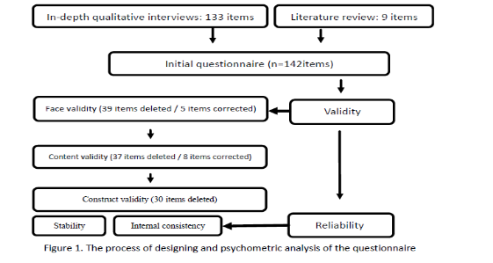

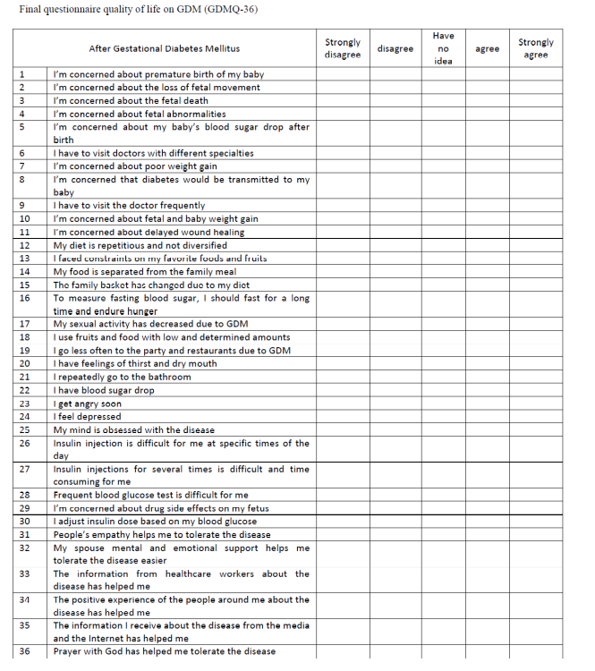


Biography (150 word limit):

Masoumeh Simbar is a full professor of Midwifery and Reproductive Health at Shahid Beheshti University of Medical Sciences in Tehran-Iran. She had more than 300 publications. She spent 25 years of her professional life to research and programming for improving midwifery and reproductive health services. She is also director of the Midwifery and Reproductive Health Research Center in Thehran.
Email: msimbar@yahoo.com

Notes/Comments:

