Title: Using the healthcare failure mode and effect analysis (HFMEA) to integrate and improve the maternal and child friendly rooming-in process
Wu Chia Ying, RN, Kao Wei Yi, RN Guo Xiu Hui, RN Guo Lin Yan, RN Lu Yi Ping, RN Xiao Su Qiu, RN

Abstract
Statement of the Problem: The implementation of the rooming-in is the seventh measure to successfully support the top ten measures of breastfeed, it is also one of the important national policies that Taiwan has been in line with the world in recent years. However, how the rooming-in process can make mothers and families feel supported, affirmed, and cared for, has always been the biggest dilemma in clinical practice, especially in the High-risk pregnancy cases admitted-hospital. Our hospital is the premier medical center in the SouthTaiwan.It has been certified by Taiwan Maternal and Child Friendly Hospital for many years. However, the implementation of the maternal and child-friendly policy does not let the mother feel positive support during the hospital stay. Methodology & Theoretical Orientation: After the inspection process, it was found that the medical personnel departments lacked the integration of education and implemented the care elements in the family. Therefore, we formed a cross-disciplinary team using medical failure modes and effect analysis (HFMEA), plus field observations and interviews, process inspections, data surveys, implementation of integration and improvement of baby and mother rooming-in processes. Conclusion & Significance :After that we complete rooming-in cross-team process、integration Introducing the SDM concept to design a health education plan, and make tools based on the maternal pregnancy check schedule 、Integrate cross-team care resources ,and set rooming-in care standards. Also using the flip teaching mode to strengthen the team's rooming-in care motivation and skills、establish a highly intelligent team care communication platform. The number of accidental incidents of infant accidents in 106-107 was reduced to 0, 24hours rooming-in Rate maintain a total of 26% of the challenge rate in our hospital and the rate of goal achievement of rooming-in was 100%.

Image 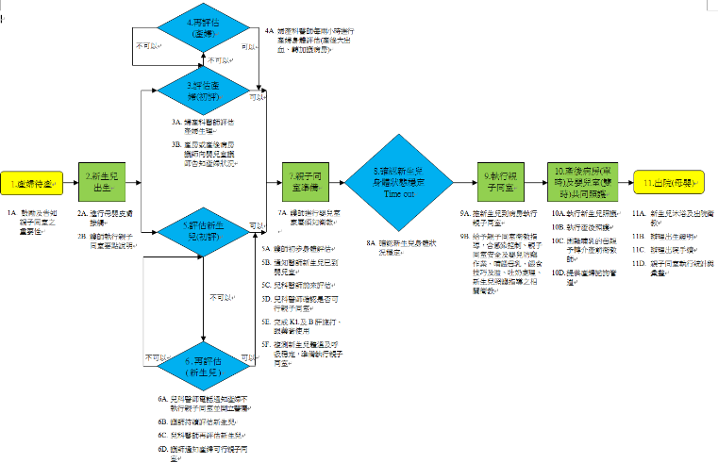
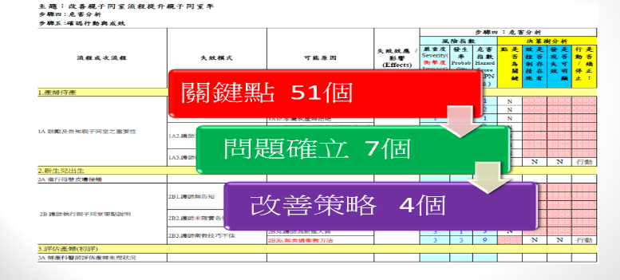
FIGURE 1. Healthcare Failure Mode and Effect Analysis worksheet
FIGURE2. Hazard analysis: failure key point 51、Problem establishment 7、Improvement strategy:4

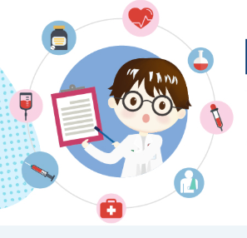 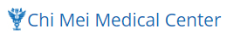 Biography
Chi Mei Hospital is a modern, fully equipped medical center with more than 2450 beds capacity. We are the largest integrated health care system in the Yunlin-Chiayi-Tainan area in Taiwan. We provide high quality health services to more than 3 million patients. Chi Mei Hospital aims to offer safe and quality medical care, promotes health and well-being of staff and the community, and educates outstanding medical professionals. Our Core Values are: Compassion, Accountability and Effectiveness. We are a maternal and child friendly team dedicated to high quality newborn and mother care.
cchiayingwu@gmail.com

Notes/Comments:

