Microencapsulation of Solid Particles by Microfluidics
Wei Gao¹, Chengbin Zhang¹, Yongping Chen*¹²

¹ Key Laboratory of Energy Thermal Conversion and Control of Ministry of Education, School of Energy and Environment, Southeast University, Nanjing, 210096 P.R. China
² School of Environmental Science and Engineering, Suzhou University of Science and Technology, Suzhou, 210096 P.R. China

Abstract (not more than 300 words)

Most current microfluidic technologies are applicable to encapsulate liquid cores into liquid shells to form liquid–liquid–liquid emulsion, such as oil-in-water-in-oil (O/W/O), water-in-oil-in-water (W/O/W), and water-in-water-in-oil (W/W/O) emulsion. Once the core and shell of a double emulsion are the same material, or the cores are the same solvents with different solutes, these liquid–liquid–liquid emulsions cannot be used as the template for the preparation of solid core–shell structure material. In this case, we can produce the solid core–shell structure material via solid-in-water-in-oil (S/W/O) or solid-in-oil-in-water (S/O/W) double emulsions.
Recently, several researchers have conducted relevant studies to encapsulate partilces. Seiffert et al. prepared multilayered and distinct hydrogel capsules consisting of very similar materials via a double cross-junction geometry. Gao et al. constructed a co-flow microfluidic structure to disperse reactive multicompartment microspheres into an oil surfactant solution, and efficiently fabricate various robust hydrogel microspheres with controlled size and porosity. However, the encapsulation success ratio and the number of the inner droplets still cannot be effectively controlled by these methods. Therefore, there is an urgent need to further modify current microfluidic devices and develop a microfluidic method for the controllable encapsulation of S/W/O and S/O/W double emulsions.
In this paper, we present an improved microfluidic device based on facile glass capillary assembly with expected characteristics (Figure 1). Correspondingly, a high-speed visualization experiment is conducted to test the encapsulation performance of S/W/O and S/O/W double emulsions from the presented microfluidic device. It is demonstrated that our microfluidic device enables the encapsulation of both light and heavy particles with a 100% success ratio and the precise control of the quantity of particles by adjusting the flow rate. In addition, by employing multiple injection microchannels into the microfluidic device, multiple types of solid particles can be encapsulated into single emulsion droplets with different combinations.

Keywords—Microfluidics, Microencapsulation, Multicomponent, Solid particles
This work was supported by the NSAF Foundation of China (Grant No. U1530260), the National Science Foundation of China (Grant No. 51725602).

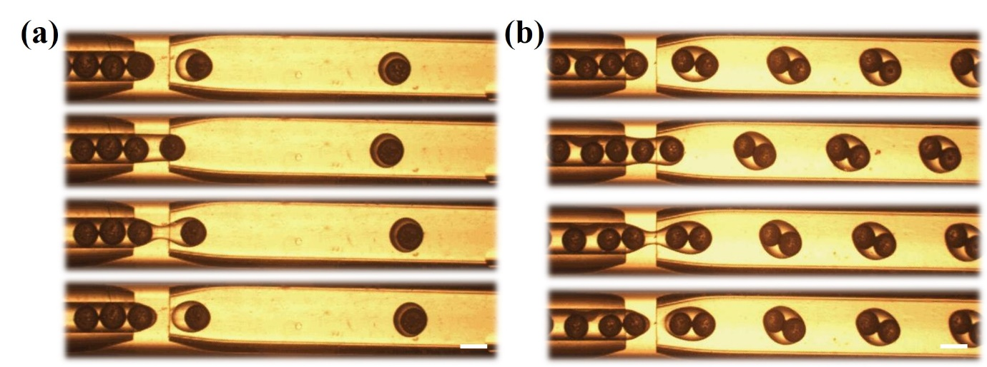
Figure 1. The flow-focusing microfluidic device for encapsulation.
Professional Biography (100-150 words)

Wei Gao, a 3rd grade Ph.D. candidate of power engineering and engineering thermophysics in Southeast University. His major interest is focused on droplets generation, manipulation and application and the fabrication of functional materials. He has published four papers on international journals, such as Lab on a chip, Science Advances, Angewandte Chemie and Advanced Functional Materials. One of his work "Three-dimensional splitting microfluidics" has been published in Lab on a Chip as inside cover letter. He also applied for eight Chinese invention patents.

Paste your Photograph here

Email Id: weigao@seu.edu.cn

Any Comments:
This abstract is expected to oral presentation.

