Abstract Title: A micromixer with asymmetric circular channels having forward and backward facing steps
Wasim Raza¹, Kwang-Yong Kim¹

¹ Inha University, Incheon, Republic of Korea

Abstract (not more than 300 words)

A three-dimensional passive micromixer with forward and backward facing steps in circular sub-channels is proposed to achieve high mixing performance over a wide range of Reynolds number. The proposed design with forward and backward facing steps (FBFS) in the major and minor sub-channels of the micromixer is shown in Fig. 1. Numerical analyses of fluid flow and mixing performance were conducted using three-dimensional Navier-Stokes equations and an advection-diffusion equation for mass transport in a Reynolds number range from 0.1 to 100. Two fluids, i.e., solution of dye in water and water enter from the inlet A and inlet B, respectively. Uniform velocity at the inlets, zero static pressure at the outlet, and no-slip at the walls were assigned as the boundary conditions. The mixing performance was estimated by mixing index which is defined using variance of mass fraction of the mixing fluids on a plane perpendicular to the flow direction. Three different mechanisms i.e., dean vortices in the curved channels, unbalanced collision, and three-dimensional flow structure due to FBFS contribute to the mixing. The locations of FBFS in the sub-channels alter the proportion of two fluid streams in each sub-channel on split and thereby affect the mixing performance. In addition, sudden changes in cross-sectional area and flow separations due to FBFS produce three-dimensional flow structures and aid in chaotic mixing. The proposed micromixer shows the mixing indices at the exit larger than 0.86 for Re ≥ 20. The micromixer achieves a mixing index value more than 0.80 within 39% of total length at Re ≥ 50.

Keywords— Chaotic advection, micromixer, numerical analysis, steps
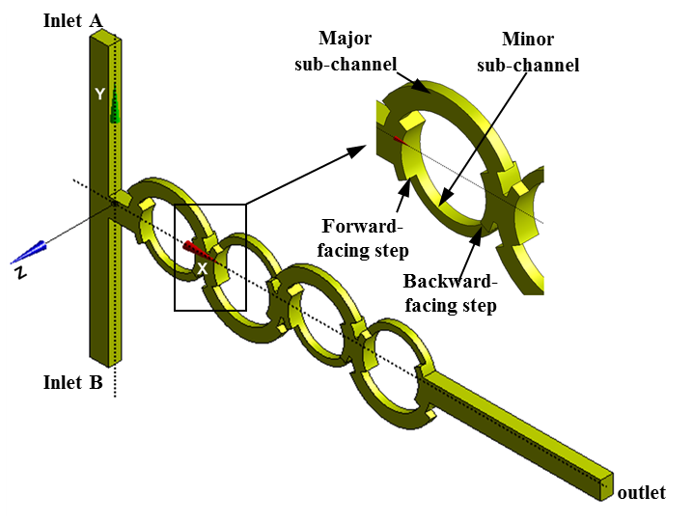
Figure 1. Geometric model of the proposed micromixer with forward and backward facing steps
Professional Biography
Kwang-Yong Kim received his B.S. degree from Seoul National University in 1978, and his M.S. and Ph.D. degrees from the Korea Advanced Institute of Science and Technology (KAIST), Korea, in 1981 and 1987, respectively. He is currently a Dean of Engineering College and an Inha Fellow Professor in the Department of Mechanical Engineering of Inha University, Incheon, Korea. He is a co-editor-in-chief of the International Journal of Fluid Machinery and Systems, an associate editor of ASME Journal of Fluids Engineering, and an editorial board member of Micromachines. He is also a fellow of the Korean Academy of Science and Technology, a fellow of the American Society of Mechanical Engineers (ASME), and an associate fellow of the American Institute of Aeronautics and Astronautics (AIAA). He has published about 370 peer-reviewed journal papers, and presented about 530 papers at international/domestic conferences.

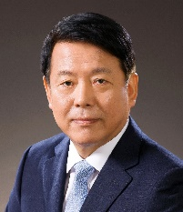

Email Id: kykim@inha.ac.kr

Any Comments: This is a submission for plenary speech on request of the Program Manager Kevin Wilson.

