Title: The microbiology of extreme environments as analogue to assess the feasibility of life in other planets.

Name: Parro V
Affiliation: Centro de Astrobiologia (CSIC-INTA), Spain

Abstract (up to 300 words)
One of the outstanding questions of the humanity is, are we alone in the universe? We don’t know whether other intelligent civilization or even simple forms of life exist elsewhere. Astrobiology tackles this issue by considering life as a consequence of the evolution of the energy and chemistry in the universe, and it focuses on the study of key processes leading to the life as we know it. From the planetary exploration missions to the Solar System, particularly Mars and Jupiter and Saturn’s moons, the scientists have learnt the main characteristics of some of the planetary environments we can find out there. Planetary missions are highly expensive and subjected to many constraints. Therefore, a cheaper approach to assess the feasibility of extraterrestrial life is through simulation either in the lab or in terrestrial extreme environments that can be considered analogous in some of their physico-chemical characteristics. Understanding the microbial diversity, how microorganisms deal with extreme conditions on Earth, and what kind of fingerprint they leave in the medium will contribute to that task and to develop methodologies and instrumentation for the search for life elsewhere. In our group, we have been using complementary techniques for an integrative study of the geomicrobiology of different extreme environments. Particularly, a multiplex microarray immunoassay and an instrument have been developed for the detection of microbial markers in the environmental samples. I will show some of the results obtained about the geomicrobiology from the surface to deep subsurface in río Tinto area (Spain), Atacama Desert (Chile), or Antarctic permafrost. Additionally, past and current work in collaboration with NASA teams to implement biosensing system for planetary exploration missions, will be reported.

Biography (up to 150 words)
Parro V completed his PhD in Biological Sciences (Biochemistry and Molecular Biology) at the age of 29 years from Autonomous University of Madrid, Spain. He is now a Research Professor and the Deputy director of Centro de Astrobiologia (CSIC-INTA), Spain, an associated center to the NASA Astrobiology Institute. He has over 100 publications in the field of molecular and environmental microbiology, and astrobiology that have been cited over 4000 times, and his publication H-index is 25 and has been serving as an editorial board member of reputed Journals.

Email ID: parrogv@cab.inta-csic.es
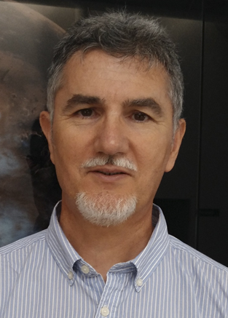

Presenter Name: Parro V.
Type of Presentation: Speaker
Contact Number: +34-915201071

