Dimerization: a structural feature for the protection of hepatitis E virus capsid protein against trypsinization

Wenjuan Wei, Nouredine Behloul, Sarra Baha, Zhenzhen Liu and Jihong Meng*
Department of Microbiology and Immunology, School of Medicine, Southeast University, Nanjing, Jiangsu province, China

Abstract
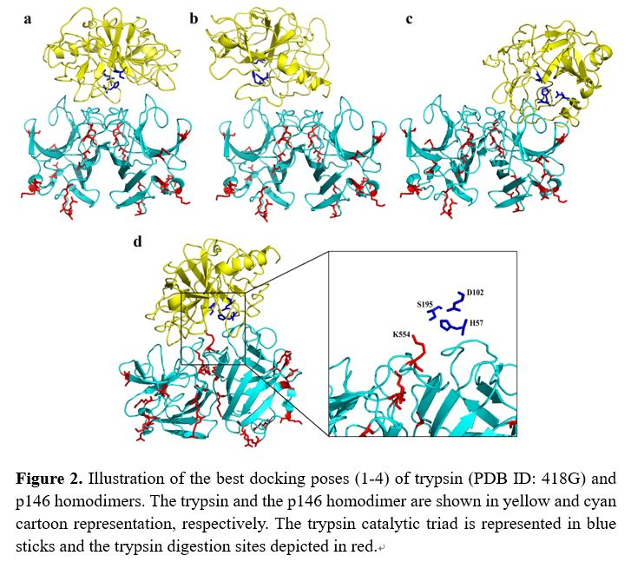
Orally-transmitted viruses have evolved the ability to resist the extreme conditions of the host’s gastrointestinal environment, especially the proteolysis of their structural proteins. However, the mechanisms allowing these viruses to survive these harsh conditions remain unclear. Hepatitis E virus (HEV) is an orally-transmitted human pathogen. Its capsid protein contains three domains S, P1 and P2. This latter forms a homodimer protruding from the virus shell, making it the most exposed part. By combining biochemical and computational methods, we found the trypsin digestion sites to be highly conserved among the HEV strains. Furthermore, the constructs of the HEV capsid protein that contain only or extended P2 domain were digested within the extensions living the P2 domain intact. The dimerization disrupts the trypsin action at three main sites in the P2 domain R542, K544 and K554. These sites are very exposed in the monomeric P2 domain constructs which makes the monomeric forms very susceptible to trypsin action. Therefore, we believe that dimerization is a structural feature that has been selected by the evolutionary forces to render the HEV capsid protein resistant to the host’s proteases; an evolutionary feature that could be common to some other (if not all) orally-transmitted viruses.

Image
Recent Publications
- Wei WJ, Yang HF. Synergy against extensively drug-resistant Acinetobacter baumannii in vitro by two old antibiotics: colistin and chloramphenicol. Int J Antimicrob Agents. 2017 Mar;49(3):321-326
- Wei WJ, Yang HF, Hu LF, Ye Y, Li JB. Activity of levofloxacin in combination with colistin against Acinetobacter baumannii: in vitro and in a Galleria mellonella model. J Microbiol Immunol Infect 2015 Nov 26. pii: S1684-1182(15)00907-X. doi: 10.1016/j.jmii.2015.10.010.
- Wei WJ, Yang HF, Ye Y, Li JB. New Delhi Metallo-β-Lactamase-Mediated Carbapenem Resistance: Origin, Diagnosis, Treatment and Public Health Concern. Chin Med J 2015; 128: 1969-76.
- Wei W, Ye Y, Li J. In vitro synergy of colistin combinations against extensively drug-resistant Acinetobacter baumannii producing OXA-23 carbapenemase. J Chemother 2015 May 15:1973947815Y0000000030.
- Wei WJ, Yang HF, Ye Y, Li JB. Galleria mellonella as a model system to assess the efficacy of antimicrobial agents against Klebsiella pneumoniae infection. J Chemother, 2017; 29(4): 252-256

Biography
She is a second-year PhD student at Southeastern University Medical College, China. During her master period, she mainly studied the mechanism of bacterial resistance and the rational use of antibiotics, especially combined use of antibiotics. Her findings provided theoretical basis for treatment of bacterial infections. Now she is doing some research on mucosal immunization and Hepatitis E oral vaccine.
Email: wjwei.hf@hotmail.com

