Efficacy and Safety of the Bedaquiline-Pretomanid-Linezolid Regimen in the Treatment of Drug-Resistant Tuberculosis: A Retrospective Analysis
Mr. Pramod Yadav, AFAF research Assistant, Amity University Noida, India

Abstract
Statement of the Problem: Drug-resistant tuberculosis (DR-TB) is still a significant global health threat. The appearance of MDR (multidrug-resistant) and XDR (extensively drug-resistant) forms of TB has made treating DR TB more challenging. The World Health Organization (WHO) recommends a combination of at least four drugs for the treatment of MDR-TB, with a treatment duration of at least 20 months. However, long treatment duration, high pill burden, and toxicities are major challenges in the management of DR-TB. The bedaquiline-pretomanid-linezolid (BPL) regimen is a promising new treatment option for DR-TB that has shown high rates of success and minimal toxicities. Methodology & Theoretical Orientation: A study looking back at earlier cases was performed on a group of individuals suffering from DR-TB who received treatment using the BPL regimen. The study included patients with MDR-TB and XDR-TB, and the treatment duration was 6 months. The primary outcome measures were culture conversion rate, treatment success rate, and safety profile. Adverse events were also monitored. Findings: The culture conversion rate was 93.3%, and the treatment success rate was 89.7%. Most adverse events were minor, with only a small percentage of patients (2.3%) experiencing severe events of grade 3 or higher. The most common adverse events were nausea and vomiting, which occurred in 2.3% and 1.4% of patients, respectively. Furthermore, there were no fatalities that were attributed to the treatment. Conclusion & Significance: The BPL regimen is a highly effective and well-tolerated treatment possibility for DR-TB. These results support the use of BPL as a first-line therapy for DR-TB. The shortened treatment duration and lower pill burden of the BPL regimen make it more feasible for patients, especially in resource-limited settings. Further studies are needed to confirm these findings in larger and more diverse populations and to evaluate the long-term outcomes of the BPL regimen. In addition, the cost-effectiveness of the BPL regimen needs to be evaluated and compared to other DR-TB regimens.


Image
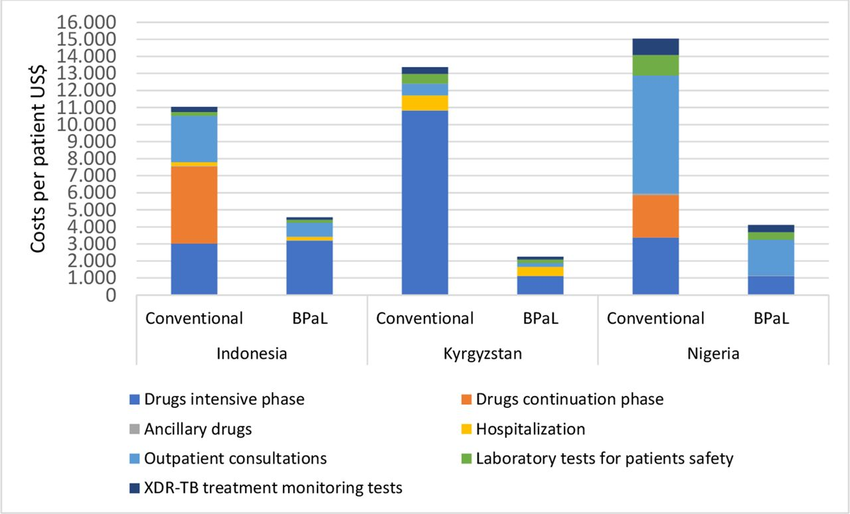
Figure 1. Cast of BPaL treatment in the united states (Christiaan Mulder et al. BMJ Glob Health 2022;7: e007182)
Recent Publications
- Yadav, P. (2023) Challenges & Solutions for Recent Advancements in Multi-Drugs Resistance Tuberculosis: A Review. Microbiology Insights 16:1-9. https://doi.org/10.1177/11786361231152438
- Yadav, P., & Raghuvanshi, V. (2019). Recent Advances in Alzheimer’s Disease Treatment. National Conference on Frontiers in Environment, Health and Biosciences, 86.
- Yadav, P. (2021). Production of Polyclonal Antibody in The Rabbit (Oryctolagus Cuniculus), Its Isolation & Quantification [Dissertation]. Chhatrapati Shahu Ji Maharaj University Kanpur Utter Pradesh India.

Photograph

Biography
Mr. Yadav is a highly skilled research assistant with expertise in evaluation and a passion for improving health in the field of multi-drug resistant tuberculosis. He has made significant contributions to the field through his research, particularly with his paper "Challenges & Solutions for Recent Advancements in Multi-Drugs Resistance Tuberculosis: A Review." This paper presents new pathways for improving healthcare and understanding of treatment and diagnosis in MDR-TB. In addition to his work on this paper, Mr. Yadav has also conducted research using a rabbit model to monitor the secondary response against administer antigen followed by the validation of inject Ag concentration in-vitro. His dedication to understanding and combating MDR-TB makes him an invaluable asset to the research community.
Email: pramodyadavk3@gmail.com

Notes/Comments: This overview provides and supports the valuable insights into the efficacy and safety of the Bedaquiline-Pretomanid-Linezolid regimen in the treatment of drug-resistant tuberculosis.

