Modulation of inflammatory response by Tannerella forsythia OMVs
in the presence of quorum sensing inhibitors
Sang-Hoon Rhee², Sun-Jin An¹, Kyung-Won Ha³, Hye-Kyoung Jun³, Hyun Young Kim¹, Bong-Kyu Choi¹

¹Department of Oral Microbiology and Immunology, ²Department of Dental Materials Science and Dental Research Institute, School of Dentistry, Seoul National University, Seoul, Republic of Korea; ³Bone Science R&D Center, OSSTEM IMPLANT Co., Ltd, Seoul, Republic of Korea

Abstract

Tannerella forsythia is among the major pathogens which are involved in periodontitis, a chronic inflammation. Outer membrane vesicles (OMVs) released from the cell envelope of Gram-negative bacteria play an important role in bacteria-host interaction. OMVs contain bioactive molecules including DNA, RNA, lipopolysaccharides, proteins, toxins, and peptidoglycan. Quorum sensing (QS) is mediated by small signaling molecules that are secreted from bacteria. QS molecules induce bacterial virulence and biofilm formation. However, there are no reports that QS molecules regulate production and virulence of T. forsythia OMVs. In this study, we purified OMVs from T. forsythia in the absence or presence of quorum sensing inhibitors (QSIs, D-arabinose and D-galactose) and investigated their biological activity in THP-1 monocytes. Highly purified OMVs isolated by density gradient ultracentrifugation were analyzed using Nanoparticle tracking analysis (NTA) and observed by TEM. qPCR array analysis and ELISA showed that the expression of pro-inflammatory cytokines (IL-1β, IL-6 and IL-8) was significantly reduced by OMVs of T. forsythia treated with QSIs (D-arabinose and D-galactose) compared to OMVs of T. forsythia without QSIs. T. forsythia OMVs activated NF-κB and MAPK signaling pathway, which were less activated by TF D-arabinose OMVs (TF D-Ara OMVs) and TF D-galactose OMVs (TF D-Gal OMVs) compared to TF OMVs. Our results indicate that QSIs regulate the inflammatory activity of T. forsythia OMVs and therefore, D-arabinose and D-galactose may be used as inhibitors of periodontal inflammation.

Image
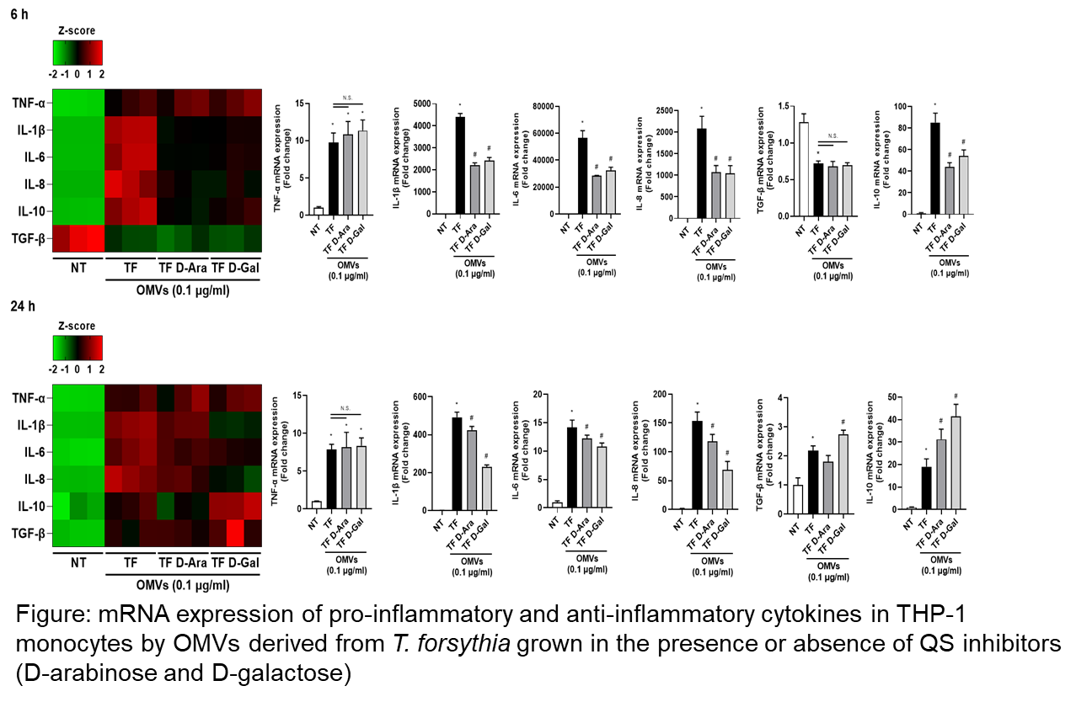

Recent Publications

Lim Y, Kim HY, An SJ, Choi BK (2022) Activation of bone marrow-derived dendritic cells and CD4⁺ T cell differentiation by outer membrane vesicles of periodontal pathogens. J Oral Microbiol 14:2123550.
- An SJ, Namkung JU, Ha KW, Jun HK, Kim HY, Choi BK (2022) Inhibitory effect of d-arabinose on oral bacteria biofilm formation on titanium discs. Anaerobe 75:102533.
- Kim HY, Song MK, Lim Y, Jang JS, An SJ, Kim HH, Choi BK (2022) Effects of extracellular vesicles derived from oral
bacteria on osteoclast differentiation and activation.
Sci Rep. 12:14239.
- Kim HY, Song MK, Gho YS, Kim HH, Choi BK (2021) Extracellular vesicles derived from the periodontal pathogen Filifactor alocis induce systemic bone loss through Toll-like rec
eptor 2. J Extracell Vesicles 10:e12157
- Jun HK, An SJ, Kim HY, Choi BK (2020) Inflammatory response of uric acid produced by Porphyromonas gingivalis gingipains. Mol Oral Microbiol 35:222–230.
Photograph

 Biography
Dr. Choi has her expertise in molecular pathogenesis of inflammation related to periodontitis caused by subgingival plaque bacteria that are highly complex and exist as biofilms. Research topics are signaling pathways for inflammasome activation, functional role of innate immune receptors, functional role of extracellular vesicles from host and bacteria, and development of quorum sensing inhibitors.
Email: bongchoi@snu.ac.kr

Notes/Comment

