Abstract Title:
DEVASTATING EXPERIENCE WITH COMPLICATED PAEDIATRIC SEPTIC JOINT, A CASE REPORT

A.M. NOORHUDA¹, A.R ISMYTH², N. NORZATULSYIMA³, N. SIVAPATHA SUNDARAM⁴

^{1,41} Orthopaedic Department, Melaka General Hospital, Malaysia
^{2,3} Orthopaedic Deartment, Miri General Hospital, Malaysia

Abstract (not more than 300 words)

Introduction
Septic joint morbidity and mortality risks are significantly reduced with advent of antibiotics. Despite arthrotomy washout and long-term antibiotics this patient still developed pan-osteomyelitis and later a pathological fracture

Case Report
This is 1 year 8 months old boy, presented with left knee pain and fever for two days. Physical examination revealed inability to weight bear on left leg, elevated temperature, swelling, tenderness and limited left knee ROM. WCC, ESR and CRP increased. Xray of showed no abnormality. Ultrasound revealed knee effusion. He was started on intravenous antibiotics. We proceeded with arthrotomy washout. Intraoperative specimens grew S.aureus. He completed 4 weeks of intravenous and 2 weeks of oral antibiotics. Two weeks later after discharge, he was seen again with recurrent symptoms. Xray shows pan-osteomyelitis and supracondylar of left femur fracture. He was again started on 2 weeks of IV antibiotics. As the symptoms improves, patient was put on above knee POP and discharge with oral antibiotics for another 4 weeks. Xray repeated 6 weeks upon discharged showed united fracture and improving bone density. Four months later, child came well, and ambulating normally.

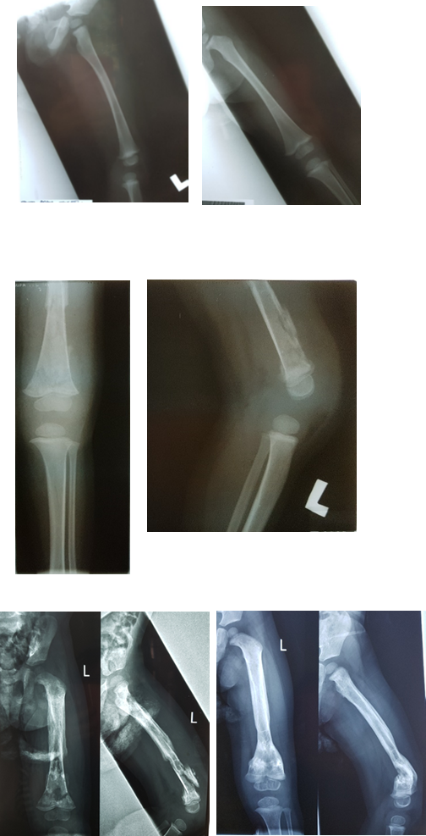

Figure 1
Xray on first presentation – showing no osteomyelitic changes

Figure 2 -Osteomyelitic changes after 4 weeks of antibiotics

Figure3
Xray on second presentation – panosteomyelitis and pathological fracture

Figure 3
Figure 4
Figure 4
Xray after 12 weeks of antibiotics and off cylinder cast – united fracture, good bone quality

Discussion

Incidence of osteomyelitis in septic joint patient is 68%. Strict monitoring and protected weight bearing until there is evidence of radiological improvement is suggested. Shortened intravenous and oral antibiotic therapy should be reserved for uncomplicated cases.

Conclusion
Prolonged monitoring and treatment is a must in complicated septic joint. Protected weight-bearing is important until bone quality improves as evident by serial radiography

Keywords—septic arthritis, osteomyelitis, pathological fracture

Professional Biography

Dr Noorhuda Abdul Mutalif has completed her Medical Doctor (M.D.) degree from The National University of Malaysia 2013. She is currently working as Medical Officer in Orthopaedic Department, Melaka General Hospital, aspiring to be Orthopaedic Surgeon.



Email Id: mshuda88@gmail.com

Any Comments:

