PREVALENCE OF ORAL CANDIDIASIS AMONG DIABETICS - NON DIABETICS PATIENTS AND EVALUATETHE CONTRIBUTION OF RISKFACTORS.

Associated Professor Dr.Abdullah Al-Mamari
Edna Adan University, Hargeisa, Somaliland.
Scientific Research Coordinator.

Background:

Studies of oral fungal have indicated that prevalence of Candida was significantly higher in diabetics both in healthy controls and complete denture wearers compared to non -diabetics. The aims of study was to determine the prevalence oral Candidiasis among both diabetics and non–diabetics patients and evaluate the contribution of risk factors with the prevalence and distribution of Candida species with oral Candidiasis.

Materials & Methods:

The present investigation was carried out in the department of medical microbiology and clinical samples were collected through regular visits to three main hospitals Al-Noor, Al-Amean, Al-Thawra and diagnosis was in the ALFA medical laboratory in Ibb City during period from January into November 2016 .In the current study 70 oral swabs samples were collected from surfaces of the upper of oral cavity and denture of all patients and then placed into a test tube containing 5ml subouraud's dextrose broth. The positive sample was processed for Gram's staining, Germ tube test, Chlamydospores test, Carbohydrate utilization medium examination and Chromagar test was made for differentiation between Candida a species.

Results &Discussion:

The results in this study showed that prevalence of Candida oral infection in Ibb City was 36(52%) positive with oral candidiasis out of 70 samples studied while, 34(48%) of patients studied were negative with oral candidiasis. On the other hand, the results also showed the distribution of oral Candida infection among diabetes and non-diabetes patients was 29(41%) and 7(11%) respectively, this results concordant with many previous studies. Candida albicans was the most prevalent types of Candida a species in this study. The results in current investigation also showed a significantly relationship between crews users, diabetes patients, age and oral candidiasis.

Conclusion:

Through, our study we recommended that many future studies with advanced diagnostics methods have to do for conformed our results.

Image:-48-h-culture growth of Candida albicans on SDA plate isolated from oral cavity positive patient. 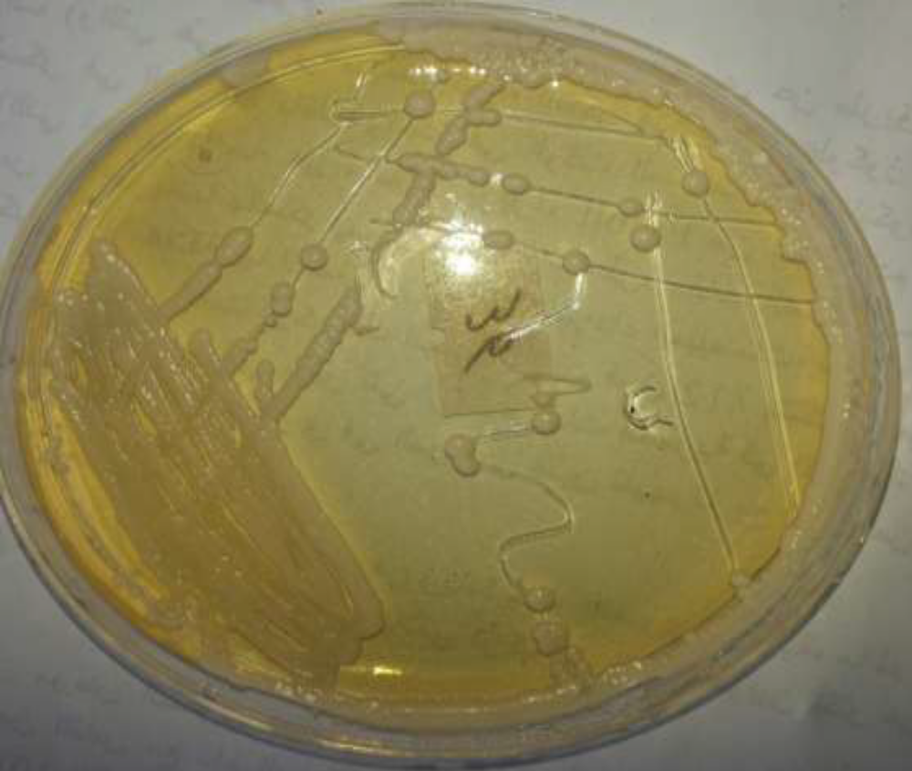

Recent References:
1-Agwu, E.; Ihongbe, JC.; McManus, BA.; Moran, GP.; Coleman, DC. and Sullivan, DJ. (2012).Distribution of yeast species associated with oral lesions in HIV-infected patients in South west Uganda. Med Mycol. 50 (3): 276-280.

2- Katiraee, F.; Khosravi, AR.; Khalaj, V.; Hajiabdolbaghi, M,;Khaksar, A. and Rasoolinejad, M. (2010). Oropharyngeal candidiasis and oral yeast colonization in Iranian Human Immunodeficiency Virus positive patients. J. Med Mycol. 20(1): 8-14.
3- Peleg, AY.;Weerarathna, T.; McCarthy, JS. and Davis, TM. (2007). Common infections in diabetes: Pathogenesis, management and relationship to glycaemic control. Diabetes Metab Res Rev. 23:3–13.

4- Mousavi, SAA.;Salari, S. Rezaie, S. Nejad, NS. Hadizadeh, S,;Kamyabi, H. and Aghasi, H. (2012). Identification of Candida species isolated from oral colonization in Iranian HIV-positive patients, by PCRRFLP method. Jundishapur J Microbiol. 5(1): 336-340. DOI: 10.5812.

5- Yarahmadi, SH.; Khosravi, A.R.; Larijani, B. and et .al. (2002). Assessment of the fungal flora and the prevalence of fungal infections in the mouth of diabetics. Irn J. EndcorinolMetab 4:14.


Dr.Abdullah Almamari exceptional leadership abilities with demonstrated capabilities to perform and train highly productive and motivated team members in health and education field. -Technical expertise and hands on experience in numerous biological & microbiological techniques, protocols and administration tools with various Biological & microbiological computer applications. I have completed my PhD in India in 2007 -2008 and I have already published more than ten papers in international journals.
Email: almamarynew@yahoo.co.in
Contact number:+252-636444652

