The relationship of some fat soluble vitamins and trace elements deficiencies with to dromedary camels (Camelus dromedarius) health statues
Hany Hassan, Ahmed Zaghawa, Ahmed Kamr, Mahmoud Aly, Mohamed Nayel, Ahmed Elsify, Akram Salama and Ali Abdelazeim
Department of Animal Medicine and Infectious Diseases, Faculty of Veterinary Medicine, University of Sadat City, Sadat City, Egypt

Abstract
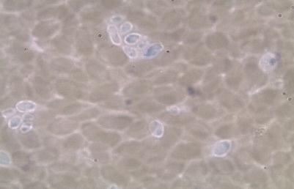
This study aimed to measure blood serum levels of retinol and α-tocopherol and some microelements as selenium, copper and zinc during different diseased conditions of dromedary camels to detect their relationship with changes in hemogram, leukogram and immune status of examined camels. A thirty investigated dromedary camels were compare with sixty-five apparently healthy camels in this study. The age of camels were ranged between four to twelve years and body condition scores ranged from 1 to 3. Camels were collected in different seasons throughout the year from different areas of El-Behaira and El-Menoufia governorates. The mean values of blood serum retinol and α -tocopherol, zinc and selenium were statically reduced in diseased camels than apparently healthy ones (P<0.05). The mean values of phagocytic activity, and phagocytic index were significantly advanced in apparently healthy camels than diseased ones. Engulfed Candida albicans were existing in large numbers by active neutrophils in good conditioned healthy camels. Person correlation (r) between low concentration of serum zinc, and retinol negatively correlated with phagocytic index in diseased camels (P>0.05), while there were a positively correlation between phagocytic index in diseased dromedary camels and lower serum level of retinol, α -tocopherol and copper (P<0.05). Female diseased camels had lower values of retinol and α -tocopherol, selenium and zinc than males ones, also for these item values were decreased in young age diseased camels <6 years old compared to old ones (P<0.05). Low retinol, α-tocopherol and microelements concentrations were associated with diseased camel’s low phagocytic activity and index. The prevalence of low retinol, α -tocopherol, zinc and selenium concentrations were frequent in female diseased camels of age < 6 years old suggesting severe oxidative stress. The information of this study could be a predictor of health outcomes in hospitalized dromedary camels.
A

Image

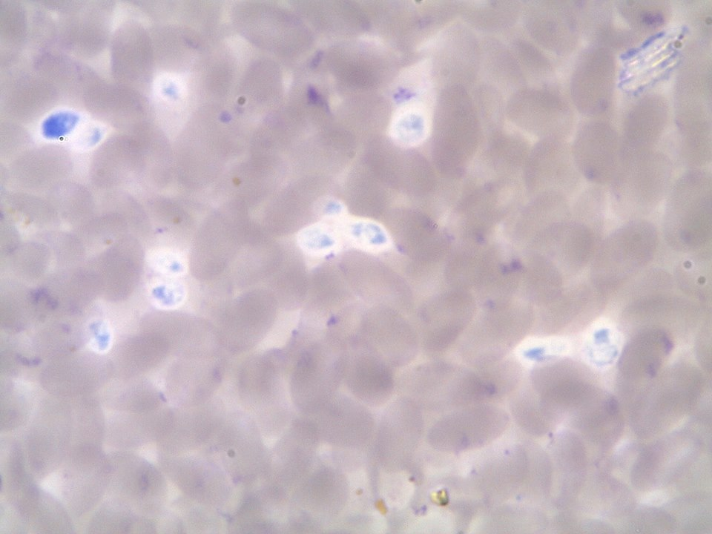
B
Fig (A): Blood film showed that engulfed Candida albicans (large numbers) by active neutrophils in good conditioned camel (red arrows). (B): Blood film showed that numbers of inactive neutrophils and engulfed candida albicans (small number) by active neutrophils in diseased camels (red arrows).
Recent Publications (minimum 5)
- Brunelli, E., Domanico, F., La Russa, D. and Pellegrino, D. 2014. Sex differences in oxidative stress biomarkers. Curr. Drug Targets 15, 811-815. Heilig M, Egli M (2006) Pharmacological treatment of alcohol dependence: Target symptoms and target mechanisms. Pharmacology and therapeutics 111:855-876.
- DeMoranville, V.E. and Best, M.A. 2013. Haematocrit. Encyclopedia of Surgery. A guide for patients and caregivers. Available at: enwikipedia.org /wiki/haematology.
- Mehrzad, J., Maleki, M., Raji, A. and Ramzi, G. 2014. An ultrastructural investigation of the blood neutrophils in camel (camelus dromedarius). Comp. Clin. Pathol. 23(4), 885-892. Room R, BaborT, Rehm J (2005) Alcohol and public health. Lancet
365: 519-530.
- Pourjafar, M., Khalil, B., Saeed, S., Aliasghar, C., Azin, S. and Mojtaba, N. 2014. Correlations between Serum Trace Elements (Selenium, Copper and Zinc) and Antioxidant Vitamins (Vitamin A, E and C) in Clinically Healthy Dromedary Cam
- Yatoo, M.I., Saxena, A., Deepa, P.M., Habeab, B.P., Devi, S., Jatav, R.S. and Dimri, U. 2013. Role of trace elements in animals: a review. Vet. World 6 (12), 963-967.

Photograph

 Biography
Dr. Hany has capability in evaluation and desire in improving the veterinary education and research. He also is an expertise in a quality assurance in higher education and in the student assessment methods. He is a PI to interested developmental projects in his university. He has a vision after years of experience in research, evaluation, teaching and administration both in veterinary hospitals and education institutions. In the same time he is PIs for different scientific projects beside that, he is in the editorial board of various veterinary research journals. The research vision based on back to the nature, so he is interested in alternative veterinary medicine, especially herbal medicine. From his educational point of view, he encourages and implements teaching and learning through peers. He also participates in organizing many educational and service veterinary medical convoys.
Email: hanyhassan1959@gmail.comsted
Notes/Comments:

