Gender differences in clinical features and complications of infective endocarditis: 11- year experience of a single institute in Egypt
﻿
Dr Ahmed Elamragy, PhD, Cairo, Egypt
Dr Marwa Meshaal, PhD, Cairo, Egypt
Dr Amani El-Kholy, PhD, Cairo, Egypt
Dr Hussein Rizk, PhD, Cairo, Egypt

Abstract (300 word limit)
Background
No data exists about the gender differences among patients with infective endocarditis (IE) in Egypt. The objective was to study possible gender differences in clinical profiles and outcomes of patients in the IE registry of a tertiary-care center over 11 years.
Results
The IE registry included 398 patients with a median age of 30 years (interquartile range: 15 years); 61.1% were males. Males were significantly older than females. Malignancy and recent culprit procedures were more common in females while chronic liver disease and intravenous drug abuse (IVDU) were more in males. IE on top of structurally normal hearts was significantly more in males (25.6% vs 13.6%, p= 0.005) while rheumatic valvular disease was more common in females (46.3% vs 29.9%, p= 0.001). There was no difference in the duration of illness before presentation to our institution. The overall complication rate was high, but significantly higher in females. However, there were no significant differences in the major complications: mortality, fulminant sepsis, renal failure requiring dialysis, heart failure class III-IV or major cerebrovascular emboli.
Conclusion
In this registry, IE occurred predominantly in males. Females were significantly younger at presentation. History of recent culprit procedures was more common in females while IVDU was more common in males; who had a higher incidence of IE on structurally normal hearts. The overall complication rate was higher in women. IE management and its outcomes were similar in both genders.

Image
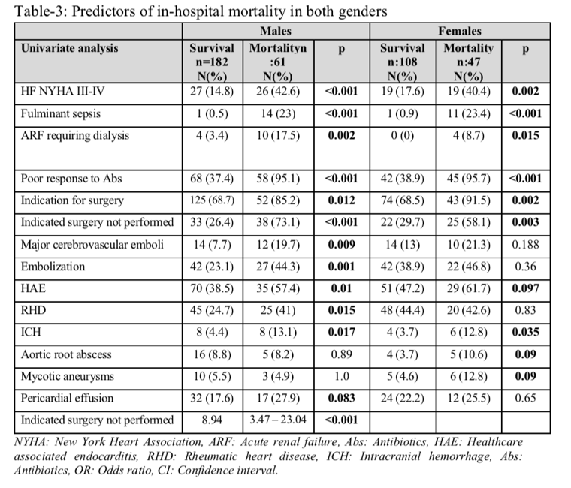
Recent Publications (minimum 5)
- Farouk, H., Shaker, A., El-Faramawy, A., Mahrous, A., Baghdady, Y., Adel, A., Soliman, H., Abdel-Meguid, M., Elasry, A.-A., & Sorour, K. (2015). Adult Congenital Heart Disease Registry at Cairo University. World Journal for Pediatric and Congenital Heart Surgery, 6(1), 53–58.
- Elamragy, A. A., Abdelhalim, A. A., Arafa, M. E., & Baghdady, Y. M. (2019). Anxiety and depression relationship with coronary slow flow. PLOS ONE, 14(9).
- Fahim, M., Pislaru, C., Nkomo, V., Pellikka, P., Elamragy, A., Fahim, M., Taha, H., Eleid, M., Greason, K., & Pislaru, S. (2018). STRAIN ECHOCARDIOGRAPHY PREDICTS DIFFERENCES IN OUTCOMES BETWEEN TRANSAPICAL AND TRANSFEMORAL TRANSCATHETER AORTIC VALVE REPLACEMENT. Journal of the American College of Cardiology, 71(11), A1559.
- Farouk, H., Shaker, A., El-Faramawy, A., Mahrous, A., Baghdady, Y., Adel, A., Soliman, H., Abdel-Meguid, M., Elasry, A.-A., & Sorour, K. (2015). Adult Congenital Heart Disease Registry at Cairo University. World Journal for Pediatric and Congenital Heart Surgery, 6(1), 53–58.
- Azza El Eraky, A. F., Azza Farrag, Azza El Eraky, Wafaa El Aroussy, Ghada Sayed, Ahmad Mahrous, Ahmad Adel, A. M. I. and M. I., & Azza El Eraky, A. F. (2015). Obesity and Other Cardiovascular Risk Factors in Egyptian University Students: Magnitude of the Problem. Epidemiology: Open Access, 5(01), 1–5.
- Elamragy, A. A. (2014). PARIS: A good start for exercise in HFPEF. Global Cardiology Science and Practice, 2014(3), 40.
- Ibrahim, M. M., Elamragy, A. a, Girgis, H., & Nour, M. a. (2011). Cut off values of waist circumference & associated cardiovascular risk in egyptians. BMC Cardiovascular Disorders, 11(1), 53.

Photograph


Biography (150 word limit)
Dr. Elamragy is a faculty member of the Department of Cardiology, Cairo University. He is now the head of the Cardiology Department of Al Nas Hospital as well. He specializes in coronary interventions and imaging. He also has a special interest in infective endocarditis and one of the founders of a special unit dedicated to this disease in Cairo University. This unit established the biggest registry of infective endocarditis in Egypt (more than 500 cases so far), which became ﻿part of two international multicenter registries: the International Collaboration on Endocarditis Prospective Cohort Study (ICE-PCS) in 2007 and the European Infective Endocarditis registry (Euro- ENDO registry) in August 2016.
Email: ahmed.elamragy@kasralainy.edu.eg

Notes/Comments:

