Effect of colibacillosis on the immune response to a rabbit viral haemorrhagic disease vaccine
Abdelfattah H. Eladl*, Verginia M. Farag, Reham A. El-Shafei, Rasha M. Elkenany,
Mona M. Elsayed, Marwa M. Mona, Hanaa S. Ali, Mohamed A. Saif

*Department of Poultry Diseases, Faculty of Veterinary
Medicine, Mansoura University, Mansoura, Egypt

Abstract
Statement of the Problem: Viral haemorrhagic disease (VHD) and colibacillosis are common diseases in rabbits that cause economic losses worldwide. The effect of colibacillosis on the immune response of vaccinated rabbits against rabbit haemorrhagic disease virus (RHDV) was studied. Methodology: Four groups (G1-G4) were included. G1 was the negative control group; G2 was the RHDV vaccine group; G3 was the E. coli-infected group; and G4 was the E. coli-infected + RHDV vaccine group. The E. coli infection and RHDV vaccination were simultaneously performed, with another previous infection, 3 days before vaccination. At 28 days post-vaccination (PV), the rabbits (G2-G4) were challenged intramuscularly with 0.5 ml of RHDV at a dose of 103 50% median lethal dose (LD50)/rabbit. The rabbits were observed for clinical signs, body weight gain and mortality rates. Tissue, blood, serum, and faecal samples and rectal swabs were collected at 3, 5, 7, 14, 21 and 28 days PV. Findings: Significant clinical signs and mortality and a decrease in BW were observed in the infected + RHDV vaccine group. On the 3rd day post-infection (PI), compared with all the other groups, the vaccinated group (G2) had significantly upregulated hepatic tumor necrosis factor- α (TNF- α) and interleukin-6 (IL-6) levels; however, the infected+ RHDV vaccine group had significantly higher intestinal levels of TNF- α and IL-6 than the other groups. Furthermore, E. coli infection in vaccinated rabbits led to immunosuppression, as shown by significant decreases (P <0.05) in heterophil phagocytic activity, the CD4+/CD8+ ratio, and HI antibody responses to RHDV and a significant increase in the heterophil to lymphocyte (H/L) ratio. Conclusion: Colibacillosis leads to immunosuppression involving a shift in the equilibrium of cytokines and reduced weight gain and mortality in vaccinated rabbits and could be a contributing factor in RHDV vaccination failure in rabbit farming.

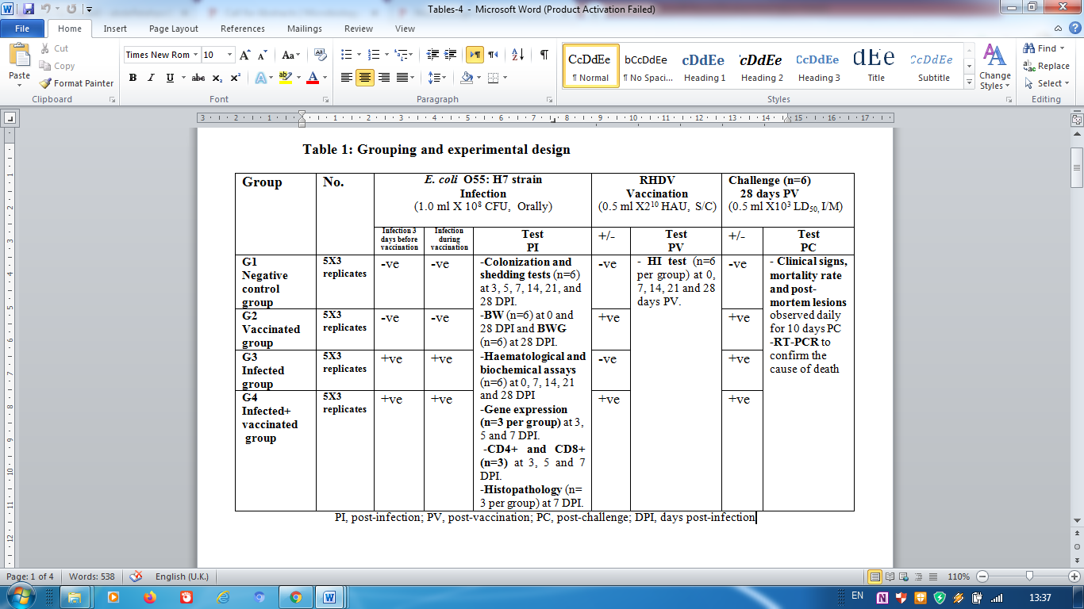
Recent Publications (minimum 5)
- Elkady, B.A., Al-Ebshahy, E.M., Khalil, S.A., Saleh, A.A., 2016. Development of Fluorescein-labelled antisera for rapid detection of Rabbit haemorrhagic disease virus. Alex. J. Vet. Sci. 51, 46-51.
- Fahmy, H.A., Arafa, A., Mahmoud, A.H., 2010. Molecular diagnosis of rabbit hemorrhagic disease virus (RHDV). Egypt. J. Comp. Path. Clinic. Path. 23, 85 – 101.
- Ghodratizadeh, S., Kanbak, G., Beyramzadeh, M., Dikmen, Z.G., Memarzadeh, S., Habibian, R., 2014. Effect of carotenoid β-cryptoxanthin on cellular and humoral immune response in rabbit. Vet. Res. Commun. 38, 59-62.
- Ismail, M.M., Mohamed, M.H., El-Sabagh, I.M., Al-Hammadi, M.A., 2017. Emergence of new virulent rabbit hemorrhagic disease virus strains in Saudi Arabia. Trop. Anim. Health Prod. 49, 295–301.
- Yang, D., Kim, H., Nah, J., Song, J., 2015. Rabbit hemorrhagic disease virus variant recombinant VP60 protein induces protective immunogenicity. J. Microbiol. Biotechnol. 25, 1960–1965.

Photograph


Biography
Dr Eladl has B.V.Sc., with a very good grade, appointed a demonstrator, Assistant Lecturer, lecturer and then Assistant Professor of Poultry and Rabbit Diseases since 2016 till now. His professional experience targets on genetic characterization and antigenic analysis of H5N1 highly pathogenic avian influenza viruses circulating in Egypt. His work also focused on researches of vaccine and vaccination in poultry and rabbit diseases. These include phylogenetic, gene sequencing, cloning and reverse genetic techniques. He participates in the department scientific research. Foreign grants were obtained from FAHRP, USA, 2009 and 2011. Courses taught as practical and lectures parts of Poultry and Rabbit diseases for undergraduate and graduate students.
Dr. Abdelfattah H. Eladl,
Assistant Professor,
Department of Poultry diseases, Faculty of Veterinary Medicine, Mansoura, 35561, Egypt
Phone: +20502704110
Mobile: +201011280688
Email: abdelfatahpo@yahoo.com
:

