Diversity of microbial communities associated with mercury contamination in the Colombia's Amazon region
Gladys Cardona, PhD(c), Instituto Amazónico de Investigaciones científicas– Sinchi, Colombia
María Camila Escobar, MSc, Instituto Amazónico de Investigaciones científicas– Sinchi, Colombia
Silvia Marques, PhD, Estación experimental del Zaidin, España
Alejandro Acosta-Gonzalez, PhD, Universidad de la Sabana, Colombia

Abstract (300 word limit)

The use of mercury (Hg) in gold mining is a disturbance process that severely affects the ecosystems of the Colombian Amazon. In environments contaminated with Hg, microbial transformations (reduction and methylation) are the main mechanisms of metal speciation. There are few studies that evaluate the composition of microbial communities and their relationship with biotic and abiotic variables in Hg contaminated areas. In this work we have analyzed, through massive sequencing with Illumina Miseq, the structure of bacterial communities in waters, soils and sediments with different degrees of intervention with gold mining, in two locations of the Colombian Amazon: Tarapacá - Amazonas (low intervention) and Taraira - Vaupés (high intervention). We found that in both locations the microbial composition is similar, predominating the Phylum Proteobacteria, Acidobacteria, Actinobacteria and Chloroflexi, which includes genera resistant to Hg. The comparison of the diversity indices for the two localities indicates that in Tarapacá the average richness of OTUs was generally higher than in Taraira, although with a high dispersion, attributable to the differences in richness between sample types and sampling sites: samples from aquatic ecosystems have communities with less richness, which increases in sediments and forest soils. Additionally, the interaction between locality and sample type is also evident in the degree of divergence between the regions: the soil and sediment samples are more similar between the two locations than the respective water samples. Among the environmental variables that modulate the composition of the community between localities are the textures of the support (sand and clay). And, other environmental variables are Na and K, that modulate the composition by the type of samples (water versus soil and sediment). Regarding the variables mercury and methyl-mercury (CH₃Hg), its effect is not global but site-specific. This could be due to the ability of Hg to be immobilized with other elements and form stable non-bioavailable molecules.
Image
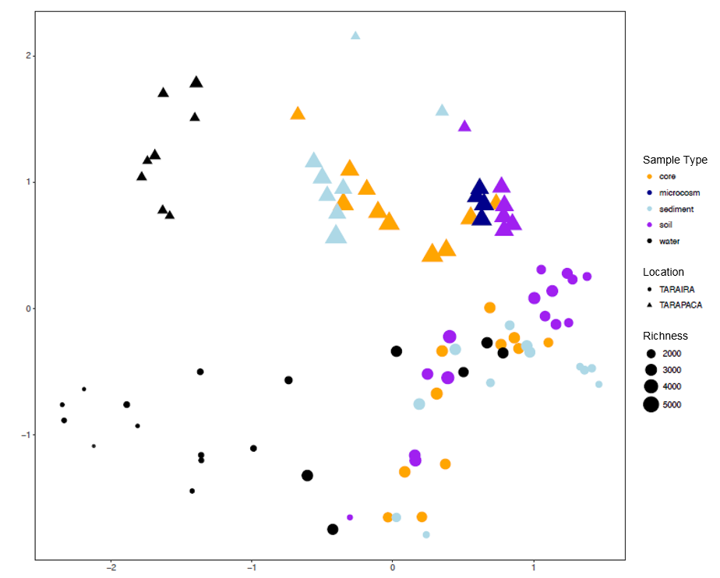
Figure 1. NMDS calculated based on the Bray Curtis index. The color code represents the type of sample (i.e. Sample type) and the forms, the location to which each point belongs.

Recent Publications (minimum 5)
- Dash.H.R and S. Das. 2016. Diversity, community structure, and bioremediation potential of mercury-resistant marine bacteria of estuarine and coastal environments of Odisha, India. Environ Sci Pollut Res. 23:6960–6971.
- Marcin.C., G.Marcin., M-P. Justyna., K. Katarzyna and M.Niklinska. 2013. Diversity of microorganisms from forest soils differently polluted with heavy metals. Applied Soil Ecology 64: 7–14
- Oregaard. G and S. J. Sørensen. 2007. High diversity of bacterial mercuric reductase genes from surface and sub-surface floodplain soil (Oak Ridge, USA). The ISME Journal: 1, 453–467.Room R, BaborT, Rehm J (2005) Alcohol and public health. Lancet
365: 519-530.
- Virsek.M.K., B.Hubad and A. Lapanje. 2013. Mercury induced community tolerance in microbial biofilms is related to pollution gradients in a long-term polluted river. Aquatic Toxicology 144–145 208–217.
- Wang. Y., E.Boyd., S.Crane., P.Lu-Irving., D.Krabbendhoft., S. King., J.Dighton., G. Geesy and T. Barkay. 2011. Environmental Conditions Constrain the Distribution and Diversity of Archaeal merA in Yellowstone National Park, Wyoming, U.S.A. Microb Ecol 62:739–752.

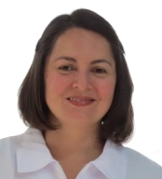Biography (150 word limit)
Bacteriology, with master’s degree in Biological Science, PhD student in biological systems. With experience in microbial ecology in Amazonian ecosystems, especially in forest soils to look for microorganisms that promote growth, bioremediation and restoration. Also, she works with mercury reducing and demethylating bacteria isolates in ecosystems contaminated by Hg, with bioremediation potential.
Email: gcardona@sinchi.org.co

