Optimization of confocal microscopy for visualization and quantification of yeast biofilm
Smolova J.¹, Nemeckova I.¹, Turonova H.²
¹ Dairy Research Institute, Ke Dvoru 791/12a, Prague 6, Czech Republic
² University of Chemistry and Technology, Technicka 5, Prague 6, Czech Republic
Corresponding author: jana.smolova@gmail.com

Abstract:
Due to the resistance of biofilm to conventional cleaning processes, an industrial biofilm, especially in dairy industry, could cause extensive problems in final products in case of insufficient sanitation process. Our work focuses on visualization and quantification of yeasts biofilm using confocal microscopy. Commercial dying kits are optimized for pathogenic bacteria, therefore, the dying protocol for yeasts must have been created. The yeasts were isolated as industrial contaminants from cheese and saline solution and were identified as Yarrowia lipolytica and Debaryomyces hansenii using MALDI-TOF.
Material and methods: µCLEAR® Chimney well plate was used for yeasts cultivation and the cultivation time, washing, dying and visualization of yeasts biofilm was optimized. LIVE/DEAD® BacLightTM Bacterial Viability and Counting Kit was used for dying and the biofilm visualization was performed by a confocal laser scanning microscopy with a rotating disc, a ten-fold magnification and a 1 μm z-step. For the living, dead and damaged cells, biomass volume and total biofilm structure were determined using Imaris software.
Results: The cultivation time was set to 24 hours with fresh broth well washing after 2 hours which better corresponds with real conditions. While living cells predominated in D. hansenii biofilm, the damaged cells prevailed in the Y. lipolytica biofilm, which may have been related to the different aging rates of the biofilm of both strains. The dying time was shortened to 60 minutes to reduce the toxic effect of propidium iodide.
Conclusion: New approaches for visualization and quantification of biofilm are needed for better understanding of the biofilm forming and persistence. We have shown that visualization of yeast biofilm is one of the ways to study these biofilms. These findings can lead to monitoring the effectiveness of sanitation solutions and to designing better cleaning processes.

Image
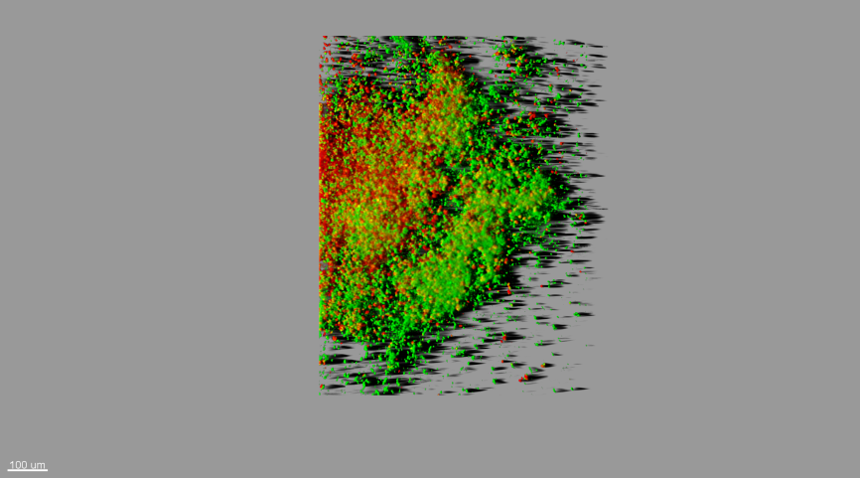
Fig.1: Easy 3D projection of Y.lipolytica biofilm. Green - living cells, yellow - damaged cells, red - dead cells.

Recent publications:
Abbes, S., et al. "Analysis of virulence factors and in vivo biofilm-forming capacity of Yarrowia lipolytica isolated from patients with fungemia." Medical mycology 55.2 (2017): 193-202.
Dusane, D. H., et al. "Biofilm formation by a biotechnologically important tropical marine yeast isolate, Yarrowia lipolytica NCIM 3589." Water Science and Technology 58.6 (2008): 1221-1229.
Schlafer, Sebastian, and Rikke L. Meyer. "Confocal microscopy imaging of the biofilm matrix." Journal of microbiological methods 138 (2017): 50-59.
Shikano, Ayane, et al. "Effect of quantity of food residues on resistance to desiccation, disinfectants, and UV-C irradiation of spoilage yeasts adhered to a stainless steel surface." LWT-Food Science and Technology 80 (2017): 169-177.
Stellato, Giuseppina, et al. "Coexistence of lactic acid bacteria and potential spoilage microbiota in a dairy processing environment." Applied and environmental microbiology 81.22 (2015): 7893-7904.

