Formation of Rhodococcus biofilms at water-oil interfaces and their role in bioremediation of contaminated environments

Maria S. Kuyukina and Irena B. Ivshina
Perm State University, Institute of Ecology and Genetics of Microorganisms, Perm, Russia

Actinobacteria of the genus Rhodococcus often dominate in oil-contaminated environments and they are well-known hydrocarbon degraders. We previously used Rhodococcus strains for the clean-up of soil and water contaminated with petroleum hydrocarbons. Bacterial adhesion to hydrocarbons is an initial step in the biofilm formation, which enhances assimilation and biotransformation of these hydrophobic substrates. While Rhodococcus adhesion to solid surfaces was described previously, their biofilm formation in two-phase liquid systems is not yet elucidated. In this study, we monitored thermodynamic behavior of rhodococcal cells attached to water-oil interfaces using precise temperature-controlled interfacial tensiometry. Electrophoretic mobility and bacterial adhesion to hydrocarbons (BATH) measurements were performed to characterize roles of hydrophobic and electrostatic interactions in the biofilm formation. Long-term tensiometry revealed an initial thermodynamically unstable stage of weak interactions between adhered cells followed by the equilibrium stage corresponding to biofilm development. Using a coupled atomic force and confocal laser microscopy, we monitored the elastic properties of rhodococcal biofilms at micro- and nano-levels. To assess the response of biofilms to environmental stresses (petroleum hydrocarbons, organic solvents, heavy metals), cellular adaptations such as changes in cell-wall rigidity, lipid composition, and efflux pump activation were elucidated. These properties are unique for Rhodococcus biofilms and provide creative opportunities to improve biofilm-based bioremediation.

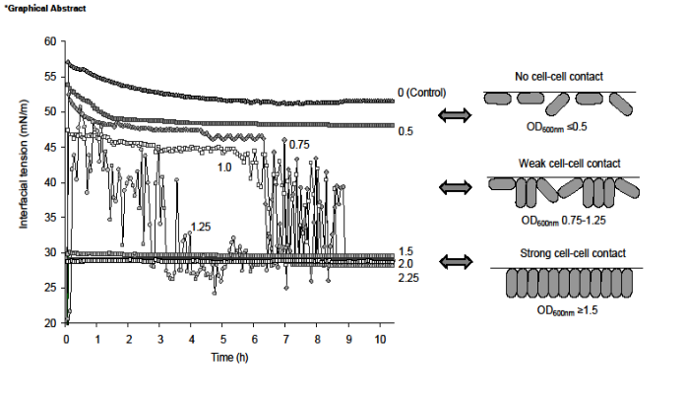

Figure 1. Long-term tensiometry and schematic of Rhodococcus cell arrangement at the oil-water interface.

- Kuyukina MS, Ivshina IB (2010) Application of Rhodococcus in bioremediation of contaminated environments. Microbiology Monographs. 16: 231-262.
- Ivshina IB, Kuyukina MS (2013) Turning Russian specialized microbial culture collections into resource centers for biotechnology. Trends in Biotech 31: 609-611.
- Ivshina IB, Kuyukina MS et al. (2015) Oil spill problems and sustainable response strategies through new technologies. Env Sci Proc Impacts 17: 1201-1219.
- Ivshina IB, Kuyukina MS, Krivoruchko AV (2017) Hydrocarbon-oxidizing bacteria and their potential in eco-biotechnology and bioremediation. In: Microbial Resources: From Functional Existence in Nature to Industrial Applications. 121-148.
5. Kuyukina MS, Ivshina IB et al. (2017) Oilfield wastewater biotreatment in a fluidized-bed bioreactor using co-immobilized Rhodococcus cultures. J Env Chem Engin 5:1252–1260.

