Inhibiting the activity of human serious pathogenic bacteria using crude saps of plants growing in Palestine
Hazem Sawalha Professor of Microbiology/ Department of Biology & Biotechnology. Faculty of Sciences/Arab American University
Saed Khaseeb MSc. Of Biology/ Department of Biology & Biotechnology. Faculty of Sciences/Arab American University

Abstract
Antibacterial activity of some Palestinian plants against seven human pathogenic bacteria using the agar disk-diffusion method was studied. Based on the width of the zone inhibition, Eucalyptus camaldulensis (0.3 cm), Allium sativum (0.2 cm), Ceratonia siliqua (0.15 cm) and Amygdalus communis(0.15 cm) revealed the best antibacterial activities against the bacterial mixture compared with the rest of the assayed plants. Furthermore, E. camaldulensis showed the strongest antimicrobial activity among the four plants. Also, A. sativum have the maximum anti-microbial action against all types of the tested bacteria. In addition, saps of E. camaldulensis and the mixture of E. camaldulensis and A. sativum have a strong ability to kill all types of the tested bacteria followed by the mixture of C. siliqua and A. sativum, the mixture of C. siliqua, A. sativum and E. camaldulensis and the mixture of A. communis, A. sativum and E. camaldulensis that have significant results as anti-microbial agents against most types of the tested bacteria. The results showed that A. sativum and the mixture of A. sativum and C. siliqua have the maximum antimicrobial affectivity against Staphylococcus aureus, whereas, Micrococcus luteus was strongly inhibited by E. camaldulensis, A. sativum, the mixture of E. camaldulensis and C. siliqua, the mixture of E. camaldulensis and A. sativum, and the mixture of E. camaldulensis, A. sativum and C. siliqua. Escherichi. coli was efficiently inhibited by A. communis, A. sativum, and E. camaldulensis and also by the mixture of A. sativum and E. camaldulensis. Pseudomonas aeruginosa was inhibited in a significant amount by E. camaldulensis and A. sativum, whereas, Proteus vulgaris was strongly inhibited by the A. sativum. Bacillus subtilis was strongly inhibited by A. sativum, while, for the Klebsiella pneumoniae, most saps revealed an intermediate inhibition except the A. communis, which showed the lowest inhibition value.
Therefore, the current study elucidated that E. camaldulensis, A. sativum, C. siliqua and A. communis are the best tested Palestinian plants containing the antibacterial agents against the tested bacterial types.

Image
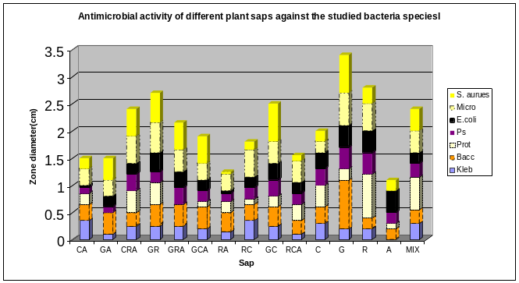
A: Almond (A. communis), R: Red River Gum (E. camaldulensis), G: Garlic (A. sativum), C: Carob (C. siliqua), Mix: A + R + G + C
Recent Publications
- Al Laham, S and Al Fadel, F. 2014. Antibacterial Activity of Various Plants Extracts Against Antibiotic-resistant Aeromonas hydrophila. Jundishapur J Microbiol.7(7): e11370.

Djeussi, D., Noumedem, J., Seukep, J. Fankam, A., Voukeng, I., Tankeo, S., Nkuete, A., and Kuete, V., 2014. Antibacterial activities of selected edible plants extracts against multidrug-resistant Gram-negative bacteria. Complementary and Alternative Medicine, 13: 164
- Farjana, A., Zerin, A., and Kabir, M. 2014. Antimicrobial activity of medicinal plant leaf extracts against pathogenic bacteria. Asian Pacific Journal of Tropical Disease 4: S920-S923
- Lee, J and Choi, H. 2015. Antiviral and antimicrobial activity of medicinal plant extracts. J. Microb Biochem Technol.7: (5) 286-288
- Sen, A. and Batra, A. 2012. Evaluation of different antimicrobial activity of different solvent extracts of medicinal plant Melia azedarack L. International Journal of Current Pharmaceutical Research, 4 (2), 67-73.
- Tortora, G., Funke, B. and Case, C. 2016. Microbiology; An Introduction, 12th Edition. Pearson: 213.

Biography (150 word limit)
Hazem Sawalha has his expertise in Microbiology and Biotechnology. He has 21 published articles in national and international journals in addition to 15 articles published in international journals and proceedings of conferences. He is working in the department of Biology and Biotechnology at The Arab American University/ Palestine since 2004. He is promoted to full professor in 2016..
Email: drXXXXXXX@xxxmail.com

Notes/Comments

